**Science Policy**

**Handbook**

**St. Andrew’s CE Infant School**



**Our School Motto**

**‘Learning, Caring and Growing together in Faith’**

**Our Vision**

St Andrew’s Infant School is a Christian school where children are happy, nurtured and love learning. Through an inspiring and aspirational curriculum, we strive to ensure our children flourish spiritually, academically, and creatively to become confident, resilient learners. Everyone here learns, cares and grows together in faith.

**Our Values**

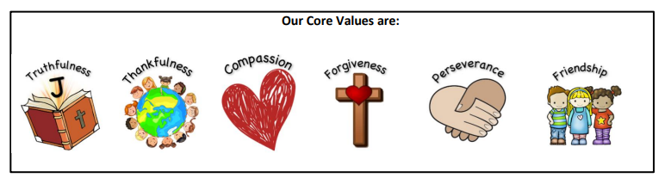

**Our Christian Narrative:**

**‘God is my strength in whom I trust.’ Psalm 18**

**Our Bible story:**

**The parable of the Two Builders - Matthew 7**

**Intent**

***“The world is full of wonders, but they become more wonderful, not less wonderful when Science looks at them”***

***Sir David Attenborough***

At St Andrew’s our aim is to plan for an enquiry-based Science curriculum that engages, excites and empowers our children. We want our children to develop a love for science that allows them to explore and understand the world around them, instilling in them an awareness of how science is relevant in their day to day lives. Science in our school provides an opportunity for the children to develop a natural curiosity through practical investigations, time to explore our outdoor spaces experiencing aspects of nature including habitats, plants, and seasons and to ask questions to further their conceptual understanding and scientific knowledge. It will encourage respect for living organisms and for the physical environment. The content of the curriculum is adapted to meet the needs of all learners and is taught in a logical progression that takes into account prior knowledge and has vocabulary at the heart of excellent daily practice. Teachers have a shared vision for science learning and reinforce an expectation that all children are capable of achieving high standards in science through immersing the children in a broad and balanced curriculum.

Our Science curriculum allows our children to:

* Develop through practical work the skills of observation, prediction, investigation, interpretation, communication, questioning and increased use of precise measurement skills and ICT
* Offer their own suggestions, and to be creative in their approach to Science
* Gain enjoyment from their scientific work
* Develop their skills of co-operation through working with others, and encourage where possible, ways for children to explore Science in forms which are relevant and meaningful to them
* Learn how to respect the living and non-living environment
* Question the world around them
* Work safely by using the correct equipment
* Develop their understanding of scientific enquiry and vocabulary
* Develop spiritually

**Implementation**

Science in EYFS is taught through the area of learning: “Understanding the World”.

This involves:

* guiding children to explore the natural world around them, making observations and drawing pictures of animals and plants.
* Knowing some similarities and differences between the natural world around them and contrasting environments, drawings on their experiences and what has been read in class.
* Understanding some important processes and changes in the natural world around them, including the seasons and changing states of matter.

In KS1 we teach the National Curriculum, supported by a clear skills and knowledge progression. This ensures that skills and knowledge are built on year by year and sequenced appropriately to maximise learning for all children. The Association for Science Education (ASE) resources (TAPS and PLAN) are used to support both planning and assessment. Age related expectations and exemplification to support planning and evidence in books has been shared to ensure continuity and a high standard across year groups. Specific science units are taught in each year group, building on from previously taught units and skill coverage. Teachers use a thematic approach to deliver cross curricular links where appropriate. Science is routinely taught weekly. Memorable knowledge and skills have been identified for each of the units to provide progressive acquisition of knowledge. This is supported by the use of specific vocabulary which are displayed on working walls that teachers regularly refer to so that it sticks and enables children to readily apply to their written and verbal communication. Teachers plan a sequence of lessons for each topic which carefully plans for progression and depth. The use of trips and visitors from experts will enhance the learning experience.

**Science Working Wall**

In every classroom, we have a working wall for Science. The following non-negotiables have been put in place and can be seen on these working walls, relating to the current unit being taught:

* ‘We are learning…’ title
* Specific vocabulary which is added to as it is taught
* Learning taking place is clearly evident, this may include pictures, models and examples of work
* Working Scientifically mat which is ticked off as skills are taught
* Good Science teaching and learning poster displayed and referred to

It is expected that teachers refer to working walls regularly, using them as a teaching tool to support learning.

**Presentation of Work**

Children use pencil in their lined Science books. Teachers may use worksheets to supplement teaching. EYFS classes have a Topic floor book which has Science learning inside. KS1 classes have a Science floor book which is used to capture learning. These include photographs, post it notes, teachers comments and examples of children’s work.

**Resources**

There is a central cupboard in the photocopying room which is accessible for all staff. Resources are organised into units of work. A list is available inside the cupboard so that staff can easily find resources.

**Additional Documents**

In addition to this Science Policy, the following documents are in place to support the implementation of Science

* Progression in Science
* Knowledge organisers
* Knowledge hands
* PLAN documents
* TAPS assessment documents
* CLEAPSS – supporting safe practical work in Science

**Planning**

The planning of the Science curriculum is organised through:

* Long term planning is demonstrated through the yearly overviews which show the organisation of the Science topics across the year for each year group, and the coverage and progression of knowledge, skills and understanding.
* Medium term planning is demonstrated through the unit overviews which reveal the progression of knowledge, skills and understanding within each topic.
* Short term planning is demonstrated through weekly planning on a medium-term plan. Activities, resources and learning is personalised to meet the needs of the children in each class.

**Formative Assessment**

Teachers continually assess children throughout Science on their use their professional judgement to decide what children need to learn and when to move on to the next step of learning. Formative assessment (or responsive teaching) is a key feature of Science lessons. Key knowledge is identified at the start of each topic, which is mapped within and across year groups to ensure progression. Teachers use effective questioning to determine the extent of children’s understanding before deciding on what the children need next (support, extension, next steps).

**Summative Assessment**

Children in Reception will complete ‘Understanding the World’ baseline assessments in September and will then be assessed at the end of each term. Science assessments in EYFS come under the ‘Natural World’ part of the ‘Understanding the World’ ELG. Assessments will be made based on children’s understanding throughout lessons including during provision.

Children in Key Stage One are assessed at the end of each half term. This involves an activity linked to the unit of work. It assesses the knowledge that they have retained. Formative assessments throughout the unit of work assess children’s personal development.

The Teacher Assessment Framework (TAF) contains a list of ‘pupil can’ statements to be used for making a statutory judgement at the end of key stage following completion of the National Curriculum (NC). The TAF splits the ‘expected standard’ for science into ‘working scientifically’ (disciplinary knowledge) and ‘science content’ (substantive knowledge). Working scientifically should be taught through, and clearly related to, the teaching of substantive science content. Both kinds of knowledge will be taught and assessed throughout the key stage.

**Impact**

The successful approach to the teaching of science at St Andrew’s will result in fun, engaging, high quality science education that provides children with the foundations for understanding the world that they can take with them once they complete their primary education.

Ongoing assessment and review allows teachers to make judgements with regards to attainment and understanding within lessons, to adapt future lessons to the needs of the children and allows for misconceptions to be addressed more immediately rather than building on insecure scientific foundations. Assessment takes place formatively, is used to identify who needs further support or further challenge. Children are also assessed at the end of each year against ARE’s and at the end of KS1 against DfE descriptors. This is documented on the school tracker and Year 2 end of Key Stage data is submitted o DfE. Attainment is recorded on Year Group specific grids that provide an overview for each child. Overall attainment is recorded half-termly to indicate those at, above or below ARE. Standards are monitored in a variety of ways: book scrutiny, teacher discussions, pupil interviews and Science Leader discussions and evidence collecting.

Staff identify the impact of our curriculum through a variety of ways.

These include:

* Observations
* Regular recall and retrieval activities
* Targeted questioning
* Marking and feedback
* Teacher assessment against key performance indicators
* Pupil interviews
* Analysis of data

We use these strategies to review our curriculum offer, inform our strategic action planning, and make adaptations where necessary.

We know our Science curriculum is effective when:

* Children confidently use scientific vocabulary
* Children talk, ask questions, share ideas and explain
* It is practical and hands on
* It is fun and engaging
* Children are curious

**Health and Safety**

Equipment that has been purchased fit for purpose, safe to use, safely stored and appropriate for pupils to use. All staff must be aware that it is their individual responsibility to ensure that equipment is safe to use, safely stored and appropriate to us every time a science activity is carried out. Where required, equipment checks and testing, e.g. PAT testing, will be carried out in accordance with the employer’s policy and manufacturer recommendations. Disposal of resources and equipment will be carried out in accordance with the employer’s policy and manufacturer recommendations. For advice on safe use, storage and disposal of equipment and resources refer to CLEAPSS resources on the website [www.cleapss.org.uk](http://www.cleapss.org.uk)

**Roles and Responsibilities**

Class Teacher

* Provide engaging, age-appropriate lessons using the long term plan to support. Teachers should plan in conjunction with knowledge organisers, knowledge hands and support/resources from TAPS and PLAN.
* Ensure that equipment is safe to use, safely stored and appropriate to us every time a science activity is carried out.

Subject Leader

* Subject leader must regularly monitor and review the teaching and delivery of Science across the school.
* The Subject Leader receives information from class teachers (end of unit assessments and end of year) to ascertain how Science is being delivered. This helps to identify strengths and any areas for development which can be tackled appropriately.
* Feedback from monitoring must be regularly fed back to staff.
* Subject leader to keep up to date with current topics and changes with regards to Science.
* Subject leader to disseminate information from training CPD with all staff.

**Monitoring and Evaluation**

At St Andrew’s C of E Infant School, we will have high expectations of the quality of pupils’ work.

We achieve this by:

* Having regular feedback provided on pupil progress
* Lessons are planned to ensure that pupils of differing abilities, including the most able, are suitably challenged
* Teaching is assessed and assessments used to identify where pupils need extra support or intervention.

It is the responsibility of the Science Lead to monitor the impact of the Science curriculum.

**Inclusion**

St Andrew’s C of E Infant School are committed to providing effective learning opportunities for all pupils. Suitable learning challenges will be set for all pupils with the aim of maximizing achievement for all individuals. Teachers will respond appropriately to pupils’ diverse learning needs and be aware of the needs of differing genders, SEND, as well as different cultural, social and ethnic backgrounds. We are committed to the principle of equality of opportunity and this will be reflected in the curriculum offered to pupils and in the conduct of staff and pupils*.*

**Professional Development and Training**

*Explorify*

*ASE – TAPS and PLAN resources*

**Features of an effective Science Teaching Sequence**

Throughout a unit of work, children build on previous knowledge and skills. Lessons should be clearly focused on the knowledge, working scientifically skills and vocabulary specified in knowledge organisers.

* Share Science vision
* Revisit prior learning
* Share key vocabulary and discuss together as a class, this can then be placed on the working wall
* Opportunities to experience and observe the natural and humanly-constructed world around them
* Opportunities to be curious and ask questions about what they notice
* Opportunities to work scientifically by using different types of scientific enquiry to answer their own questions, including observing changes over a period of time, noticing patterns, grouping and classifying things, carrying out simple comparative tests, and finding things out using secondary sources of information
* A variety of independent and group work activities planned
* Use of outdoors, where possible

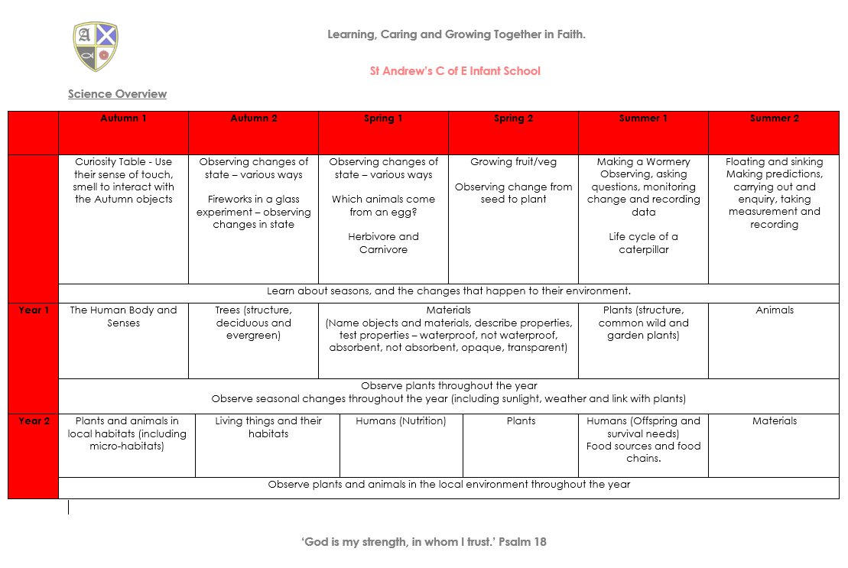**Subject Overview**

**Example of Summative Assessment**

**Medium Term Plan Template**

