**Geography Policy**

**Handbook**

**St. Andrew’s CE Infant School**



**Our School Motto**

**‘Learning, Caring and Growing together in Faith’**

**Our Vision**

St Andrew’s Infant School is a Christian school where children are happy, nurtured and love learning. Through an inspiring and aspirational curriculum, we strive to ensure our children flourish spiritually, academically, and creatively to become confident, resilient learners. Everyone here learns, cares and grows together in faith.

**Our Values**

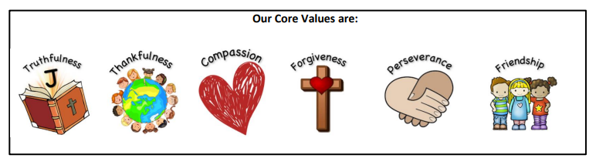

**Our Christian Narrative:**

**‘God is my strength in whom I trust.’ Psalm 18**

**Our Bible story:**

**The parable of the Two Builders - Matthew 7**

**Intent**

**‘Geography is the tapestry that weaves the world together.’**

**Gil Grosvenor**

At St Andrew’s our children are encouraged to develop a greater understanding and knowledge of the world, as well as their place in it. Geography is essentially about understanding the world we live in. It helps to provoke and provide answers to questions about the natural and human aspects of the world. Our Geography curriculum reflects the needs of our children and:

· Is progressive in skills and knowledge.

· Builds on children’s prior knowledge.

· Provides relevant and stimulating learning experiences.

· Promotes diversity and inclusion and develops spirituality.

· Has vocabulary at the heart of excellent practice.

· Develops effective and successful communicators of the future.

· Develops love and respect for the world we live in.

Our Geography curriculum allows children to articulate their ideas about both the world and their local area through adaptable and exciting learning opportunities. Children’s curiosity will enable them to explore the world around them. We will be respectful about the world, different cultures and how to preserve the environment for future generations.

**Implementation**

We teach the National Curriculum, supported by a clear skills and knowledge progression. This ensures that skills and knowledge are built on year by year and sequenced appropriately to maximise learning for all children. It is important that children develop the skills of a geographer by fully immersing them in all areas of the subject. The local area is fully utilised to achieve desired outcomes. School trips and fieldwork are provided to give first hand experiences, which enhance children’s understanding of the world beyond their locality.

Our geography units of work, where possible, have links to our locality, current environmental issues and our community. There are close links between our English units and Geography curriculum providing enhanced opportunities to immerse our children in high quality texts to deepen their understanding and develop topic vocabulary.

**Subject content**

**EYFS**

Within the Early Years Foundation Stage, geography is included as part of Understanding the World. The children learn to investigate similarities and differences, the local environment and cultures and beliefs, fostering the skills essential to developing geographical understanding. This is set out in the early year’s curriculum;

**ELG: People, Culture and Communities** Children at the expected level of development will: - Describe their immediate environment using knowledge from observation, discussion, stories, non-fiction texts and maps;

- Explain some similarities and differences between life in this country and life in other countries, drawing on knowledge from stories, non-fiction texts and, when appropriate, maps.

**ELG: The Natural World**

Know some similarities and differences between the natural world around them and contrasting environments, drawing on their experiences and what has been read in class;

 - Understand some important processes and changes in the natural world around them, including the seasons

**Key stage 1**

Pupils should develop knowledge about the world, the United Kingdom and their locality. They should understand basic subject-specific vocabulary relating to human and physical geography and begin to use geographical skills, including first-hand observation, to enhance their locational awareness.

Pupils should be taught to:

Locational knowledge

* Name and locate the world’s seven continents and five oceans
* Name, locate and identify characteristics of the four countries and capital cities of the United Kingdom and its surrounding seas

Place knowledge

* Understand geographical similarities and differences through studying the human and physical geography of a small area of the United Kingdom, and of a small area in a contrasting non-European country.

Human and physical geography

* identify seasonal and daily weather patterns in the United Kingdom and the location of hot and cold areas of the world in relation to the Equator and the North and South Poles
* use basic geographical vocabulary to refer to:
* key physical features, including: beach, cliff, coast, forest, hill, mountain, sea, ocean, river, soil, valley, vegetation, season and weather.
* key human features, including: city, town, village, factory, farm, house, office, port, harbour and shop.

Geographical skills and fieldwork

* Use world maps, atlases and globes to identify the United Kingdom and its countries, as well as the countries, continents and oceans studied at this key stage.
* Use simple compass directions (North, South, East and West) and locational and directional language [for example, near and far; left and right], to describe the location of features and routes on a map Geography – key stages 1 and 2 3.
* Use aerial photographs and plan perspectives to recognise landmarks and basic human and physical features; devise a simple map; and use and construct basic symbols in a key.
* Use simple fieldwork and observational skills to study the geography of their school and its grounds and the key human and physical features of its surrounding environment.

**Working Wall**

Our Geography working walls include;

* Vocabulary
* key knowledge
* Examples of work and picture prompts to support recall of prior learning during that topic.

**Recording our Work**

We use a variety of recording methods in history, these include;

* Writing – eg non chronological reports, letters.
* Photographs
* Floor books (EYFS)
* Drawings
* Data collection and analysis

**Resources**

We have a variety of resources located in a cupboard, labelled Geography, near the photocopier or in relevant classrooms. We make use of local environment as often as possible.

**Additional Resources**

<https://worldslargestlesson.globalgoals.org/resource/introducing-explorers-for-the-global-goals/> - Global goals website

<https://www.gapminder.org/dollar-street> - compare places/objects from around the world to compare how people live around the world.

<https://www.plickers.com/library> - set questions online to assess your class.

<https://digimapforschools.edina.ac.uk/> - see subject leader for our login details.

**Planning**

We use the National Curriculum scheme of work as the basis for our planning in Geography and we have adapted it to our local area, where possible. We ensure that there are opportunities for children of all abilities to develop their skills and knowledge in each unit, and we plan progression into the scheme of work, so that the children are increasingly challenged as they move through the school.

The planning of the Geography curriculum is organised through:

* Skills progression document (Subject leader)
* Knowledge organisers for each topic (Subject leader)
* Medium Term planning (Class teacher and monitored by subject leader)

These can all be accessed on the teacher drive in school.

**Assessment**

The knowledge, skills, understanding and vocabulary identified in the Geography knowledge organisers for each unit identify the aspects of Geography in which pupils make progress:

* Children demonstrate their ability in Geography in a variety of different ways.
* Teachers will assess children’s work by making informal judgments during lessons.
* On completion of a piece of work, the teacher assesses the work and uses this information to plan for future learning.
* Written or verbal feedback is given to the child to help guide his or her progress.

**Summative Assessment**

At the end of each Geography unit, children complete an assessment task. Examples of these could be in the form of an information poster, letter or leaflet. A quiz activity, purple mash activity and practical activities.

For each unit, pupils are assessed to be on target, to be working towards them or exceeding. These assessments can be accessed on the teacher drive.

**Impact**

Staff identify the impact of our geography curriculum through a variety of ways. These include:

· Observations

· Regular recall and retrieval activities

· Targeted questioning

· Marking and feedback

· Teacher assessment

· Pupil interviews

· Analysis of data

We use these strategies to review our curriculum offer, inform our strategic action planning and make adaptations where necessary.

By the time the children at St Andrew’s leave school they should have:

· An excellent knowledge of where places are and what they are like.

· Know some ways in which places are interdependent and interconnected and how much human and physical environments are interrelated.

· Have an excellent base of geographical knowledge and vocabulary.

· Have an ability to apply questioning skills to geographical enquiry.

· Have developed and frequently utilised fieldwork and other geographical skills and techniques.

· Have a passion for and commitment to the subject, and a real sense of curiosity to find out about the world and the people who live there.

· Have the ability to express well-balanced opinions, rooted in very good knowledge and understanding about current and contemporary issues in society and the environment.

The impact and measure of this is to ensure that children at St Andrews are equipped with geographical skills and knowledge that will enable them to be ready for the curriculum in Key Stage 2 and for life as an adult in the wider world.

We want the children to have thoroughly enjoyed learning about geography, therefore encouraging them to undertake new and relevant life experiences now and in the future.

**Health and safety**

We enable all pupils to have access to the full range of activities involved in learning Geography. Where children are to participate in activities outside the classroom, teachers should be aware of health and safety issues. Risk assessments are undertaken prior to activities, to ensure that they are safe and appropriate for all pupils. The School’s policy for visits and excursions will be adhered to for all trips.

**Roles and Responsibilities**

**Class Teacher**

* Use the knowledge organisers to write medium term plans.
* Use the key vocabulary in the knowledge organisers, display this on working walls and create a vocabulary sheet to be displayed in books at the start of each Geography topic. This vocabulary should be imbedded and children should be able to use it both in conversations and in writing.
* Provide fieldwork opportunities where possible.

**Subject Leader**

* Ensure progression and continuity across the EYFS and Key stage one, through the development of skills progression document and knowledge organisers.
* Support colleagues in the implementation of the medium term plans and provide support within units of work.
* Monitor the progress and standards within the subject.
* Keep up to date with developments in Geography and disseminate information to the teaching staff.

**Inclusion**

At our school we teach Geography to all children, whatever their ability and individual need. This is in accordance with the school’s curriculum policy of providing a broad and balanced education to all children. Through our Geography teaching we provide learning opportunities that enable all pupils to make good progress. We strive hard to meet the needs of those pupils with special educational needs, those with disabilities, those with special gifts and talents, new arrivals and those learning English as an additional language, and we take all reasonable steps to achieve this.

Teachers’ planning will set high expectations and provide opportunities for all pupils to achieve, so that everyone can take part in lessons fully and effectively. Teachers will take specific action to respond to pupils’ diverse needs.

**Spiritual, Moral, Social and Cultural opportunities**

Geography is an excellent vehicle for developing children’s learning in this area. Discussions about the use of the world’s resources and the impact of different events on the lives of local people deepen the children’s ability to understand and empathise with fellow humans across the globe. The opportunities to explore ‘putting yourself in someone else’s shoes’ flourish in the study of geography and it is embraced during the teaching wherever possible.

**Features of an effective Geography Teaching Sequence**

Throughout a unit of work, children build on previous knowledge and skills. Lessons should be clearly focused on the learning objectives that are taken from the knowledge organisers. Vocabulary should be explicitly taught in relevant lessons throughout the unit.

Lessons will include;

* Revisiting prior learning
* Active learning strategies
* Opportunities for children to ask and answer questions.
* A variety of independent and group work activities planned.
* Use of outdoors, where possible.
* Children using globes, atlases and maps where possible.

**Subject Overview**

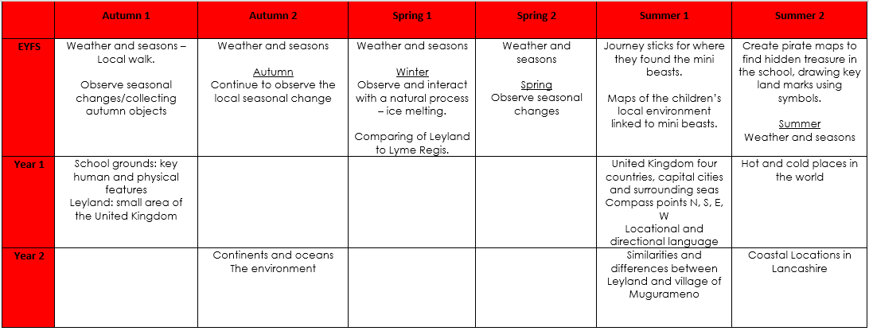

**Example of Summative Assessment**



