**Art in Action**

**Here’s how we flourish in …….**

**Autumn 1**

**Here are some examples of our Art displays…**

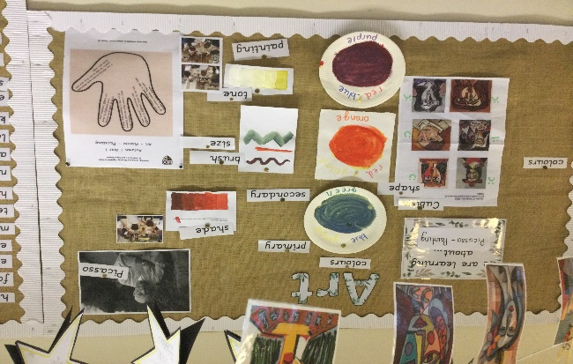

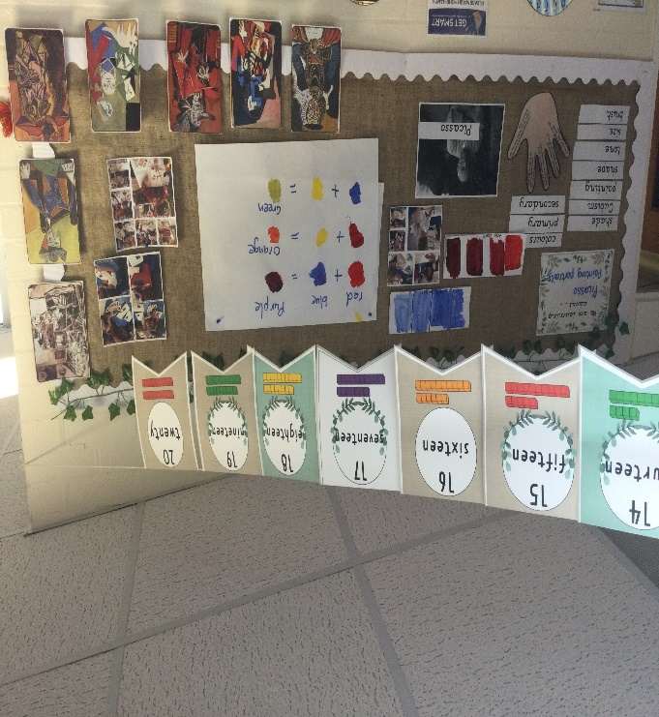

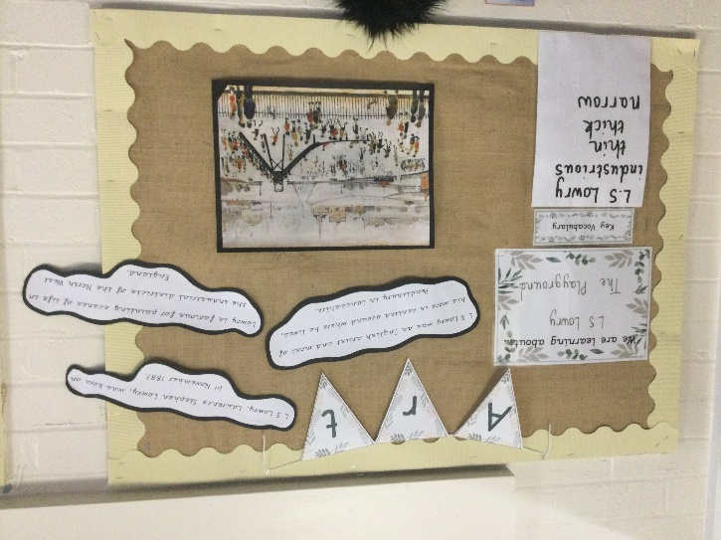

**Art in Action**

**Here’s how we flourish in …….**

**Autumn 1**

**Here are some examples of our Art work.**

**Year 1: Pablo Picasso:**

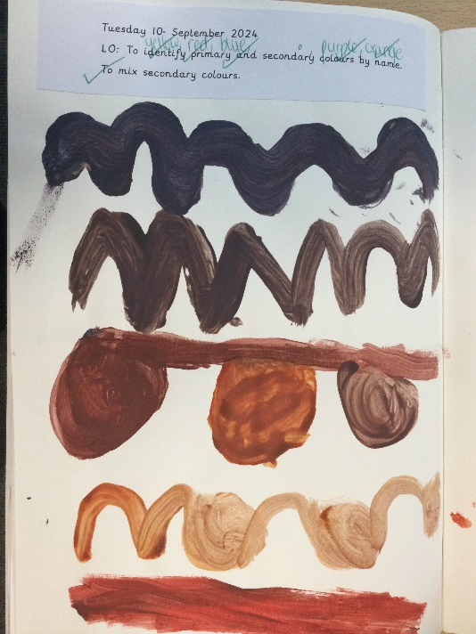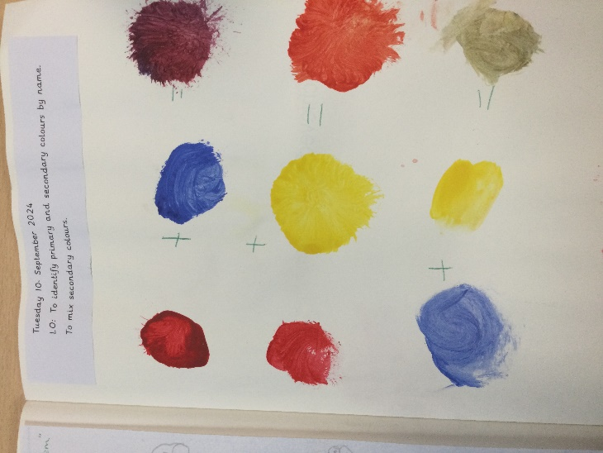

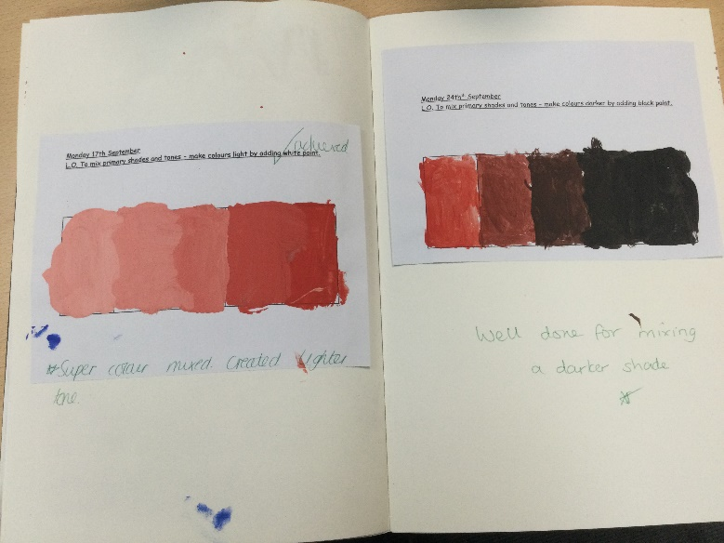

**Year 2: Lawrence Stephen Lowry:**

