**Science in Action**

**Here’s how we flourish in Science**

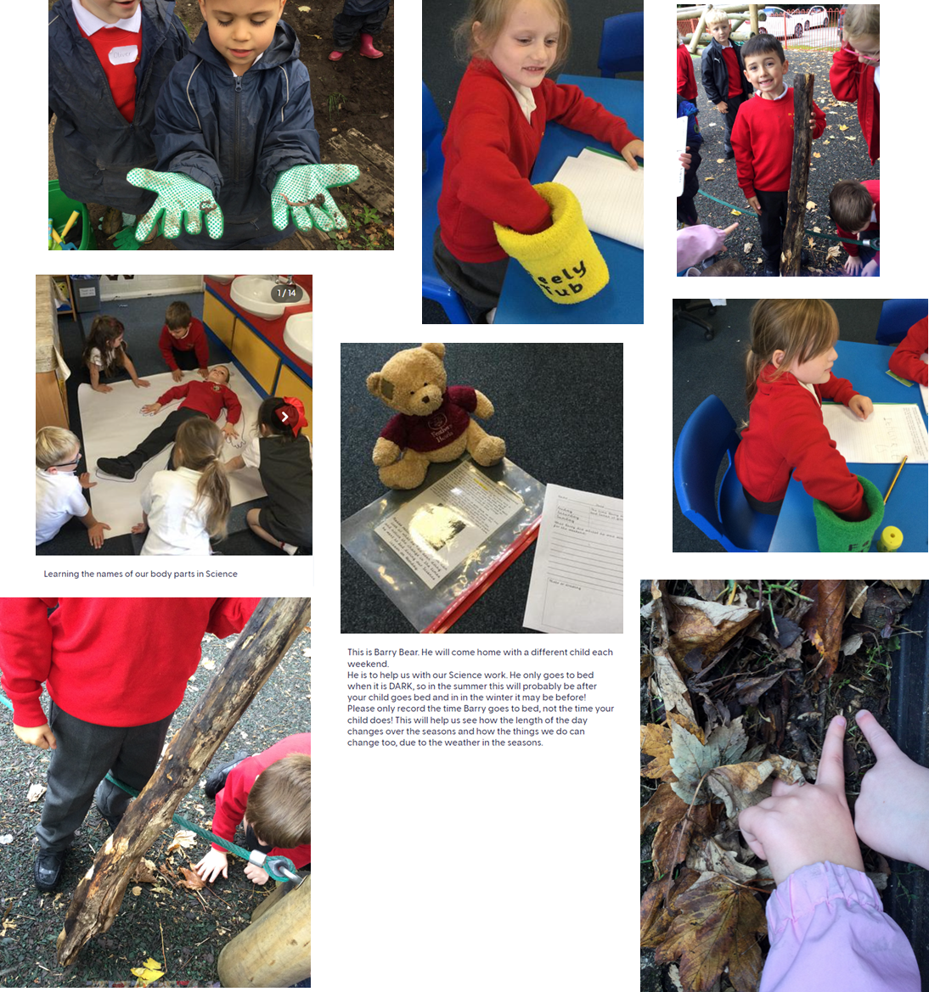**Autumn 1**