**Living Out Our Christian Vision**

**Butterflies Class**

***Here’s how we flourish***

**Autumn 1**

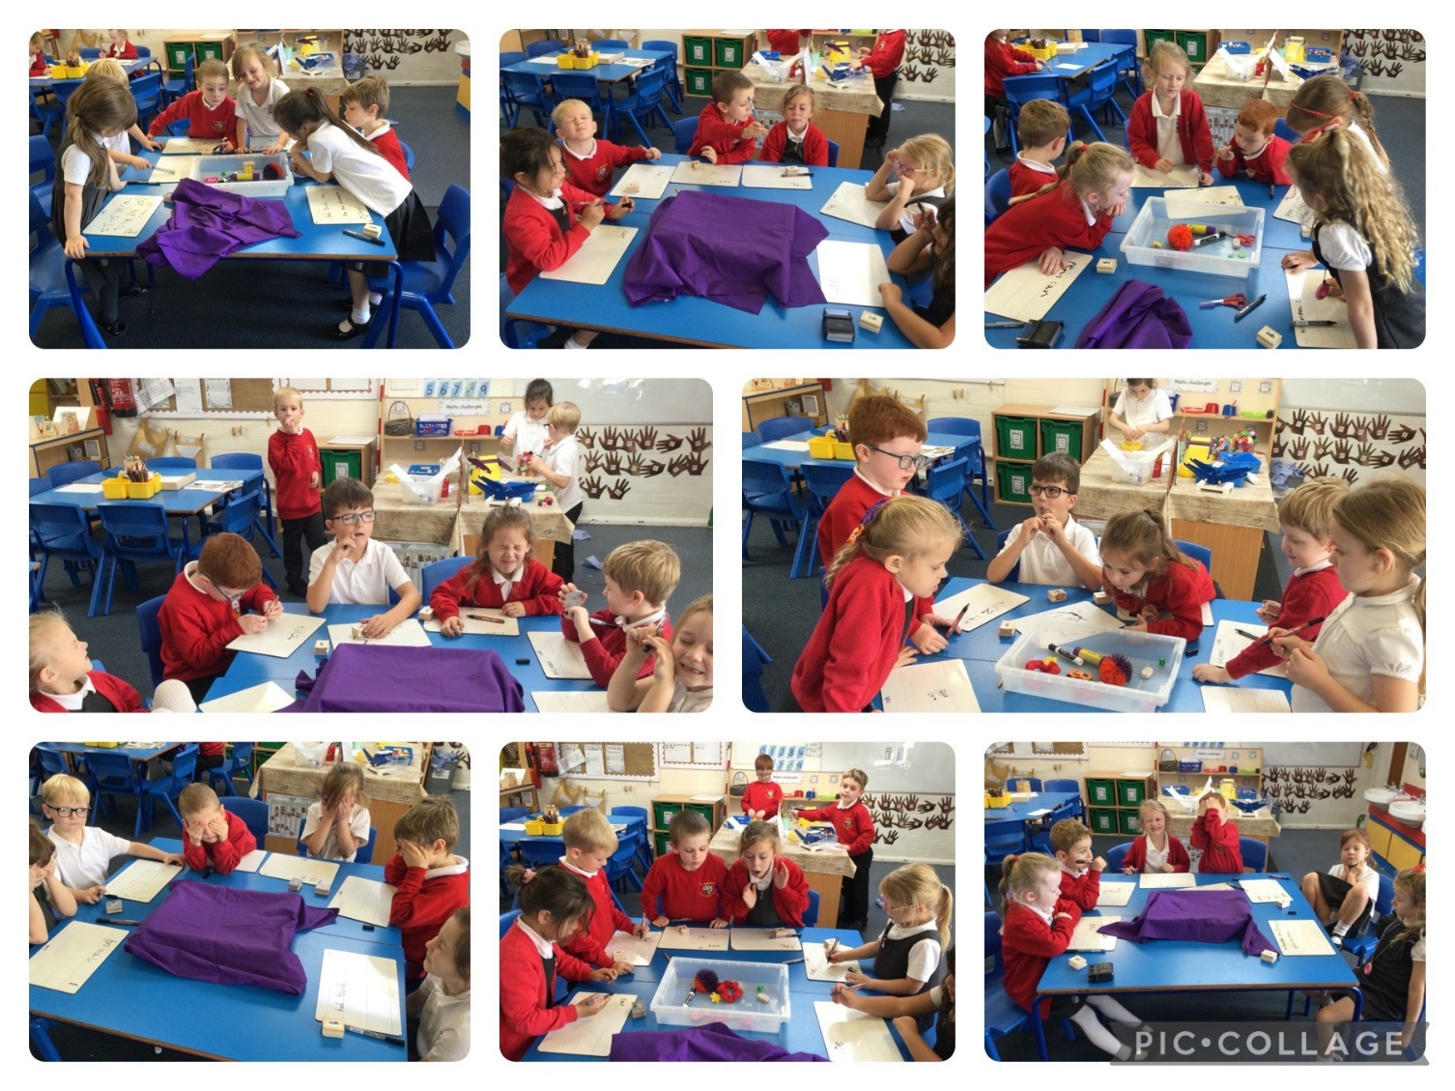

“The game was funny. I was really good at using my sense of sight!”

“I loved walking round school to listen for noises”

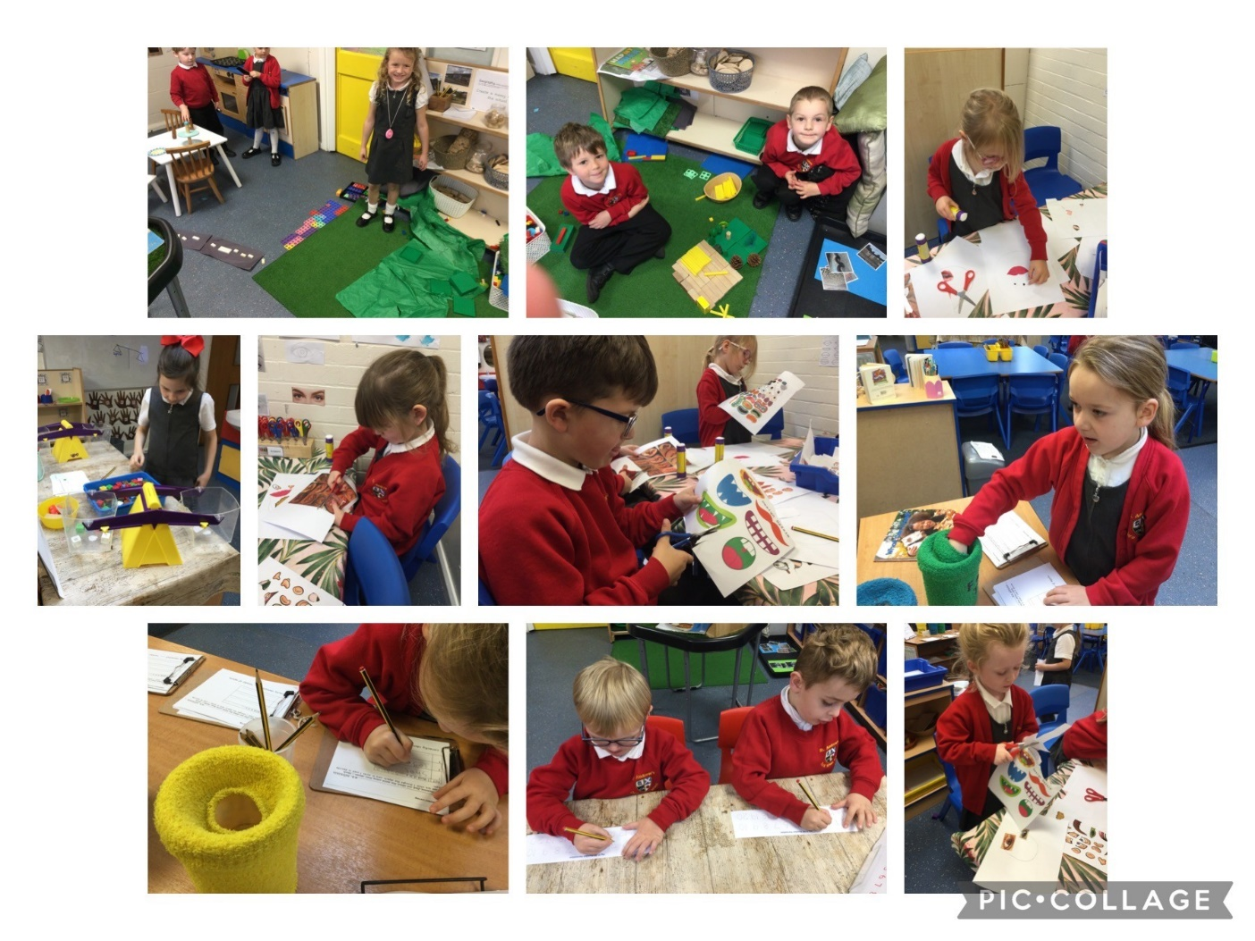

“We always enjoy working on our independent learning tasks!”

“I always complete all of the tasks!”

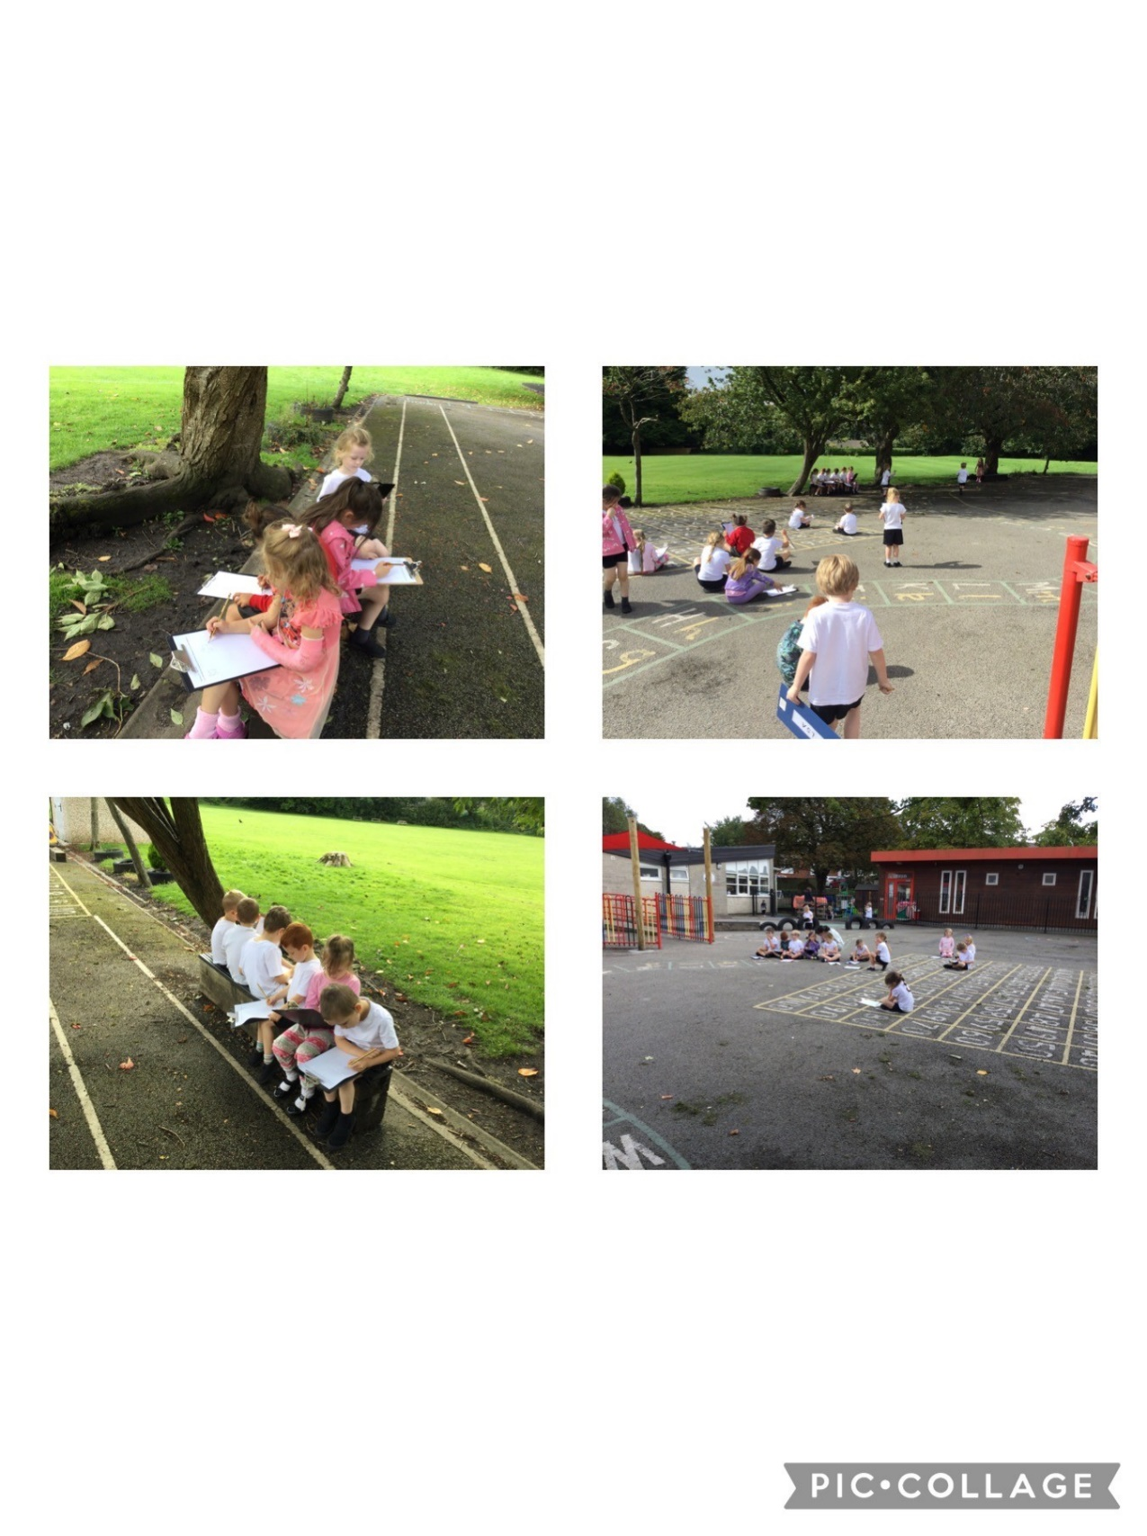

“I drew a map of the school, it was easy because we used a chatterbox map!”

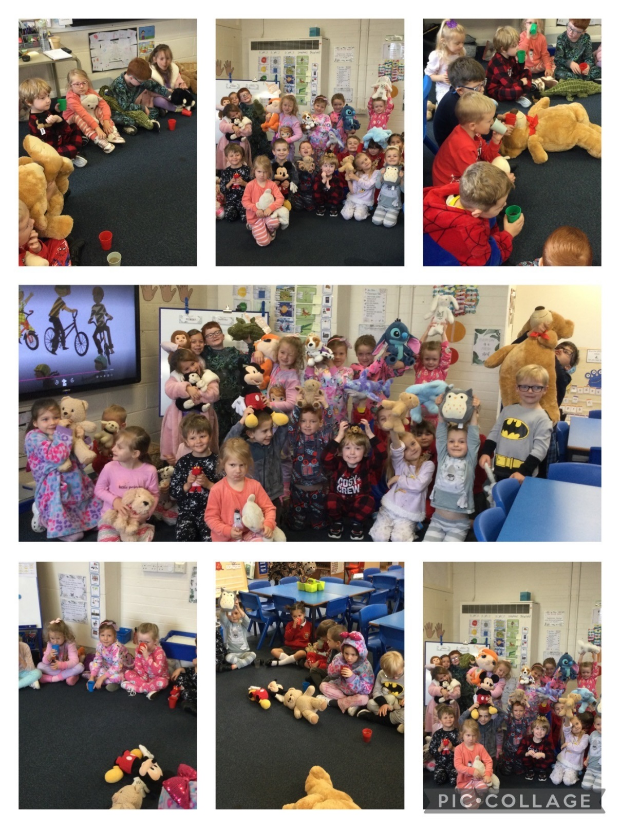

“It was the best day ever coming in our pyjamas and we got to drink hot chocolate too!!”

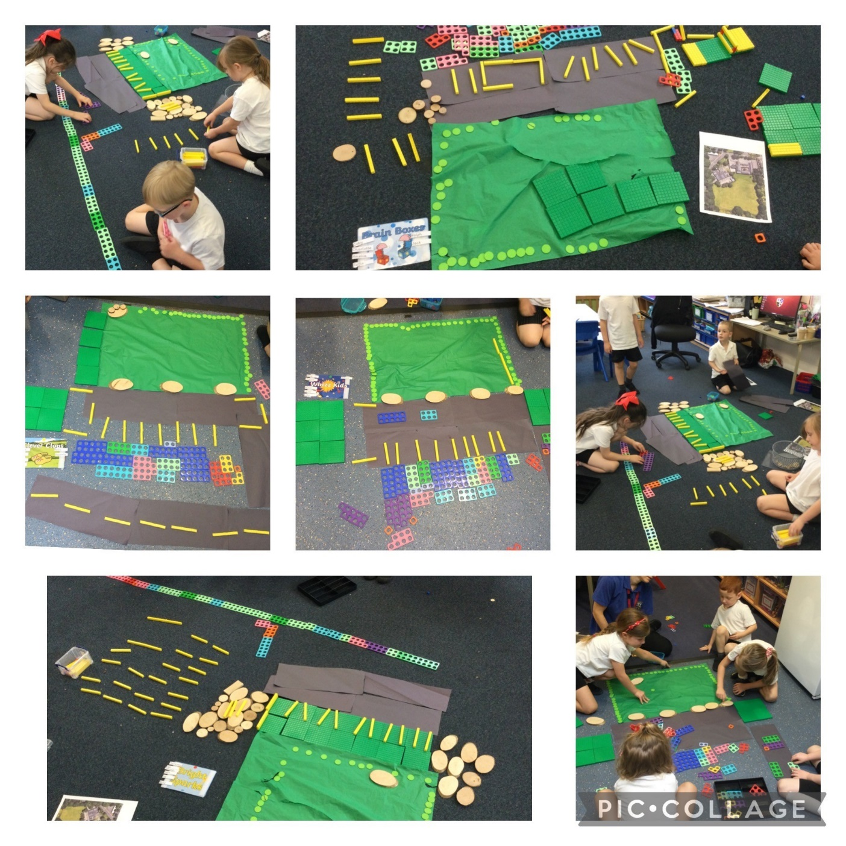“I enjoyed making a messy map of the school”

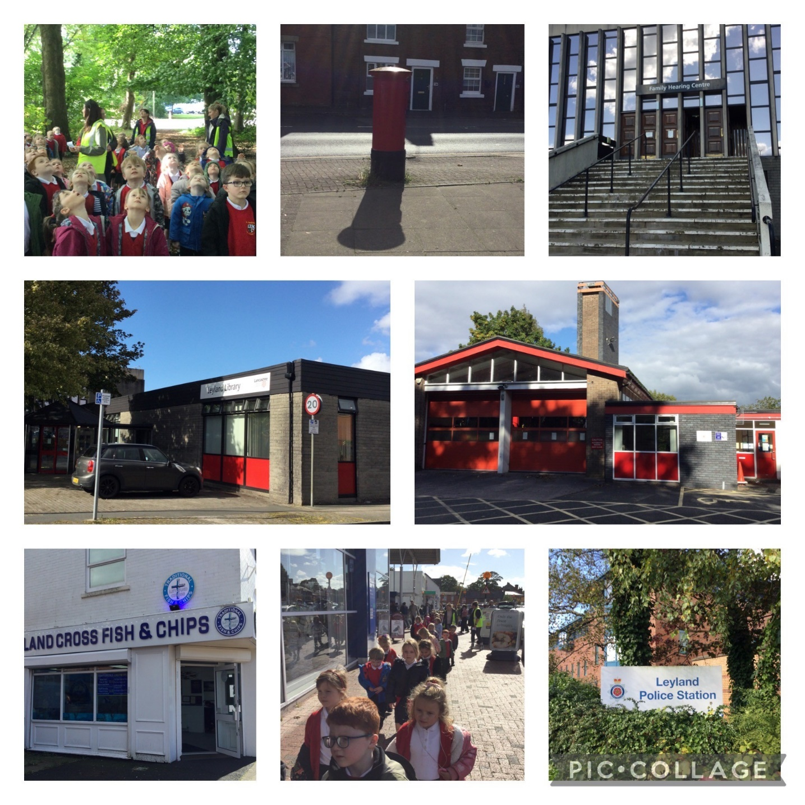

“It was fun walking around Leyland!”

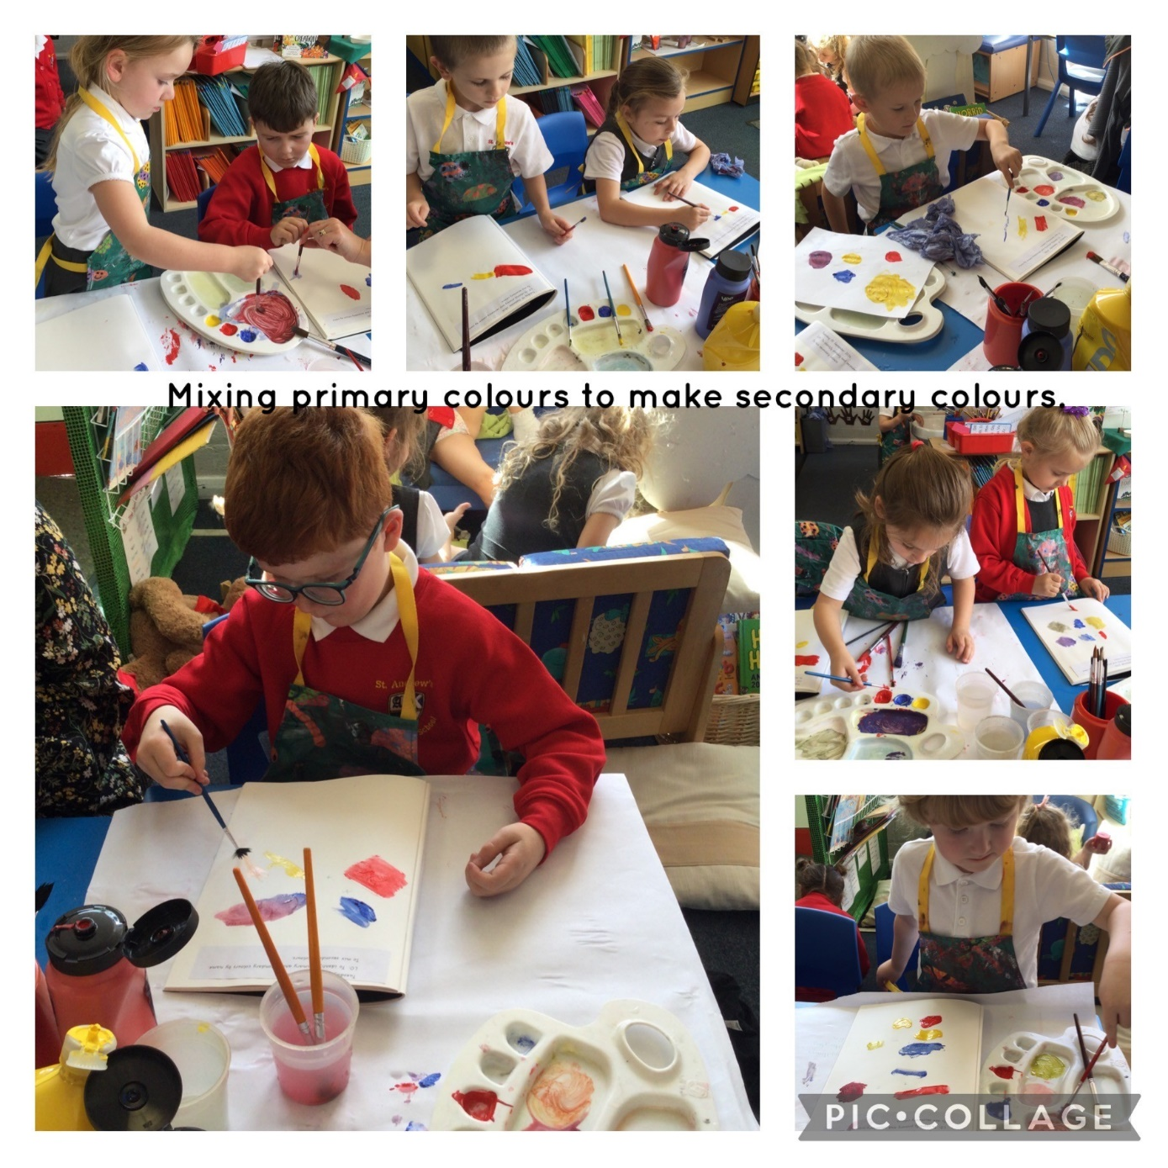

“I am really good at painting now. I can mix colours to make the colours I want!”