**Living Out Our Christian Vision**

**Butterflies Class**

***Here’s how we flourish***

**Autumn 2**

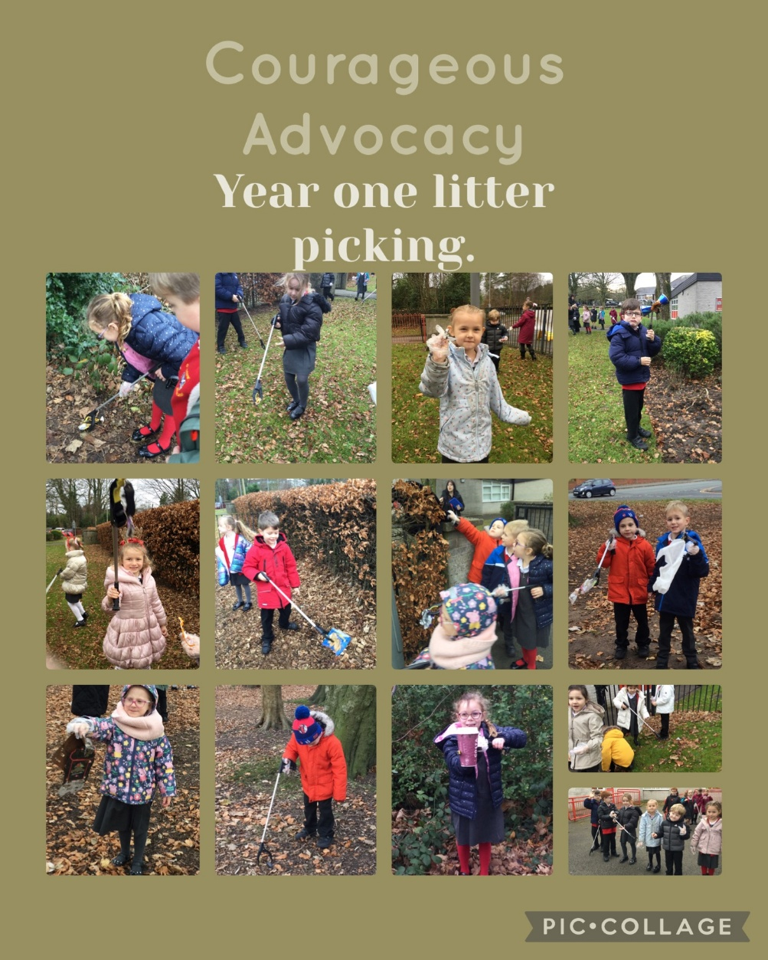

“I was excited to use the litter picker!” (Felix)

“It made me happy because we were cleaning the streets” (Bonneigh)

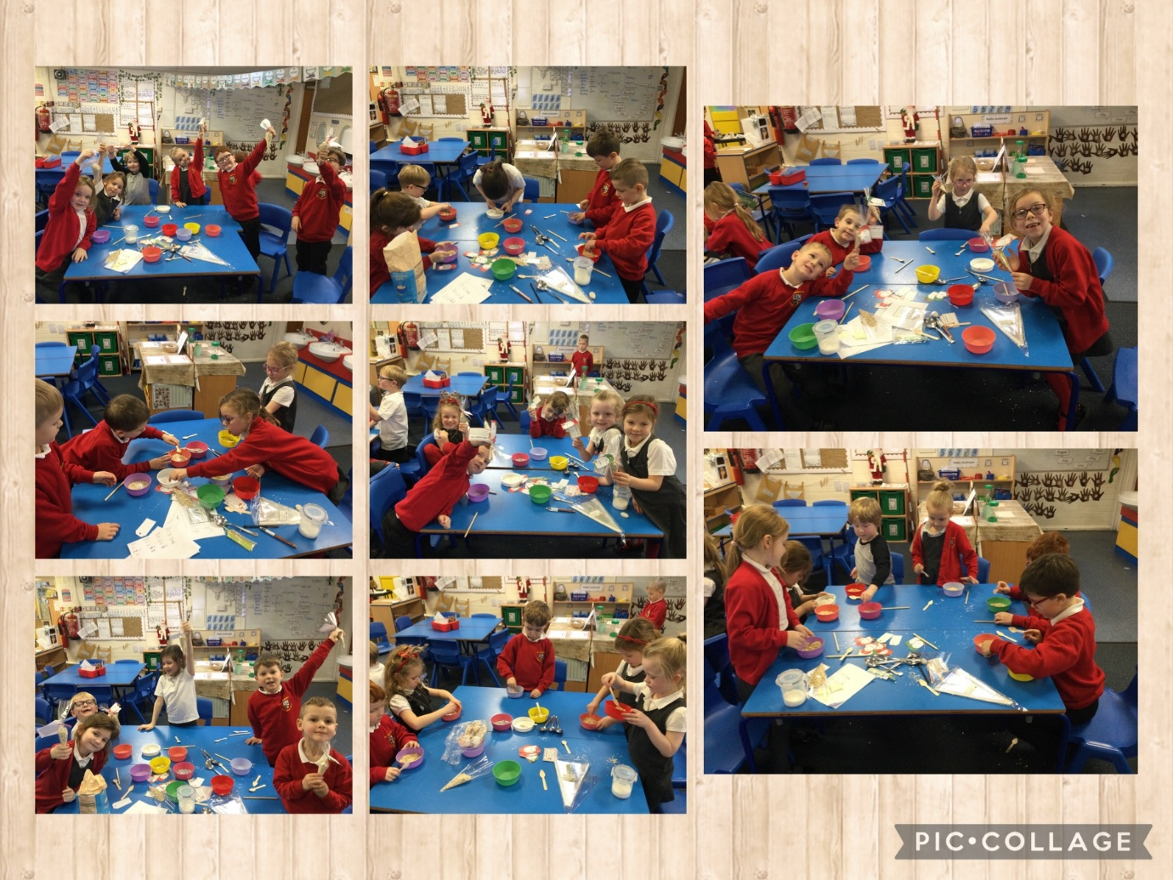

God gave Jesus to us as a gift. We made gifts for people at home.

“It made me feel really happy” (Fia)

“I was happy when I gave it to my mummy” (Soffia)

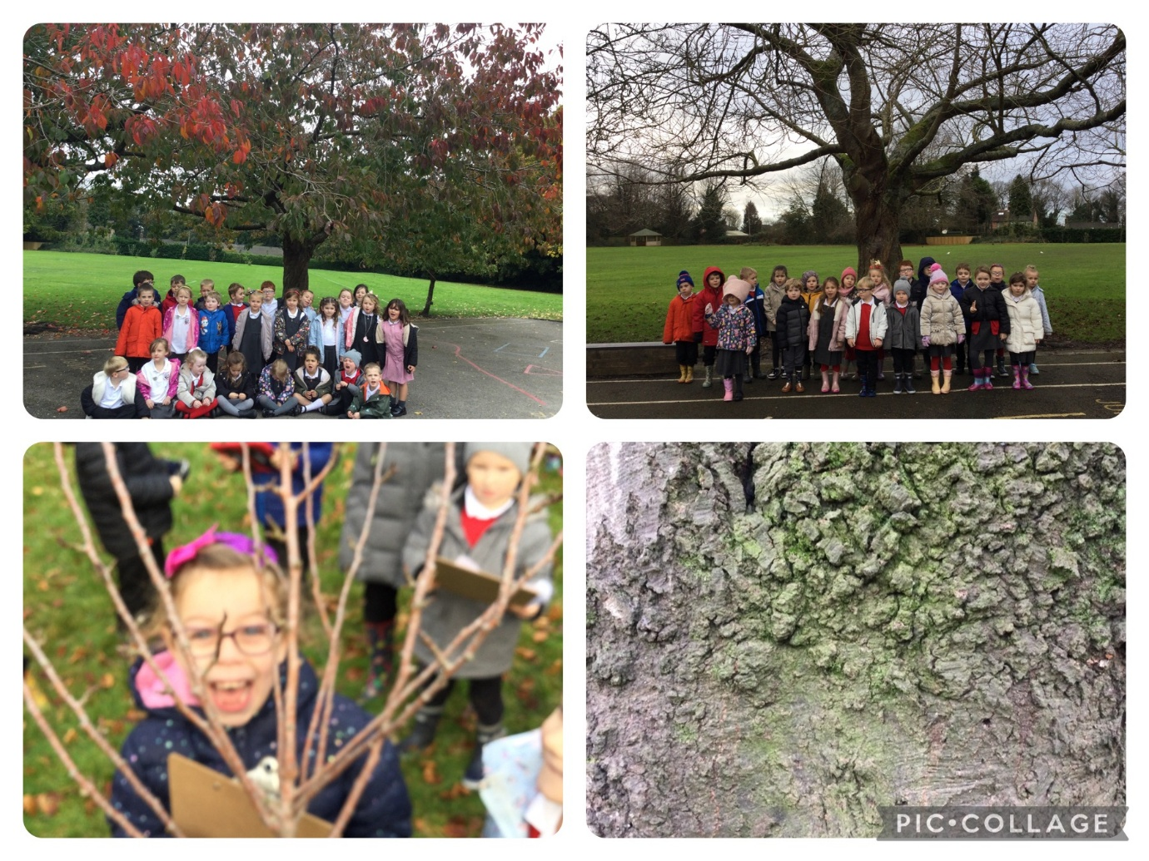

We looked for the signs of Winter

“We saw lots of signs. It was cold but it was fun!” (Felix)

“ I liked seeing all the deciduous trees with no leaves” (Olivia)

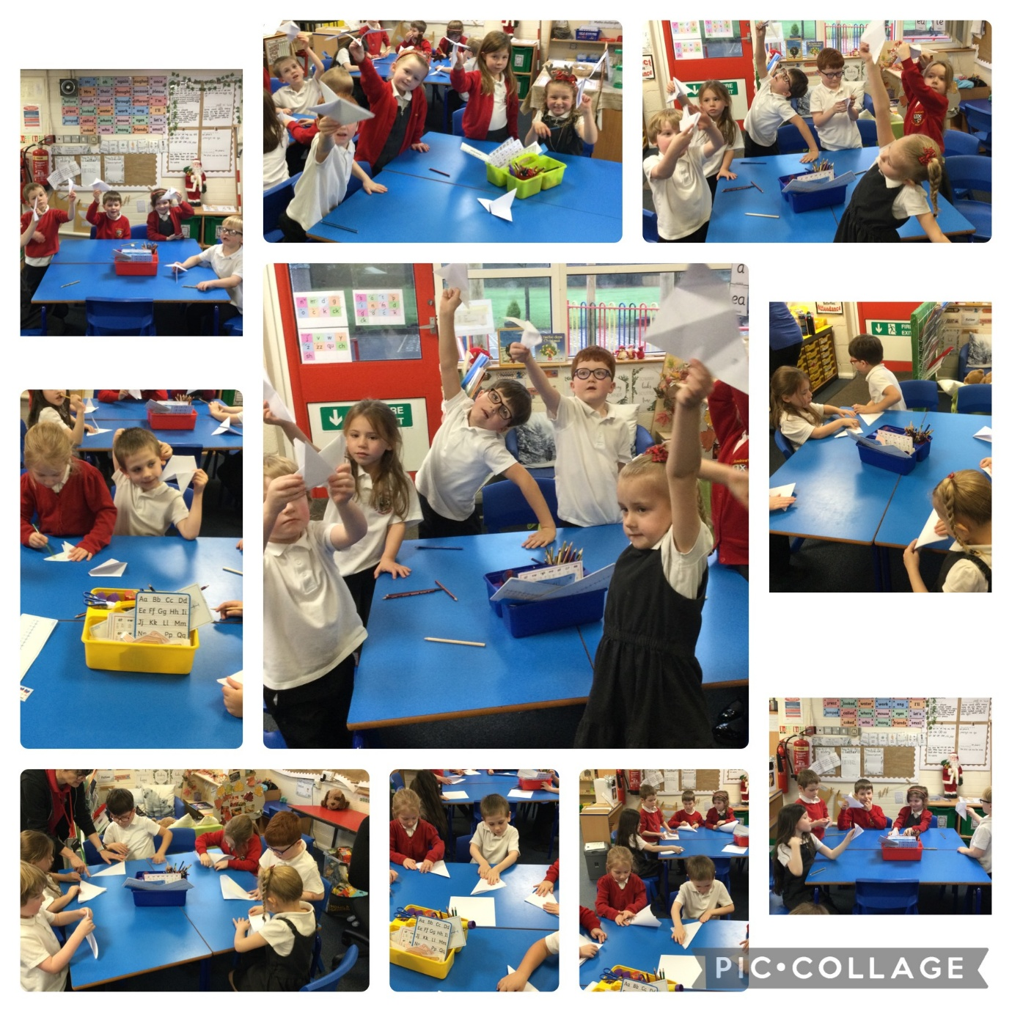

We learnt that doves symbolise peace. We thought about people who might not be in peace in the world and made our own doves.

“It was fun!” (Amelia)

“My dove is my pet now, it has a name!” (Alice)

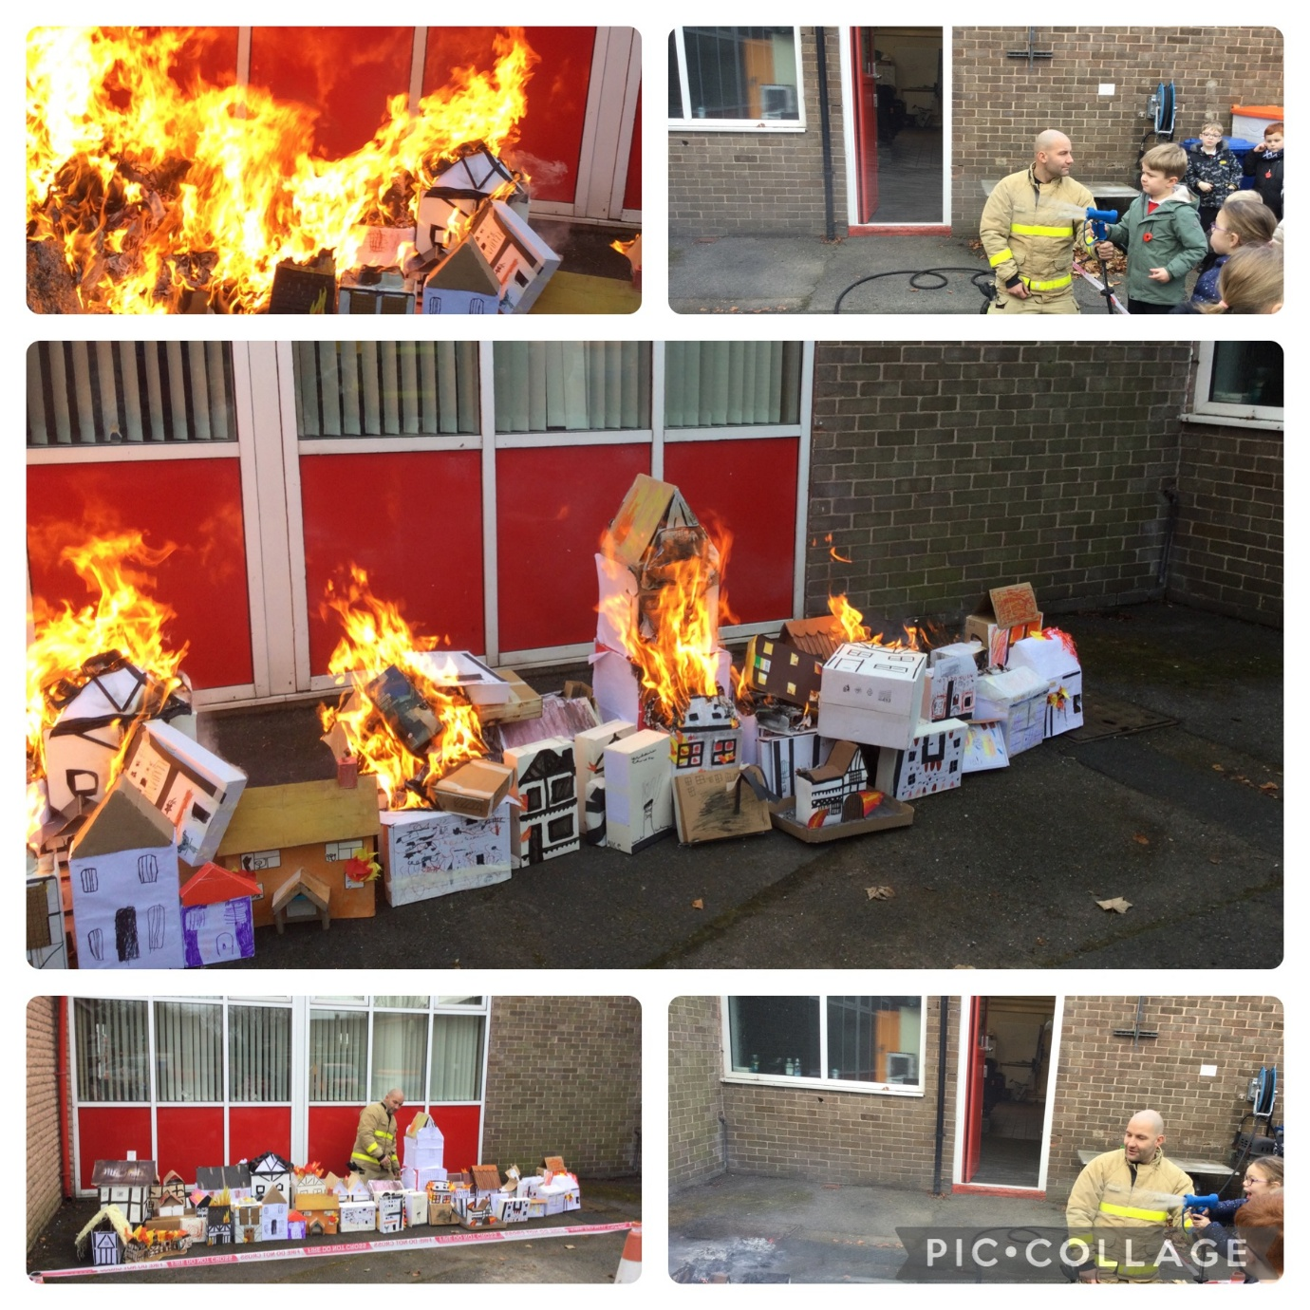

We went to the fire station to rein act the Great fire of London. We took our 1666 houses that we had made and passed buckets of water down the line like they did in 1666.

“I was excited to put the fire out” (Millie)

I was excited to burn our houses” (Sam)

W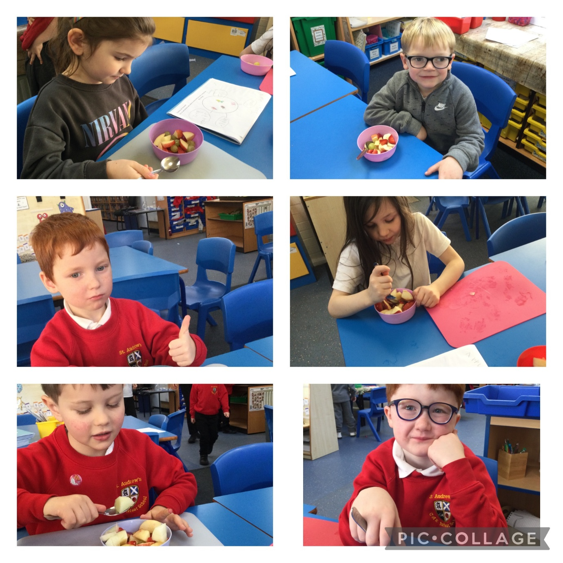

We learnt about fruit and learnt how to peel it and cut using the claw and bridge techniques. We made a fruit salad and enjoyed eating it too!

“It was delicious” (Xander)

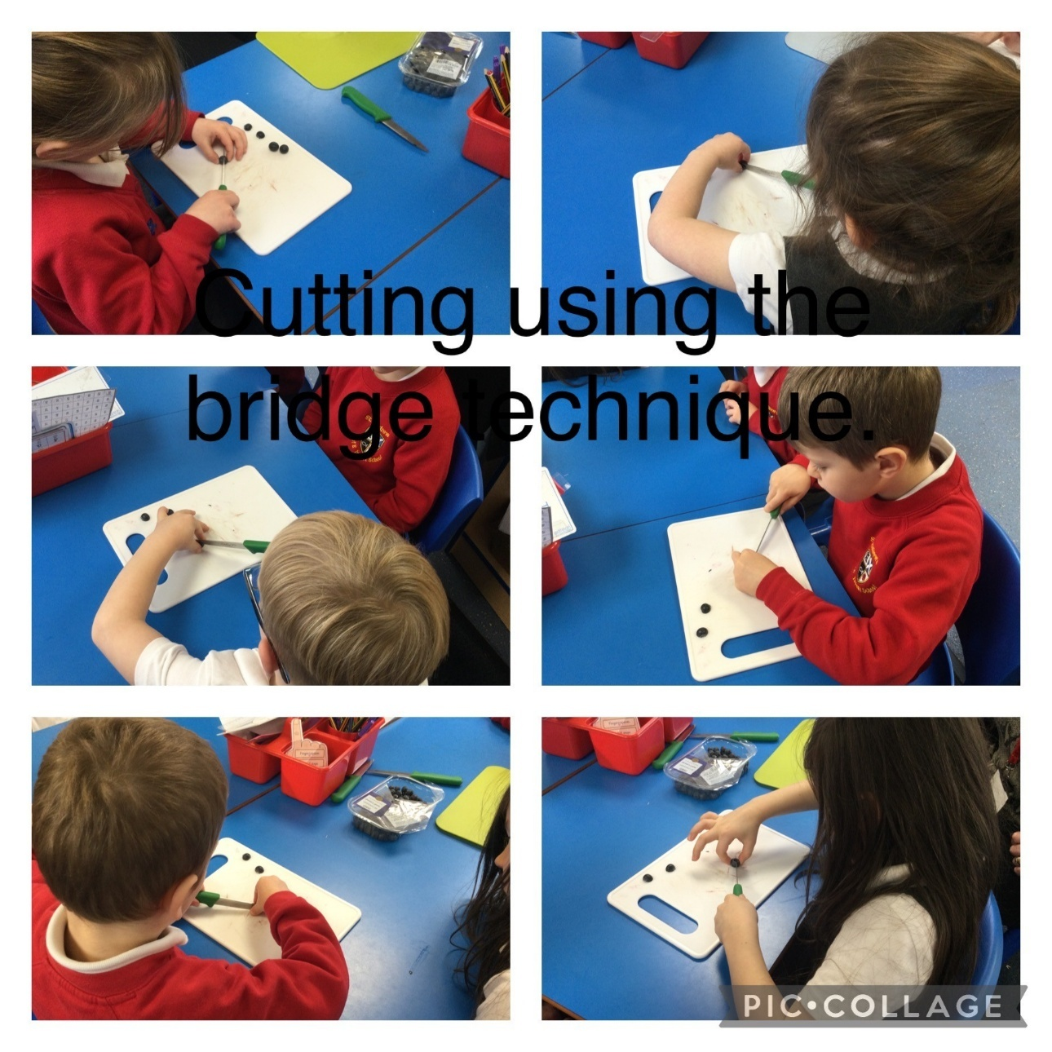

“I learnt how to use the bridge and claw. I do it all the time at home now” (Ivy)

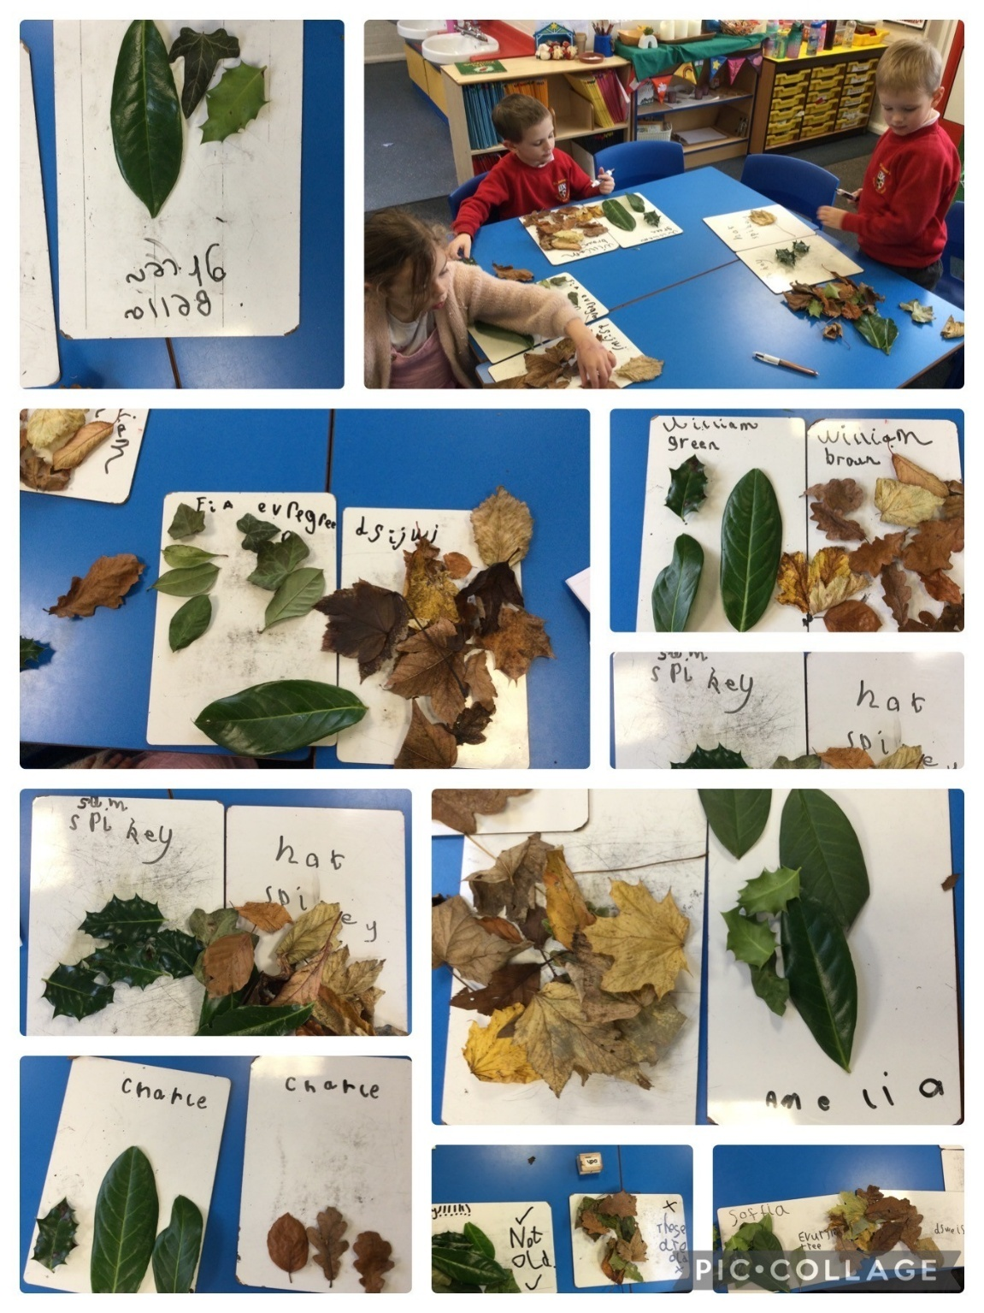

We sorted the leaves we found.

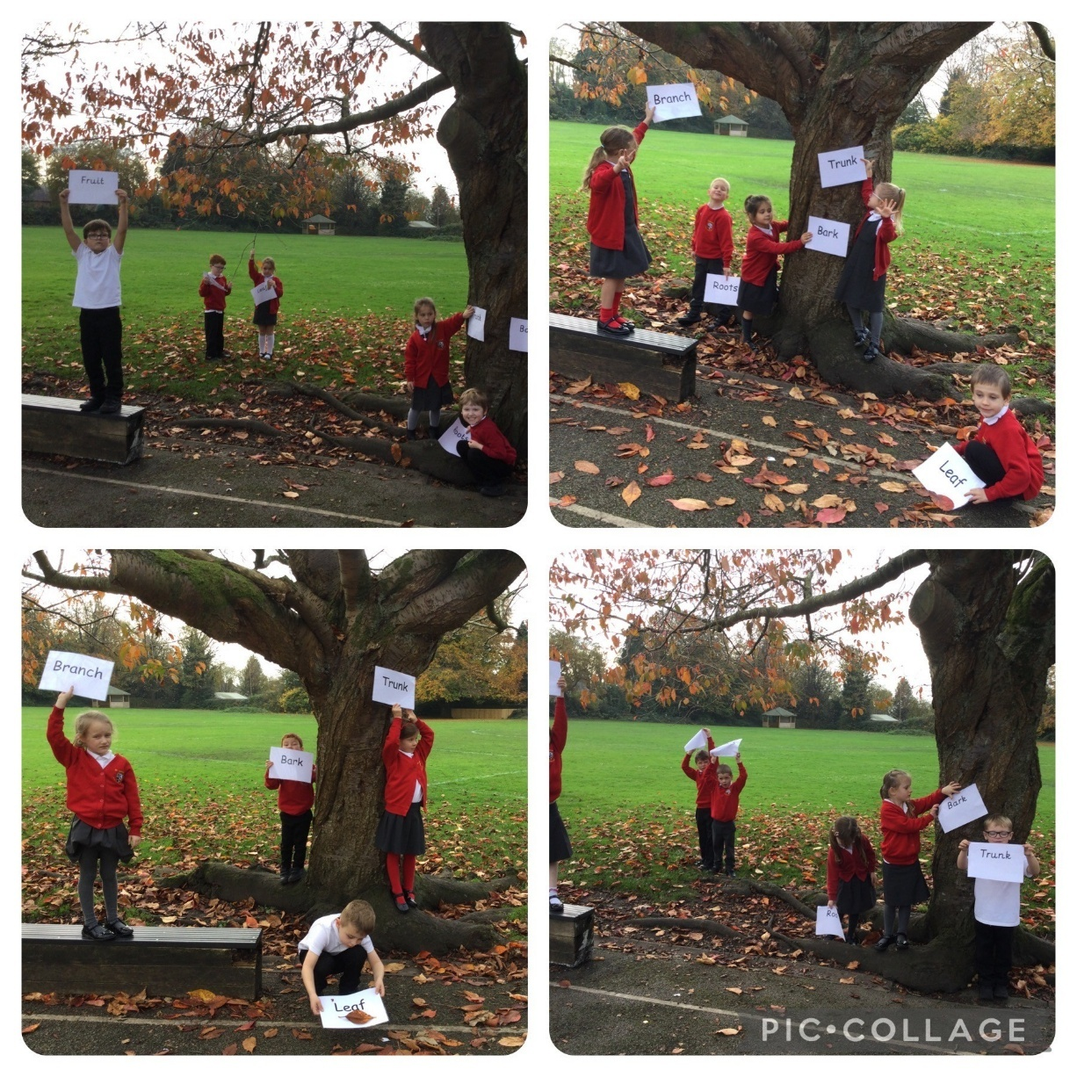

We labelled the trees outside when we learnt the names of the different parts of the trees and what each part does.

“I like going outside so I enjoyed this lesson” (Ralph)

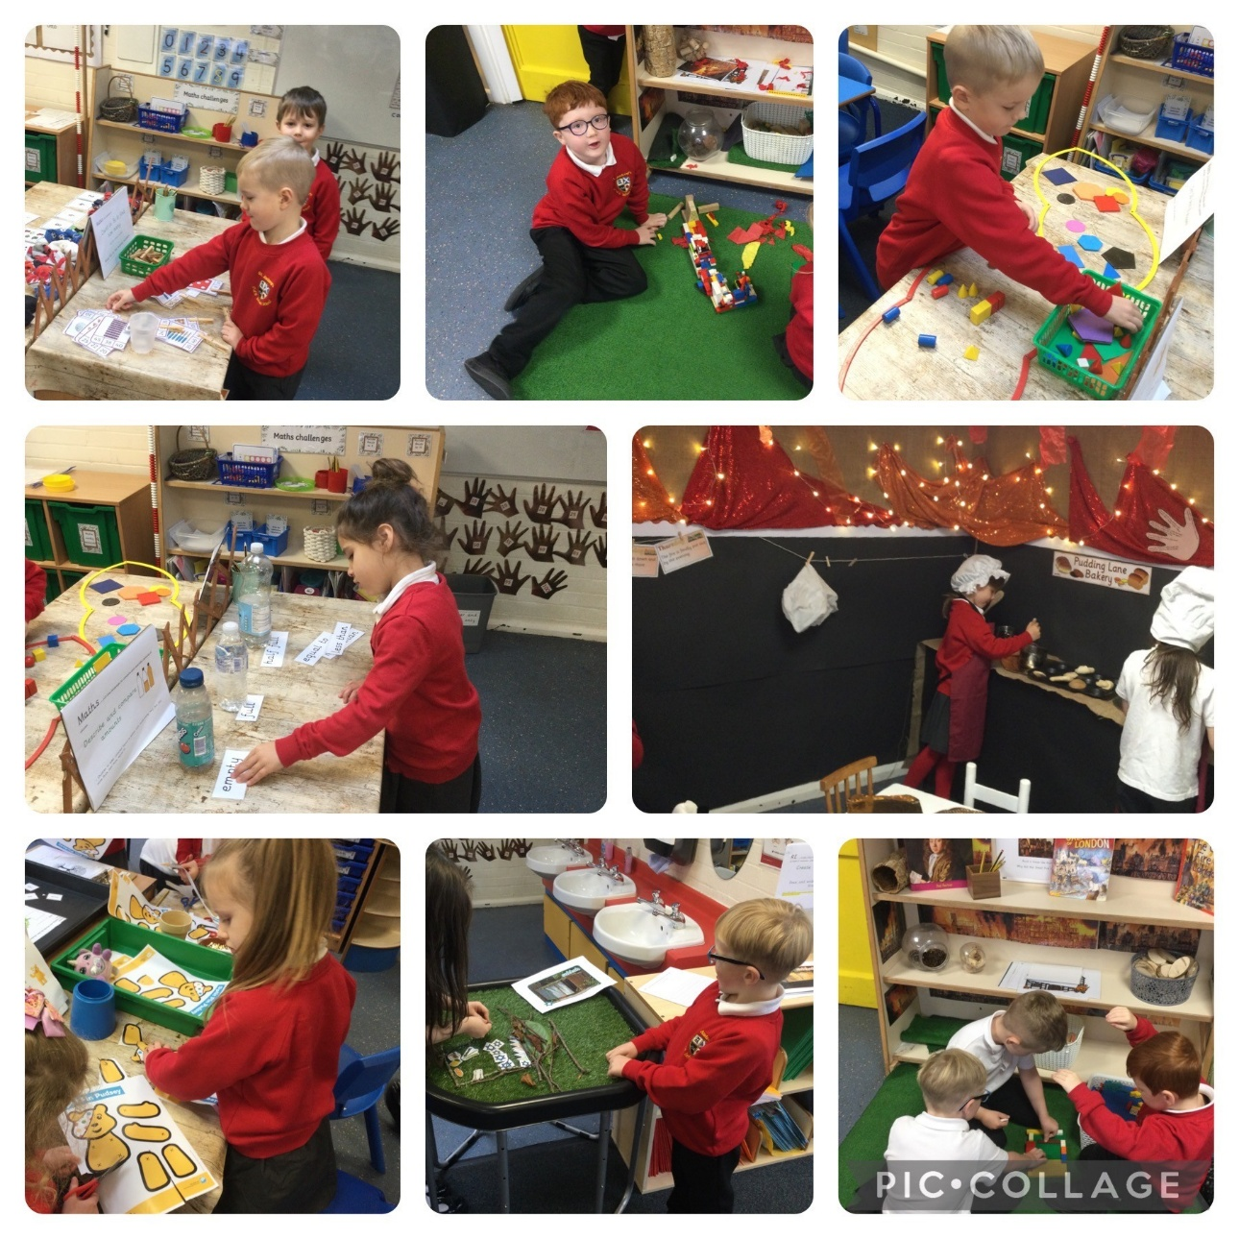

“I like our independent learning tasks because they are fun!” (Fia)