**RE Blog**

**Owls Class**

**Autumn 2 - Sukkot**

We have been learning about the Jewish celebration of Sukkot. We learnt about how God led the people out of Egypt to freedom and how the people sheltered in Sukkah’s. We enjoyed learning about Sukkot is celebrated by Jewish families. We made Sukkah’s as a group.

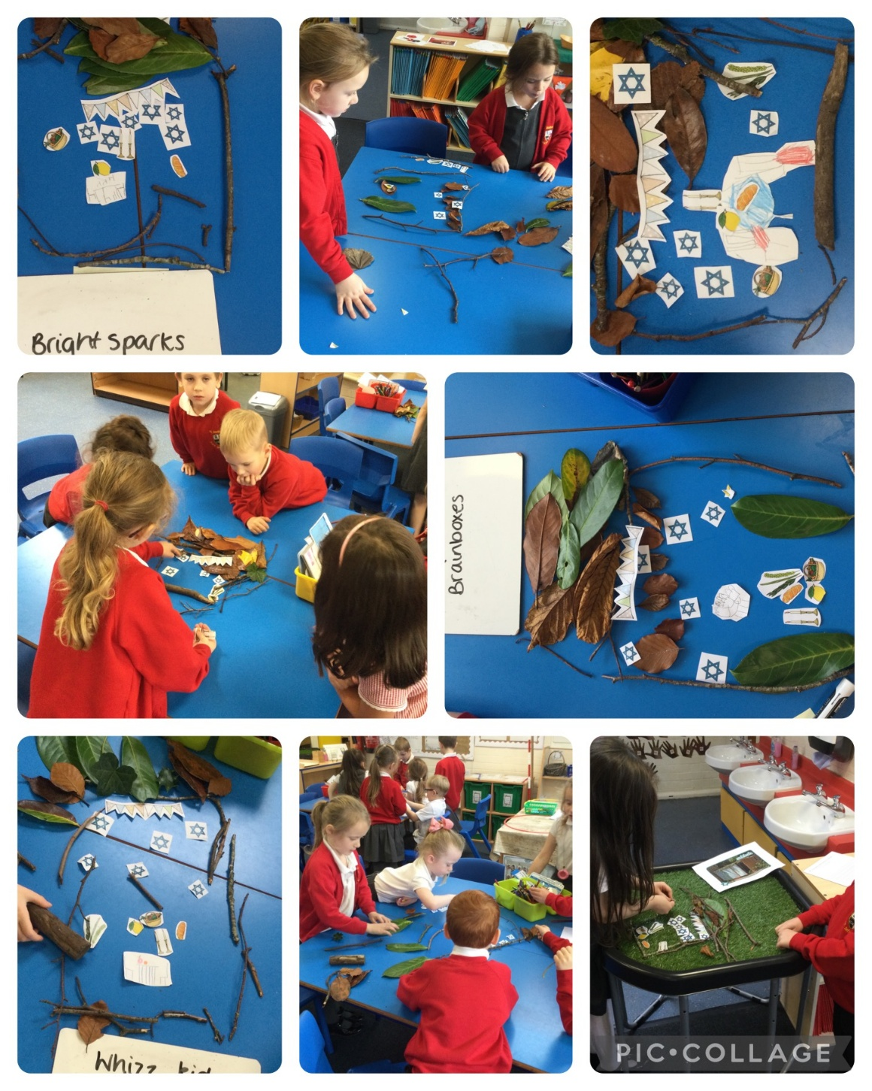

**Our Sukkah’s**

**Autumn 2 – Christmas**

We have been learning about giving and receiving gifts and that Jesus was a promised gift from God.

We talked about gifts that are not objects e.g. love.

We made our own gift for our family. We shared our ideas about what our gift to Jesus would be this Christmas.

**Our Gift-Magic Reindeer Food** 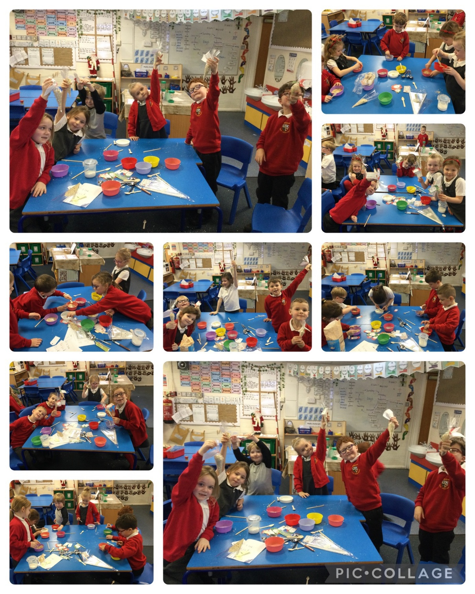

We talked about what our gift to Jesus would be and we made gifts for our family.

**Retelling the nativity story**

We read the nativity story in the Bible and we retold the story in a variety of ways. Using Lego to create the nativity scene, sequencing pictures, drawing the nativity scene and retelling the story using puppets.

