**Living Out Our Christian Vision**

**Owls Class**

***Here’s how we flourish***

**Autumn 2**

‘We made fruit salad in DT’

‘It was quite good and juicy’

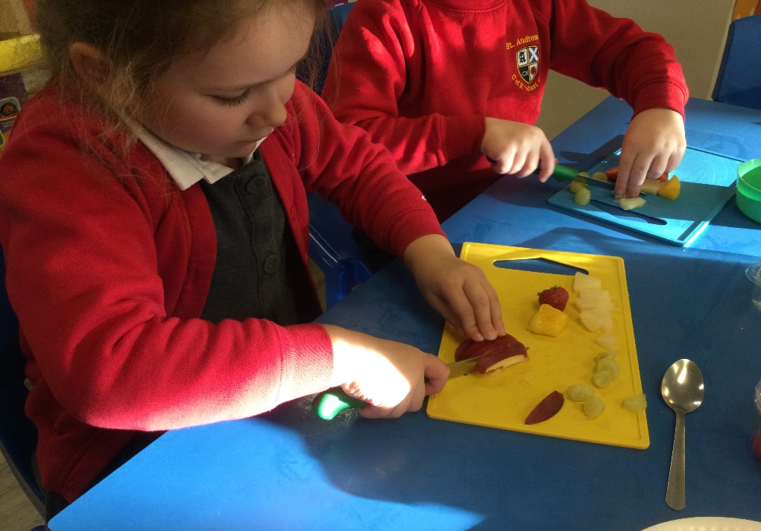

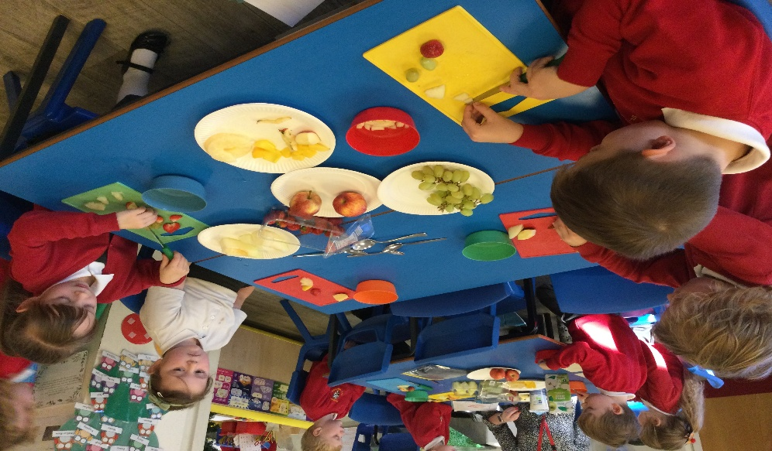

‘It was yummy!’

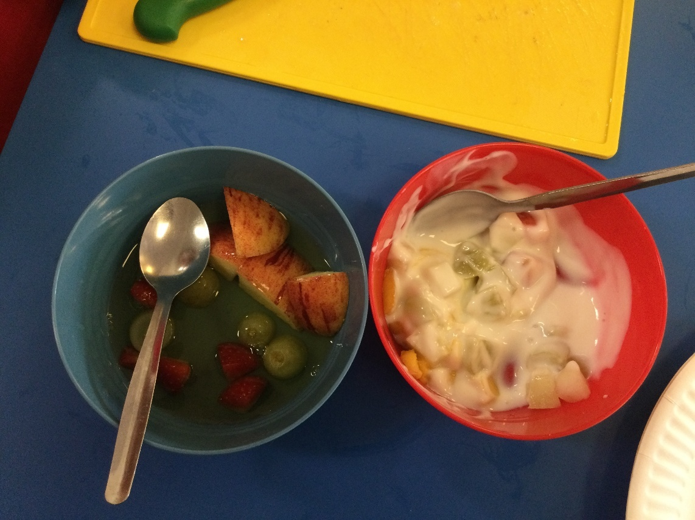

‘We had an Autumn walk, we enjoyed kicking leaves!’

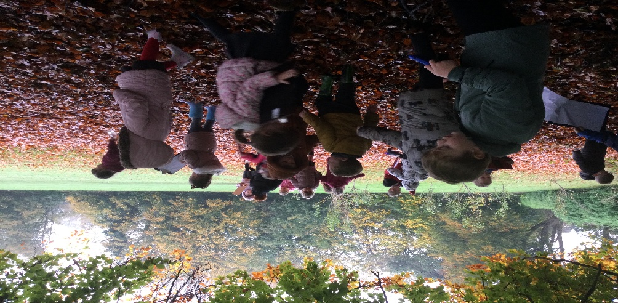

‘We labelled trees in Science’

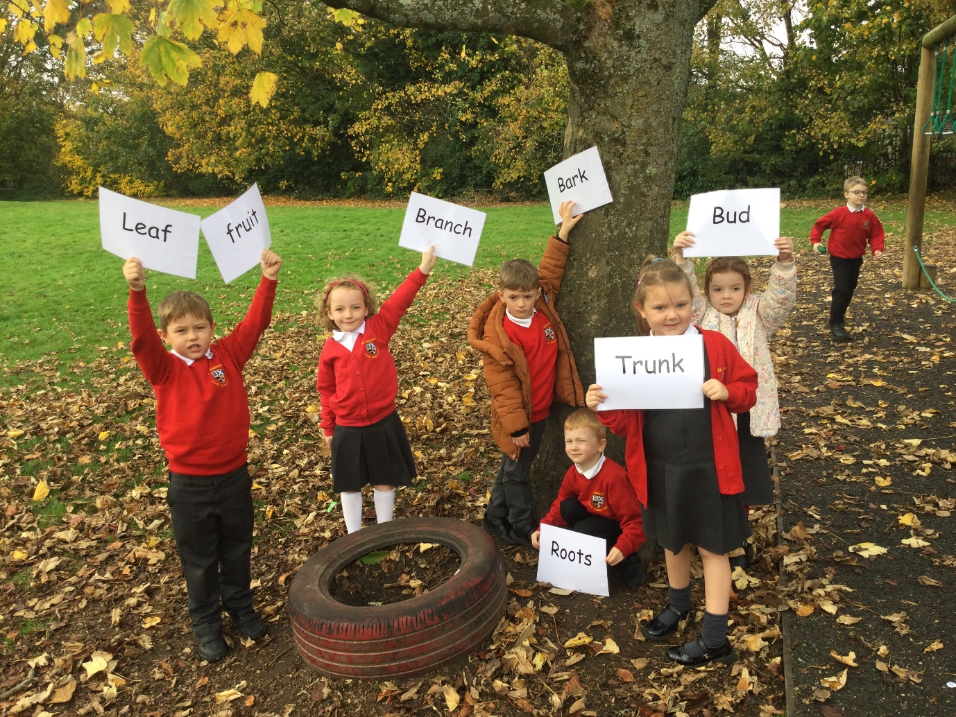

‘The Fire Station trip was fun, we enjoyed watching the houses burn’

‘We tried to put out the fire with buckets’

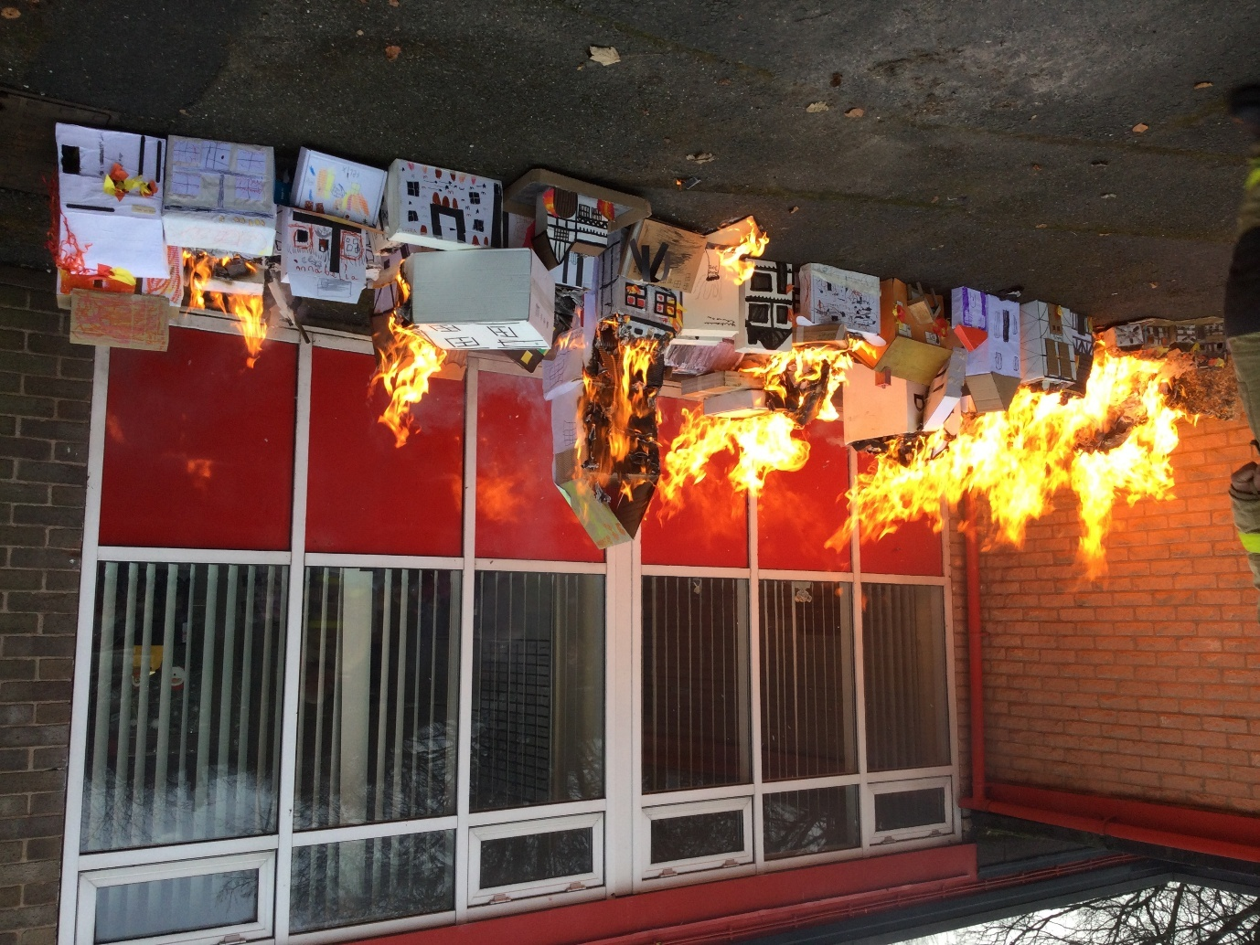

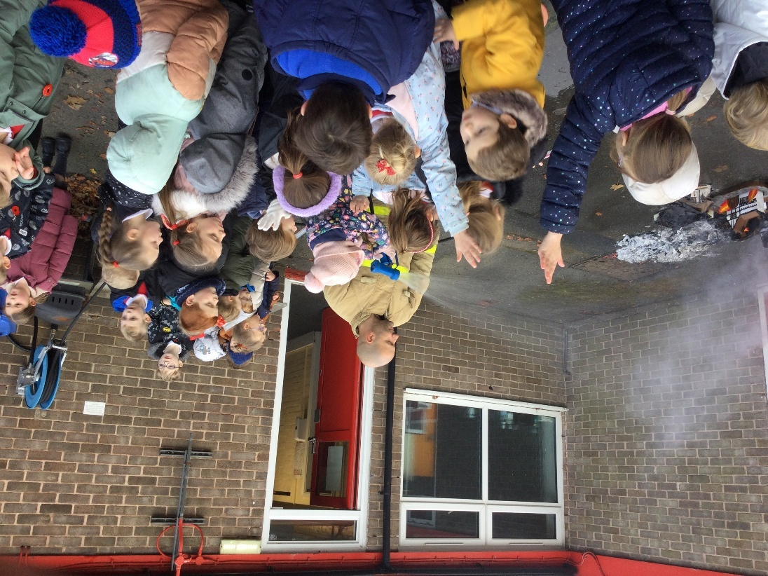

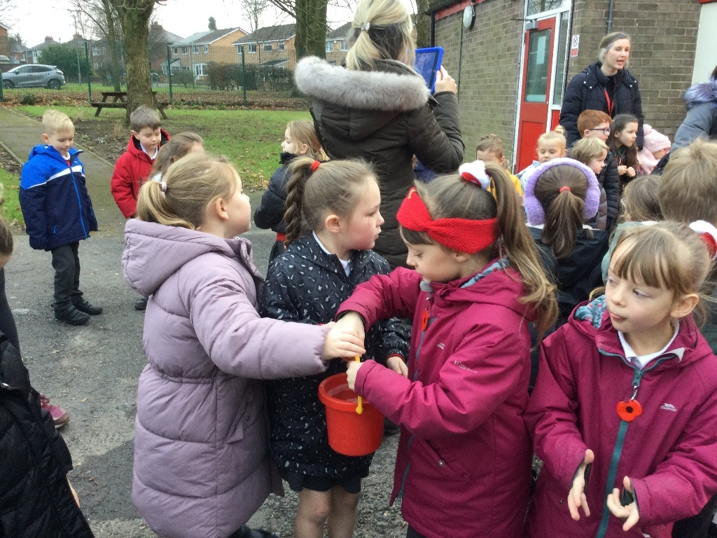

‘The panto was fantastic!’

