**Art Policy**

**Handbook**

**St. Andrew’s CE Infant School**



**Our School Motto**

**‘Learning, Caring and Growing together in Faith’**

**Our Vision**

St Andrew’s Infant School is a Christian school where children are happy, nurtured and love learning. Through an inspiring and aspirational curriculum, we strive to ensure our children flourish spiritually, academically, and creatively to become confident, resilient learners. Everyone here learns, cares and grows together in faith.

**Our Values**

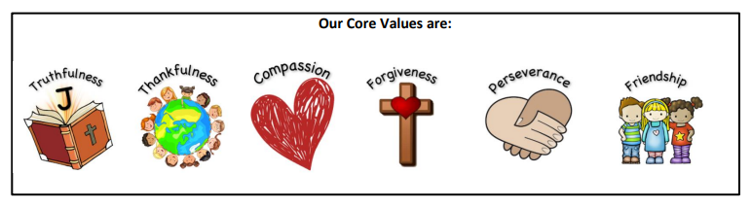

**Our Christian Narrative:**

**‘God is my strength in whom I trust.’ Psalm 18**

**Our Bible story:**

**The parable of the Two Builders - Matthew 7**

**Intent**

***‘Every child is an artist.’***

***Pablo Picasso***

At St Andrew’s C of E Infant School we recognise that Art and Design stimulates creativity and imagination. It provides visual, tactile and sensory experiences and a special way of understanding and responding to the world. It enables children of all abilities to communicate what they see, feel and think through the use of colour, texture, form, pattern and different materials and processes. We encourage children to explore ideas and meanings through the work of a range of artists and designers. Through learning about the roles and functions of art, they can explore the impact it has had on contemporary life and that of different times and cultures. The appreciation and enjoyment of the visual arts enriches all our lives. Through our art lessons, we aim to nourish children’s spirituality by enabling them to express themselves and respect the opinions of others.

• It is progressive in skills and knowledge.

• Builds on children’s prior knowledge.

• Provides relevant and stimulating learning experiences.

• Promotes diversity and inclusion.

* Supports spiritual development.

• Has subject specific vocabulary at the heart of excellent practice.

**Implementation**

Art and Design is taught as part of half termly topics, three times per year, focusing on knowledge and skills stated in the National Curriculum. We focus on progression of knowledge and skills and teach discreet progressive vocabulary as part of the units of work. Teachers use a thematic approach to deliver cross curricular links where appropriate.

At St Andrew’s we ensure that Art and Design is an important part of the curriculum. Teachers plan lessons for their class using our progression of knowledge and skills document. Knowledge organisers are carefully used for each unit to ensure the knowledge and skills taught is precise and clear. Knowledge hands are also used to support children when learning and remembering knowledge and skills within each unit.

**Celebrating Achievements**

We recognise the importance of celebrating and displaying children’s art work. Art is displayed in classrooms, on working walls, on year group learning journey displays and on the hall displays which are updated half termly.

**Presentation of Work**

Children use sketch books to record their learning in art. Children will explore a variety of materials in these books. They may also want to write about the art work using a pencil. We have high expectations of the children and expect them to present work to the best of their ability in these sketch books.

**Resources**

Sketch books are kept in classrooms. Art resources are kept centrally in the stock cupboard and staff are expected to ask the art subject leader if any topic specific resources are required at the end of each academic year, ready for the year ahead.

**Additional Documents**

In addition to this Art Policy, the following documents are in place to support the implementation of Art:

* Year Group Overviews
* Art Subject Overviews
* Art Progression Document
* Art Knowledge Organisers for each unit of work
* Art Knowledge Hands for each unit of work in Key Stage One
* Medium Plans

**Planning**

The planning of the art curriculum is organised through year group overviews and subject overviews that are stored centrally on the shared drive as well as being published on the website. Class teachers use these as well as progression documents and knowledge organisers to create medium term plans. The art curriculum has been carefully designed so that it is progressive throughout school and sequenced effectively.

**Formative Assessment**

Teachers use their professional judgement to decide what children need to learn and when to move on to the next step of learning. Formative assessment (or responsive teaching) is a key feature of art lessons. Teachers use effective questioning to determine the extent of children’s understanding before deciding on what the children need next.

**Summative Assessment**

At the end of each art unit, children complete an assessment task. This is usually their final outcome, such as a final collage or painting using their knowledge and skills gained throughout the unit.

Using this information, assessments are made against objectives listed on knowledge organisers and then recorded centrally. This allows teachers to check children’s progress towards meeting end of year expectations and organise further support when this is necessary.

**Impact**

Within Art and Design, we strive to instil an appreciation and enjoyment of the arts enriching the children’s learning experience. Our Art and Design curriculum is high quality, well thought out and is planned to demonstrate progression. We measure the impact of our curriculum through the following methods:

• Assessing children’s understanding of topic linked vocabulary throughout.

• Summative assessment of pupil discussions about their learning.

• Images or videos of the children’s practical learning.

• Interviewing the pupils about their learning (pupil voice).

• Moderation staff meetings where pupil’s books are scrutinised and there is the opportunity for a dialogue between teachers.

• Assessment of work in books.

We know that our curriculum is effective when we see the artwork that the children have produced that has been inspired by great artists, crafts people and sculptors.

**Features of an effective Art Teaching Sequence**

Throughout a unit of work, each lesson should build on the previous one. It should be clearly focused on the knowledge, skills and vocabulary specified in knowledge organisers.

**The following information provides a guide on which to sequence lessons within a unit. They are not intended to be lesson by lesson but a way of thinking and weaving activities together. Keep revisiting artist’s work every week to help the children remember. Talking about art is also a very important part that should be evident throughout the sequence of lessons. For example, what does this artwork say to you?**

1. Begin by immersing children in the work of an artist, craft makers or designer. Give children opportunities to listen to, form opinions and to try out a technique. Within this part they may also find out some key knowledge about an artist and make annotations in sketchbooks.

2. Drawing will start in sketchbooks using a variety of tools. For example, H, 2B, 6B, graphite stick, biro, felt pen, charcoal and chalk. Children will try out an artist’s methods, make brushstrokes/mark-making or explore drawing tools to build knowledge of materials.

3. Children will develop their skills in sketchbooks and use other media. For example chalk or oil pastels. They will make annotations in sketchbooks.

4. Work in sketchbooks will develop further into paint; watercolour, ready-mix or acrylics. Children will try out an artist’s methods/brushstrokes/mark-making. They may recap on colour mixing.

5. Children may work together on large scale group drawing, change scales or formats.

6.  Develop work into printing/sculpture/textile/collage/digital etc.

7. Children will respond to own work/peers’ work/artist’s work. They will respond to questions, reflect on what went well, what was tricky, what they have learnt – class critique of each other's work.

8. Opportunities to develop opinions on various art media and artists. For example, understanding how an artist works, interpreting their messages and asking big questions e.g. How design affects our lives etc.  
  
In a good art lesson you would see children immersed in an artist’s work to inspire them. Children will have opportunities to explore materials in their own creative way. They will annotate thoughts and opinions using sketchbooks. If appropriate, self-assessment annotations will support children to reflect and think about likes, dislikes and meanings.

**Health and Safety**

Equipment that has been purchased is fit for purpose, safe to use, safely stored and appropriate for pupils to use. All staff must be aware that it is their individual responsibility to ensure that equipment is safe to use, safely stored and appropriate to use every time an Art activity is carried out. Where required, equipment checks and testing, e.g. PAT testing, will be carried out in accordance with the employer’s policy and manufacturer recommendations. Disposal of resources and equipment will be carried out in accordance with the employer’s policy and manufacturer recommendations. For advice on safe use, storage and disposal of equipment and resources refer to CLEAPSS resources on the website [www.cleapss.org.uk](http://www.cleapss.org.uk)

**Roles and Responsibilities**

**Class Teacher**

* Complete medium term plans that detail the sequence of lessons and indicate the assessment focus
* Assess pupils work in each lesson
* Plan learning that is in response to assessment information
* Makes a judgement at the end of each unit of work to inform end of year assessments.

**Subject Leader**

* Monitors planning and assessments
* Ensures the policy is implemented
* Supports and guides teachers in the teaching and learning of Art and Design
* Monitors and evaluates practices in school
* Keeps up to date with latest initiatives, resources and research and communicates these to staff
* Attends relevant CPD
* Prepares, organisers and delivers appropriate CPD

**SLT**

* Monitors planning and assessments
* Monitors high quality teaching and learning
* Ensures policy is implemented

**Inclusion**

Planning at all levels ensures that the needs of all children are met and all children will have access to the full curriculum. The pupils work individually, in pairs and as part of small groups. They use a variety of means for communicating and recording their work. Additional support will be given to children as necessary to enable them to take a full and active role. Tasks will also be adapted where necessary so that the children can succeed. Teacher assessment determines the depth to which individuals and groups go during each unit of work.

**Subject Overview**

|  |  |  |  |  |  |  |
| --- | --- | --- | --- | --- | --- | --- |
|  | **Autumn 1** | **Autumn 2** | **Spring 1** | **Spring 2** | **Summer 1** | **Summer 2** |
| **EYFS** | **Collage:** Andy Goldsworthy Study  **Printing:** Autumn objects outdoors/loose parts  Leaf printing | **Painting:** Colour mixing  Firework/bonfire pictures  **Printing:** Poppy art  Christmas Cards  Diva Lamp | **Painting:** Dinosaurs  **Printing:** Dinosaur Scales | Arcimboldo study  **Drawing:** Observational drawings of flowers  Mother’s Day cards | **Painting:** Deborah Purcell Study  Dotty artwork of animals/mini beasts | **Drawing:** Summer tree sketch  Cardboard Tube Pirates |
| Exposure to different textiles are covered in Continuous Provision – see progression document.  All skills are developed through Continuous Provision – see progression grids in different areas of classroom. | | | | | |
| **Year 1** | **Artist:** Pablo Picasso  **Painting:** Portraits  **Concept:** colour |  |  |  | **Artist:** Moira West  **Textiles:** Natural Scottish Landscape  **Concept:** texture | **Artist:** Henry Moore  **Sculpture**: Animal Sculpture  **Concept:** texture |
| **Year 2** | **Artist:** Lawrence Stephen Lowry  **Drawing:** The Playground  **Concept:** colour | **Designer:** Gary Anderson  **Printing:** Environment  **Concept:** repetition |  |  |  | **Artist:** Eileen Downes  **Collage:** Coastal Landscape  **Concept:** texture |

**Example of Summative Assessment**

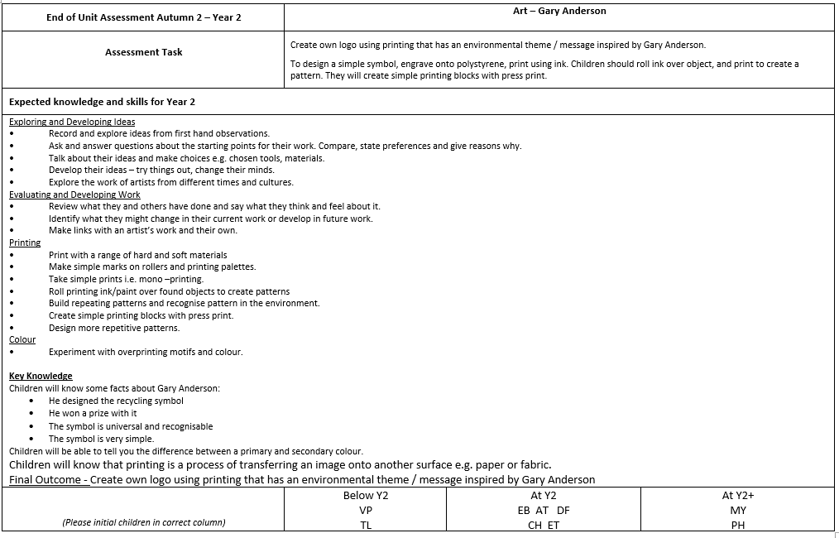

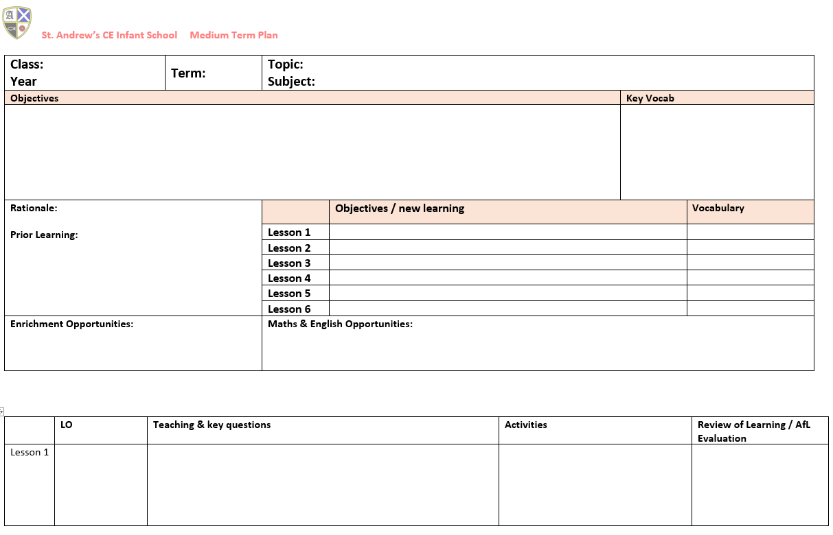**Medium Plan Template**

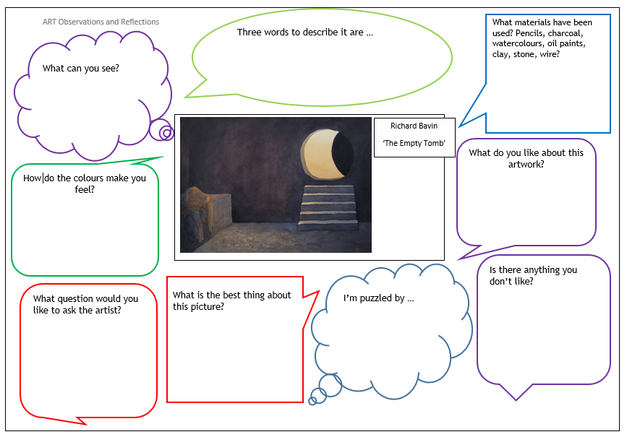**Example of focus questions**

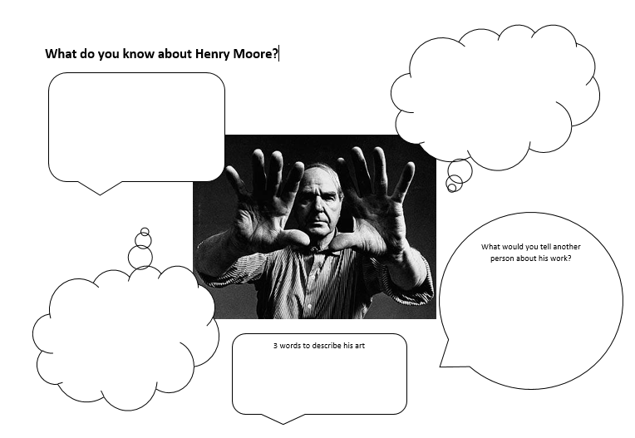**Example of reflection sheet**

