**Design and Technology Policy**

**Handbook**

**St. Andrew’s CE Infant School**



**Our School Motto**

**‘Learning, Caring and Growing together in Faith’**

**Our Vision**

St Andrew’s Infant School is a Christian school where children are happy, nurtured and love learning. Through an inspiring and aspirational curriculum, we strive to ensure our children flourish spiritually, academically, and creatively to become confident, resilient learners. Everyone here learns, cares and grows together in faith.

**Our Values**

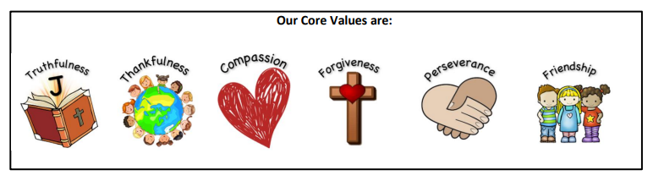

**Our Christian Narrative:**

**‘God is my strength in whom I trust.’ Psalm 18**

**Our Bible story:**

**The parable of the Two Builders - Matthew 7**

**Intent**

**‘Anyone who has never made a mistake, has never tried anything new.’**

**Albert Einstein**

At St Andrew’s C of E Infant School our aim is to build a Design and Technology curriculum which develops learning and results in the acquisition of knowledge and skills. Through our design and technology lessons, we aim to nourish children’s spirituality by enabling them to express themselves and respect the opinions of others. We have designed a Design and Technology curriculum that reflects the needs of our children and:

• Is progressive in skills and knowledge

• Builds on children’s prior knowledge

• Has vocabulary at the heart of excellent daily practice

• Develops creativity through designing and making

* Supports spiritual development

• Develops practical expertise

• Allows the application of maths, science, computing and art

• Provides opportunities for critical evaluation to adapt and improve

• Captures interests through thematic learning with cross curricular links

• Provides motivation and meaning to their learning

Our intent is to provide a DT curriculum which combines skills, knowledge, concepts and values to enable children to tackle real problems. High-quality design and technology education makes an essential contribution to the creativity, culture, wealth and well-being of the nation.

**Implementation**

At St. Andrew’s we ensure that Design and Technology is an important part of the curriculum. Design and Technology is taught as part of half termly topics, three times per year, focusing on knowledge and skills stated in the National Curriculum. We focus on progression of knowledge and skills and teach discreet progressive vocabulary as part of the units of work.

Teachers plan lessons for their class using our progression of knowledge and skills document. Knowledge organisers are carefully used for each unit to ensure the knowledge and skills taught is precise and clear. Knowledge hands are also used to support children when learning and remembering knowledge and skills within each unit. Skills and knowledge are built on year by year and sequenced appropriately to maximise learning for all children. Specific Design Technology units are taught in each year group, building on from previously taught units and skill coverage.

Teachers use a thematic approach to deliver cross curricular links where appropriate. All teaching of DT should follow the design, make and evaluate cycle. Each stage should be rooted in technical knowledge. The design process should be rooted in real life, relevant contexts to give meaning to learning. While making, children should be given choice and a range of tools to choose freely from. To evaluate, children should be able to evaluate their own products against a design criteria. Each of these steps should be rooted in technical knowledge and vocabulary. DT should be taught to a high standard, where each of the stages should be given equal weight.

**Celebrating Achievements**

We recognise the importance of celebrating and displaying children’s design and technology work. Design and Technology is displayed in classrooms, on working walls, on year group learning journey displays and on the hall displays which are updated regularly.

**Presentation of Work**

In Key Stage One, children use books to record their learning. In EYFS, floor books are used. We have high expectations of the children and expect them to present work to the best of their ability.

**Resources**

Books are kept in classrooms. Resources are kept centrally in the stock cupboard and staff are expected to ask the subject leader if any topic specific resources are required at the end of each academic year, ready for the year ahead.

**Additional Documents**

In addition to this Design and Technology Policy, the following documents are in place to support the implementation of DT:

* Year Group Overviews
* DT Subject Overviews
* DT Progression Document
* DT Knowledge Organisers for each unit of work
* DT Knowledge Hands for each unit of work in Key Stage One
* Medium Plans

**Planning**

The planning of the DT curriculum is organised through year group overviews and subject overviews that are stored centrally on the shared drive as well as being published on the website. Class teachers use these as well as knowledge organisers to create medium term plans. The curriculum has been carefully designed so that it is progressive throughout school and sequenced effectively.

**Formative Assessment**

Teachers use their professional judgement to decide what children need to learn and when to move on to the next step of learning. Formative assessment (or responsive teaching) is a key feature of DT lessons. Teachers use effective questioning to determine the extent of children’s understanding before deciding on what the children need next.

**Summative Assessment**

At the end of each unit, children complete an assessment task. This is usually their final outcome, such as soup or a completed structure using their knowledge and skills gained throughout the unit.

Using this information, assessments are made against objectives listed on knowledge organisers and then recorded centrally. This allows teachers to check children’s progress towards meeting end of year expectations and organise further support where this is necessary.

**Impact**

Within Design and Technology, we strive to instil an appreciation and enjoyment of the subject enriching the children’s learning experience. Our Design and Technology curriculum is high quality, well thought out and is planned to demonstrate progression. We measure the impact of our curriculum through the following methods:

• Assessing children’s understanding of topic linked vocabulary throughout.

• Summative assessment of pupil discussions about their learning.

• Images and videos of the children’s practical learning.

• Interviewing the pupils about their learning (pupil voice).

• Moderation staff meetings where pupil’s books are scrutinised and there is the opportunity for a dialogue between teachers to understand their class’s work.

• Assessment of work in books.

We use these strategies to review our curriculum offer, inform our strategic action planning and make adaptations where necessary. We know our Design Technology curriculum is effective when we see children who can:

• Analyse, problem solve and evaluate

• Work collaboratively and practically

• Explain the process they have taken

• Confidently question ideas and reflect on knowledge

• Recall facts and prior learning

• Progress showing increased practical capabilities

• Innovate

**School Curriculum Principles for Design and Technology**

|  |  |  |
| --- | --- | --- |
| **Curriculum Principles** | **Examples of Practice** | **Questions to support reflection** |
| **User**  Pupils should have a clear idea of who they are designing and making products for, considering their needs, wants, values, interests and preferences. The intended users could be themselves or others, an imaginary or story-based character, a client, a consumer or specific target group | At the beginning of a food technology project, a class of Y1/2 pupils discuss food they enjoy and realise that people have preferences for different types of products and ingredients. They taste a range of products made with fresh fruit, saying which they like and dislike, and describing their sensory characteristics. When designing and making their own fruit salads for a class summer picnic, pupils carry out a simple survey of favourite fruit in order to decide which combination of fruit to include in their dishes, | To what extent does your practice enable pupils to:  • identify who their products will be for?  • suggest possible users of a range of existing products?  • explore how existing products are used?  • consider where and when their own and others’ products might be used?  • evaluate whether users’ needs and preferences have been met effectively?  • appreciate the importance of the ‘user’ within design and technology? |
| **Purpose**  Pupils should be able to clearly communicate the purpose of the products they are designing and making. Each product they create should be designed to perform one or more defined tasks. Pupils’ products should be evaluated through use. | When designing and making safety jackets for Teddy, Y2 pupils think about the purpose of helping him to be seen when he is out in the dark. They explore and discuss examples of safety clothes, describing how they have been made and the colour and type of fabrics that have been used. They develop simple design criteria for Teddy’s jacket, such as making sure that it can be seen at night, that it is the right size, that it has suitable fasteners and can be taken on and off easily. | To what extent does your practice enable pupils to:  • state what their products are for?  • suggest the purposes of a range of existing products  • develop design criteria that take account of the intended purpose of their products? |
| **Functionality**  Pupils should design and make products that work/function effectively in order to fulfil users’ needs, wants and purposes | In order to design and make moving pictures to illustrate nursery rhymes in a whole class book, Y1 pupils explore how simple levers and sliders work, how they are used, and how they produce different types of movement. Through focused practical tasks they develop technical knowledge and skills, such as joining paper fastener pivots to card levers and using strips of card to make sliders. They select and use mechanisms according to how they want the parts in their pictures to move, using both directional and technical vocabulary to explain their thinking. | To what extent does your practice enable pupils to:  • know that their products should work in some way?  • know how a range of existing products work?  • develop specific technical knowledge and understanding in order to ensure that their products work well? |
| **Design decisions**  Pupils need opportunities to make their own design decisions. Making design decisions allows pupils to demonstrate their creative, technical and practical expertise, and draw on learning from other subjects. Through making design decisions pupils decide on the form their product will take, how their product will work, what task or tasks it will perform and who the product will be for | Before designing and making their own vehicles in Y2, pupils explore a range of existing products, identifying different types of vehicles, who they are for, what materials and components they are made from, and develop technical vocabulary for each of the parts. When designing their own products, pupils decide what type of vehicles they will create, who they will be for, what purpose they will perform, and what materials and components to use, including the type of wheels, axles and axle holders. | To what extent does your practice enable pupils to:  • make their own design decisions?  • discuss the design decisions that have been made in existing products?  • take into account users’ needs when making design decisions?  • develop their technical and practical expertise in order that they can make informed design decisions? • use D&T-related visits and inputs from experts to make informed design decisions? |
| **Innovation**  When designing and making, pupils need some scope to be original with their thinking. Projects that encourage innovation lead to a range of design ideas and products being developed and are characterised by engaging open-ended starting points for learning. | Pupils in Y1/2 are given the problem of designing and making a hat to keep Teddy cool in the African sun and free of insects. They investigate which materials are suitable for protection from the sun and explore different ways of keeping insects away from the face. Keeping in mind the purposes of the hat, pupils are encouraged to generate creative and imaginative ideas and solutions, developing and communicating these by modelling with paper and card. | To what extent does your practice enable pupils to:  • respond creatively and imaginatively to design briefs and problems? |
| **Authenticity**  Pupils should design and make products that are believable, real and meaningful to themselves and others. | Pupils in Y1 are challenged to create a stronger, more stable bridge using construction materials, construction kits and textiles. They respond positively to this imaginary, story-based context which sets a meaningful and engaging design problem for them to solve. Pupils design and make small-scale bridges. They think about the size, shape and parts, what materials, joining and finishing techniques to use, how to make the chairs stand up, and how to make them strong enough for the intended user. | To what extent does your practice enable pupils to:  • carry out projects that are real and meaningful to them and others?  • work within a range of relevant contexts, ranging from domestic to industrial?  • work towards realistic and credible outcomes that can be evaluated in use?  • engage in activity that mirrors design and technology in the wider world?  • create products with a genuine purpose and for a real user?  • create products which need to work in some way in order to be successful? |

**Roles and Responsibilities**

**Class Teacher**

* Complete medium term plans that detail the sequence of lessons and indicate the assessment focus
* Assess pupils work in each lesson
* Plan learning that is in response to assessment information
* Makes a judgement at the end of each unit of work to inform end of year assessments.

**Subject Leader**

* Monitors planning and assessments
* Ensures the policy is implemented
* Supports and guides teachers in the teaching and learning of Art and Design
* Monitors and evaluates practices in school
* Keeps up to date with latest initiatives, resources and research and communicates these to staff
* Attends relevant CPD
* Prepares, organisers and delivers appropriate CPD

**SLT**

* Monitors planning and assessments
* Monitors high quality teaching and learning
* Ensures policy is implemented

**Inclusion**

Planning at all levels ensures that the interests of all children. The pupils work individually, in pairs and as part of small groups. They use a variety of means for communicating and recording their work. All pupils, including those with special educational needs, undertake the full range of activities, scaffolded according to their own specific needs. Teacher assessment determines the depth to which individuals and groups go during each unit of work.

**Subject Overview**

|  |  |  |  |  |  |  |
| --- | --- | --- | --- | --- | --- | --- |
|  | **Autumn 1** | **Autumn 2** | **Spring 1** | **Spring 2** | **Summer 1** | **Summer 2** |
| **EYFS** | Learning to join and cut materials for props  Bake Gingerbread Men  Make Pumpkin Soup |  | Learn to join and cut materials for props |  |  | Make pirate hats, eye patches and cutlasses |
| All skills are developed through Continuous Provision – see progression grids in different areas of classroom. | | | | | |
| **Year 1** |  | **Food:**  Preparing and combining foods: fruit salad | **Mechanisms:** Sliders and levers – a robot scene | **Structures:** Bridges |  |  |
| **Year 2** |  |  | **Mechanisms:** Wheels and axles: Moon buggy | **Food:**  Understanding where food comes from: Healthy soup | **Textiles:**  Template and joining techniques: animal puppet based on core texts |  |

**Example of Summative Assessment**

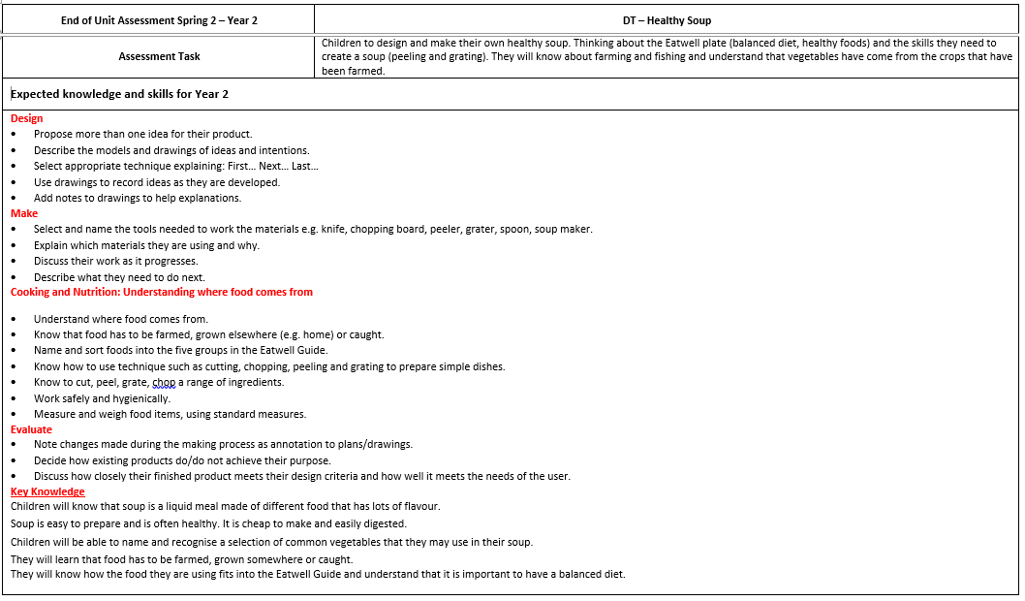



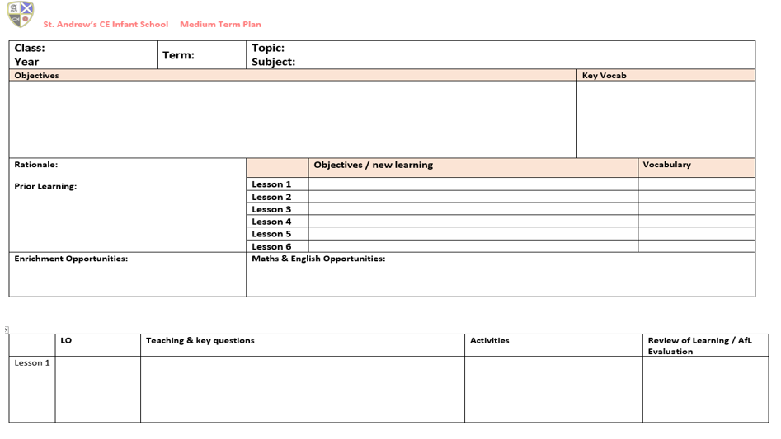**Medium Term Plan Template**

