**Living Out Our Christian Vision**

**Butterflies Class**

***Here’s how we flourish***

**Spring 1**

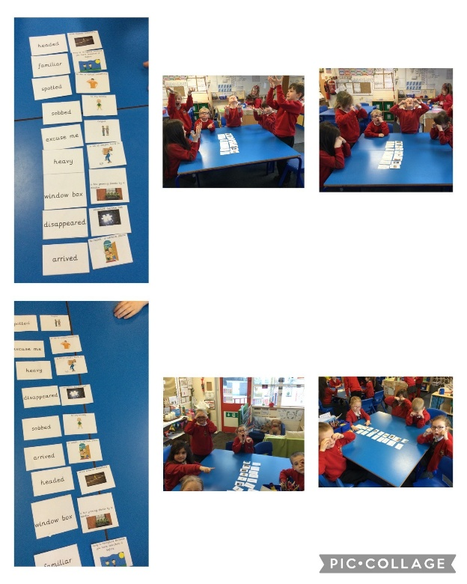

Learning new vocabulary through creating actions and putting it into oral sentences in English.

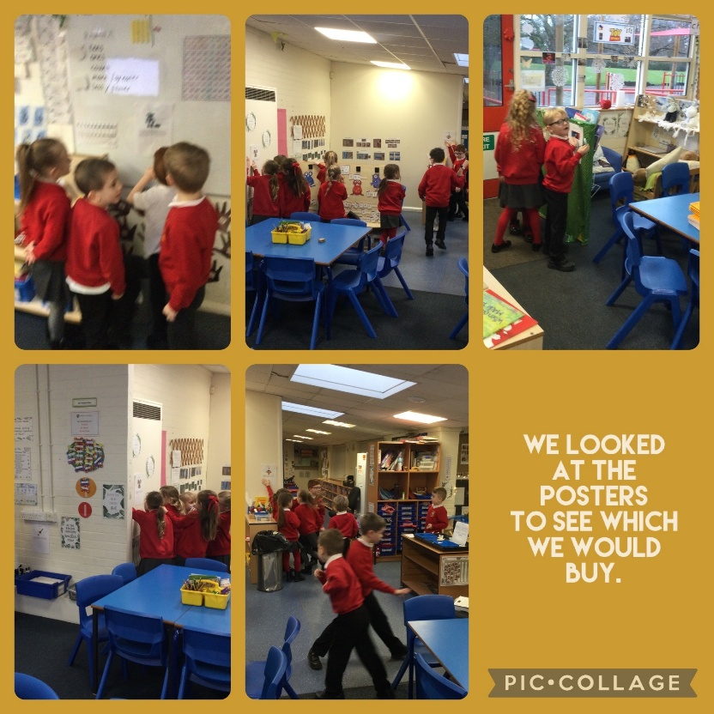

As an introduction to our new English unit on posters, we explored existing toy posters and decided which one we wanted to buy.

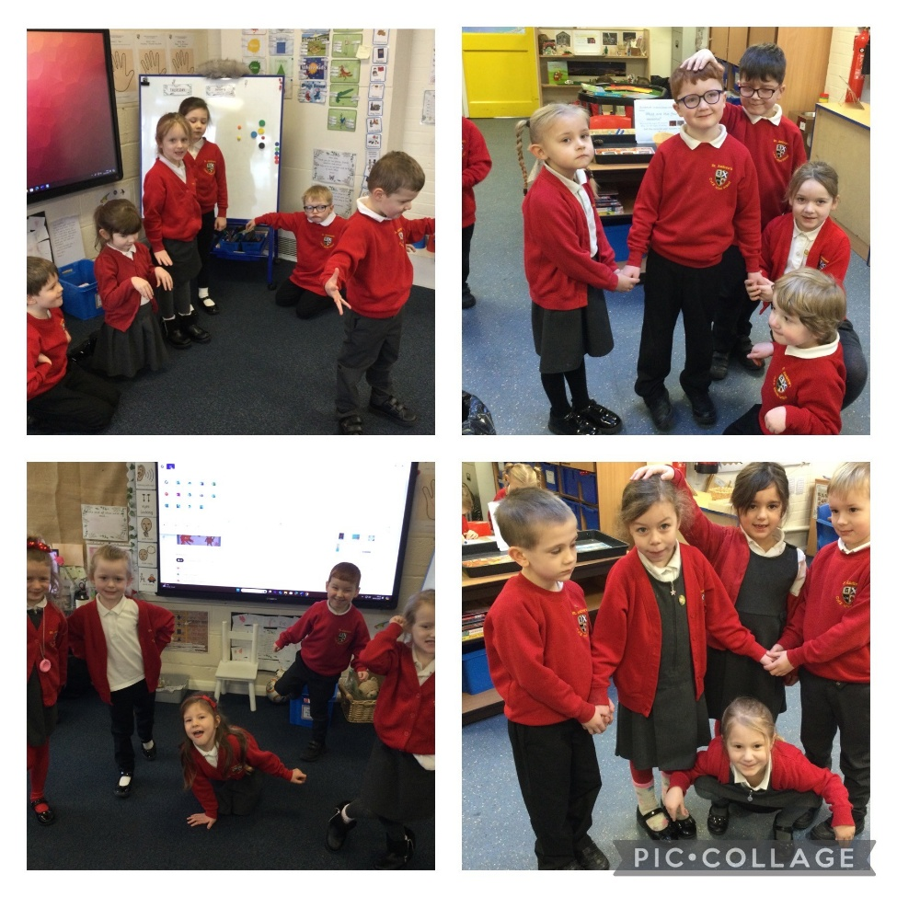

Demonstrating compassion for the characters during freeze frames of ‘Nobot the robot’.

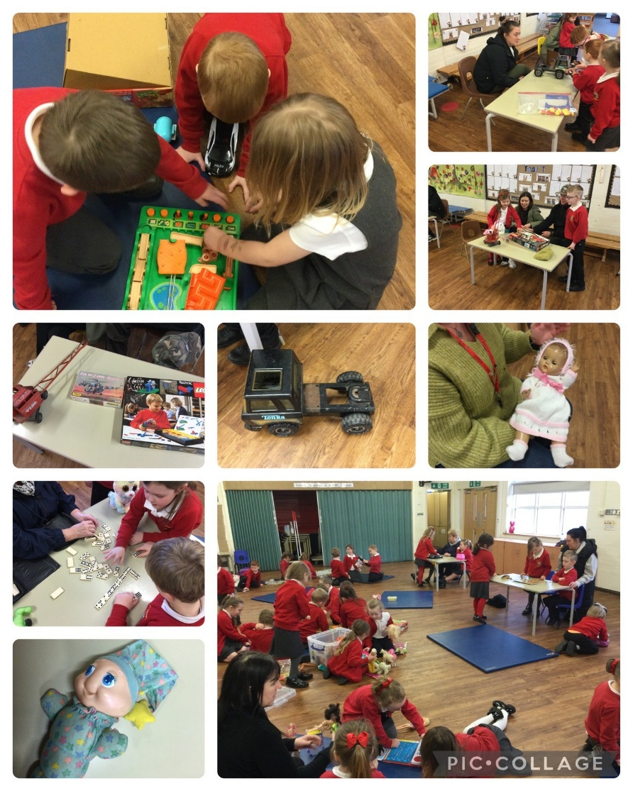

We had a toy afternoon to introduce our history topic about toys. We invited our parents in to talk about their toys from when they were little.

“I loved my mum coming!” Ralph

“My dad had old Lego! I liked them coming into school to help us” Alice

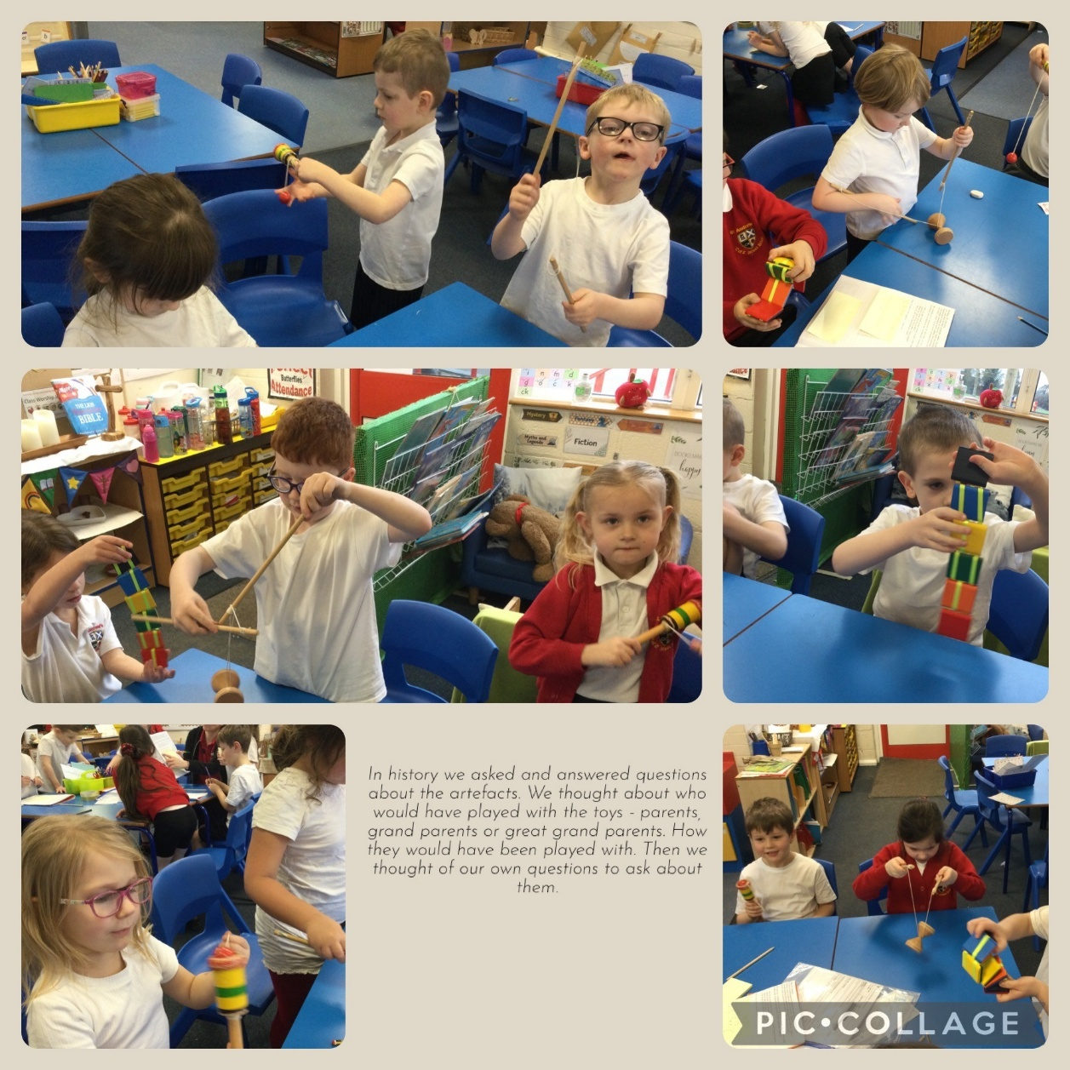

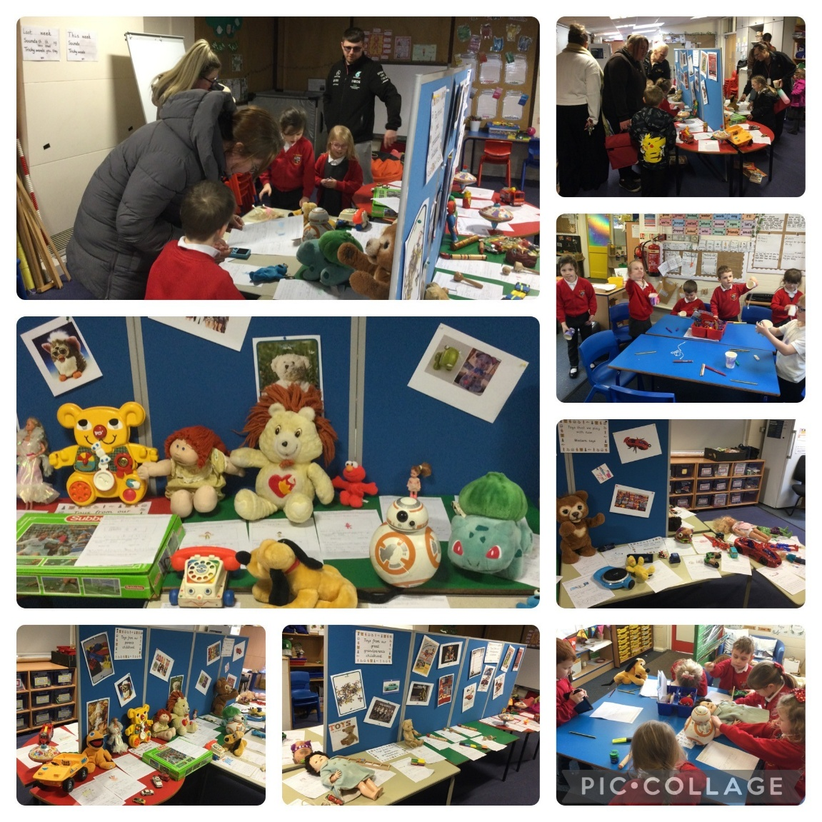

We made our own toy museum for our grown-ups to visit!

“It was the best day ever!”

“I liked making the cup and ball toy” Hayley

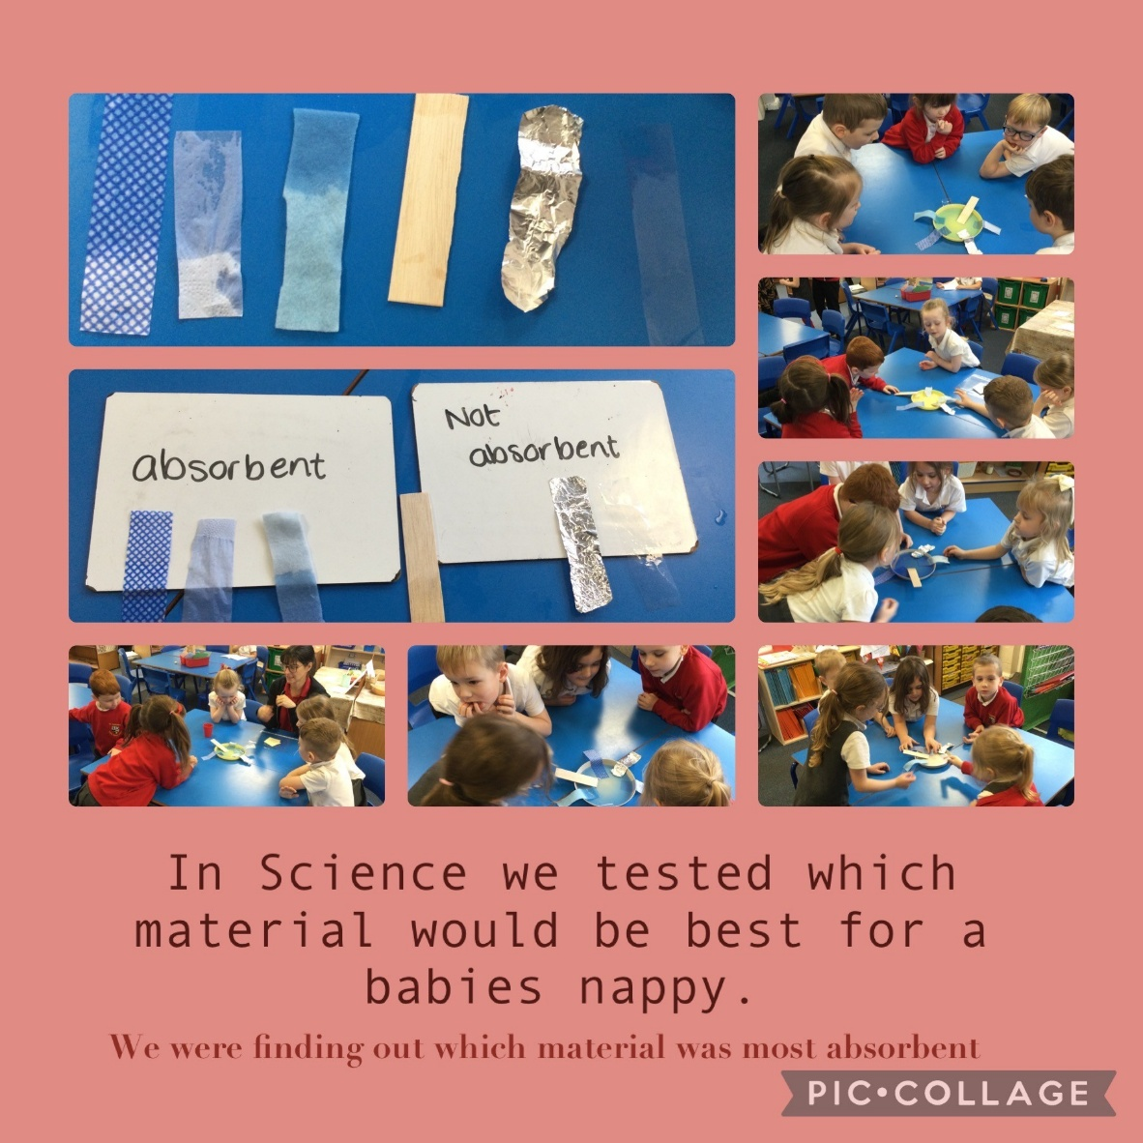

“I like Science because it’s fun!” Amelia

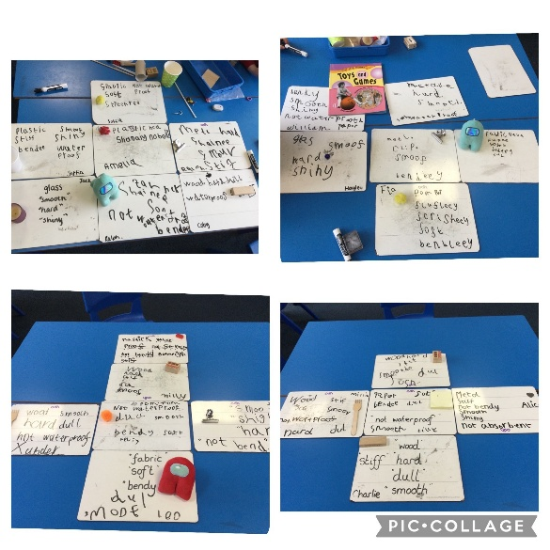

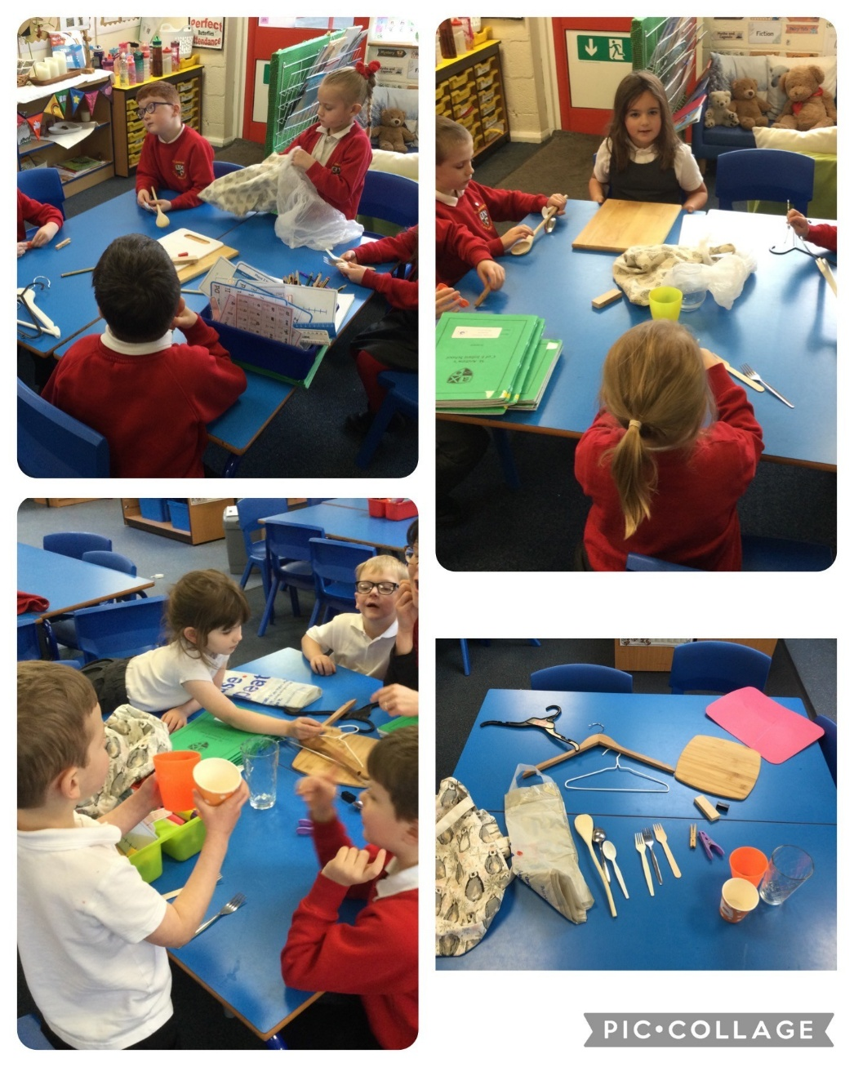

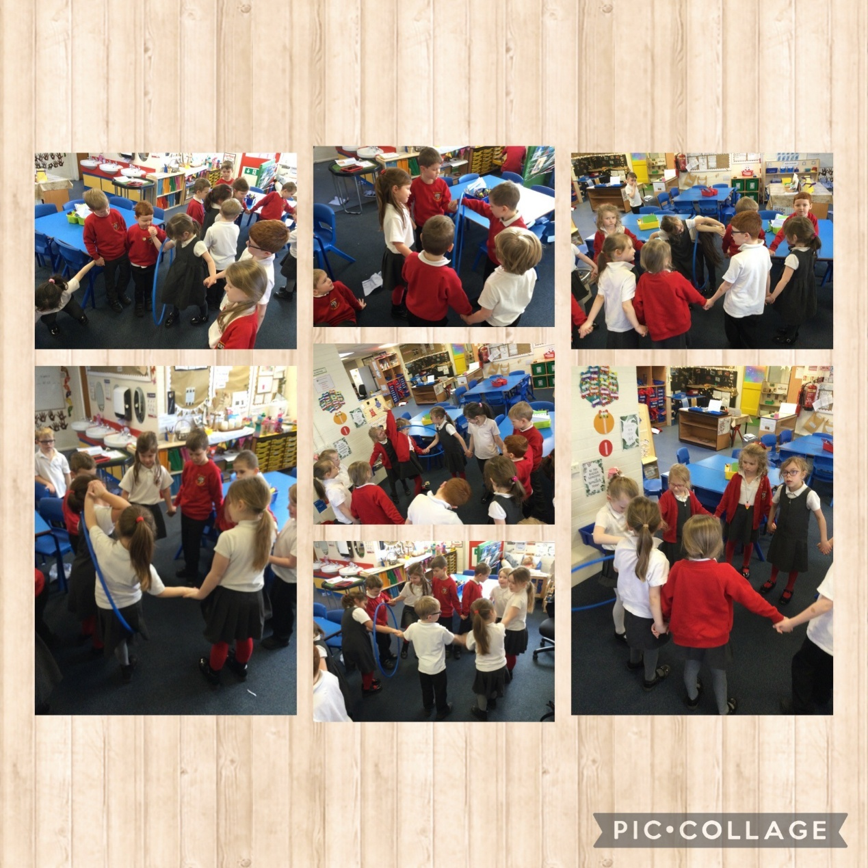

In PSHRE we learnt how to be good friends and listen and cooperate with each other to complete the challenge.

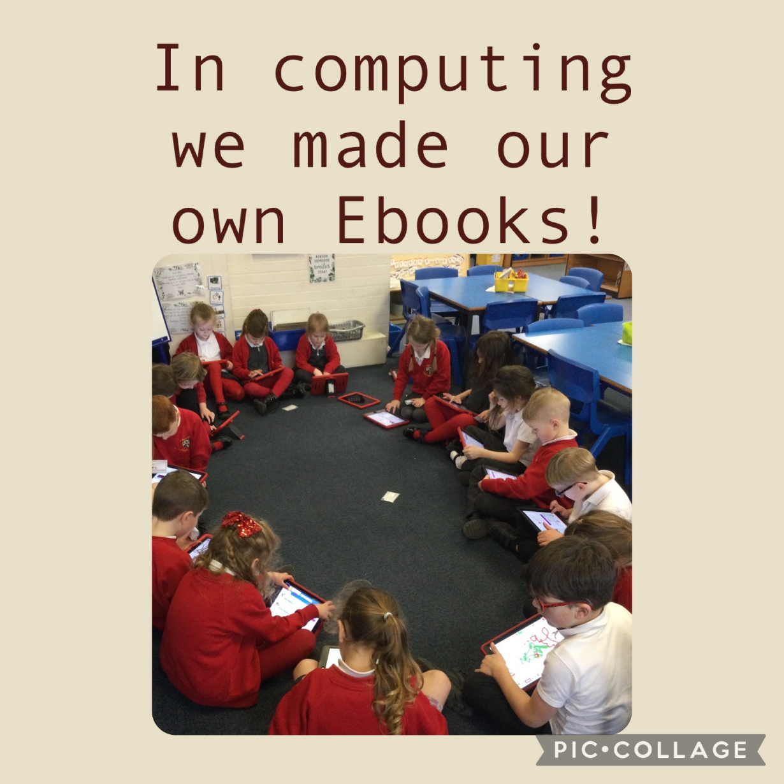

Persevering to complete our tricky Ebooks. Everyone did a super job!

“My book can move and make noises and it has different backgrounds” Felix

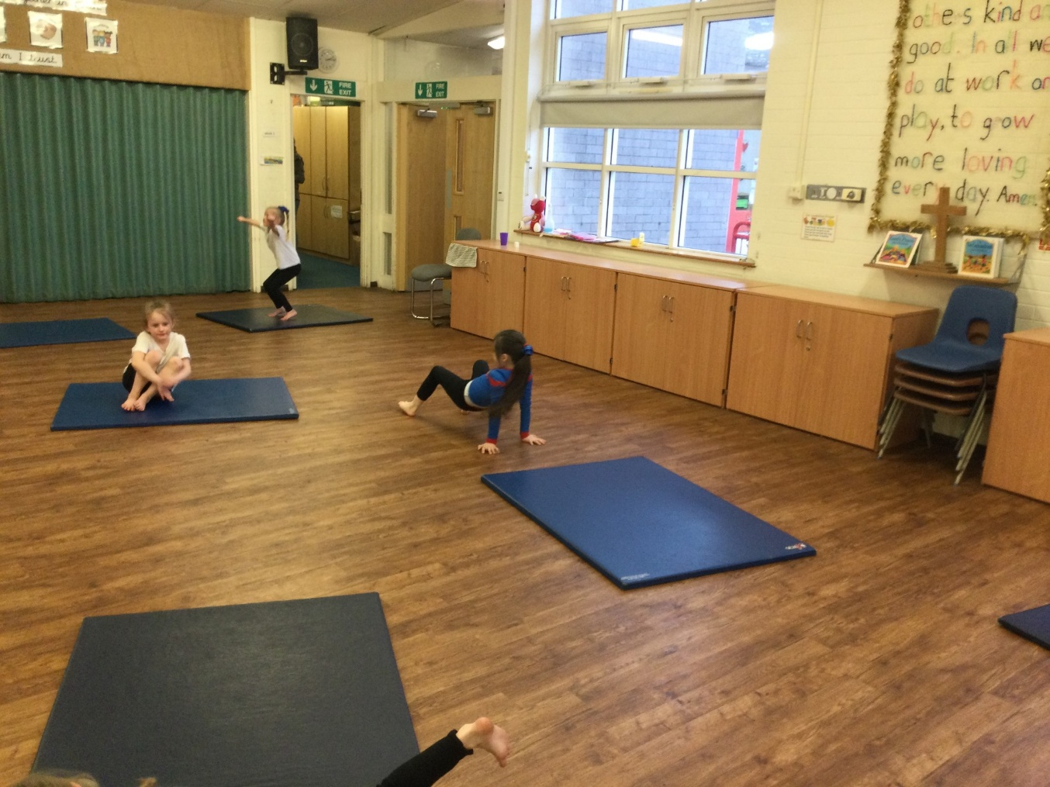

In PE we worked hard to complete our own sequences. WE helped our friends by telling them the positive things about their sequence and if they needed to do anything to improve it.