Living Out Our Christian Vision

Owls Class

Here’s how we flourish

Spring 1

DT: We made sliders and levers.
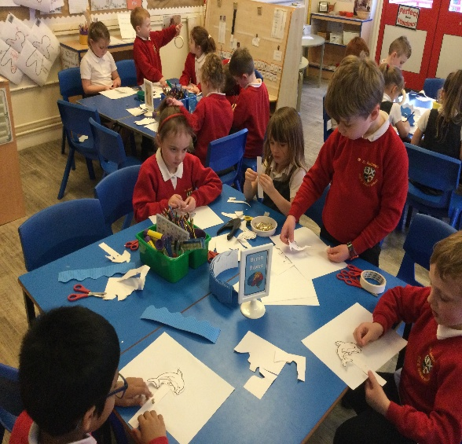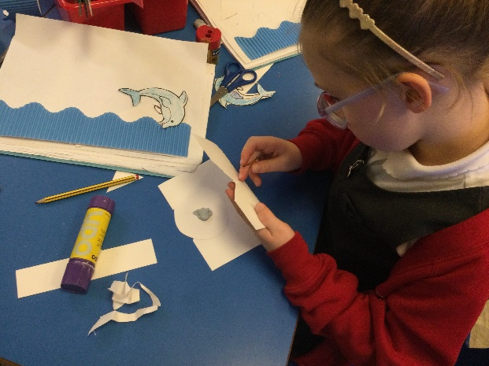
PE: We have sport’s coaches to do athletics festivals.

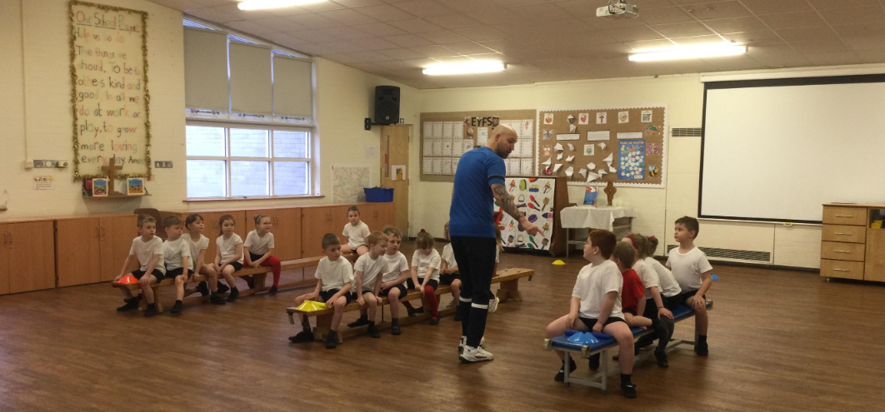
Computing: We enjoyed making our animated E-Books, we added pictures, sound, animation and backgrounds.

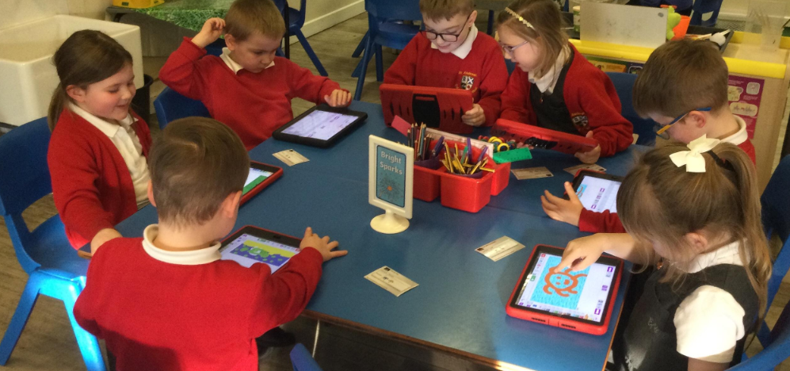

Science: we chose objects and discussed what materials they were made of and described their properties.

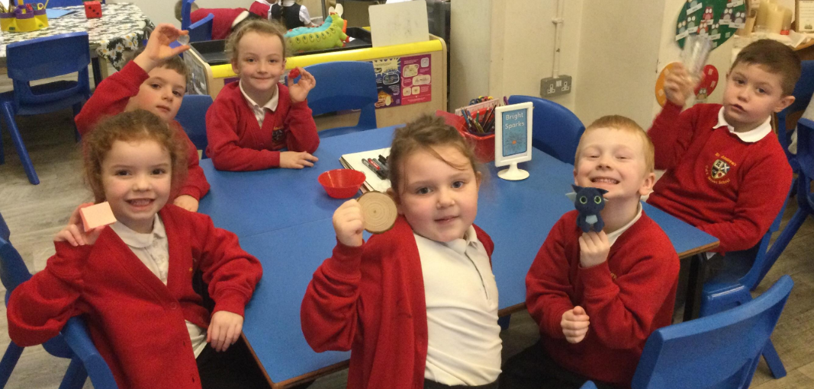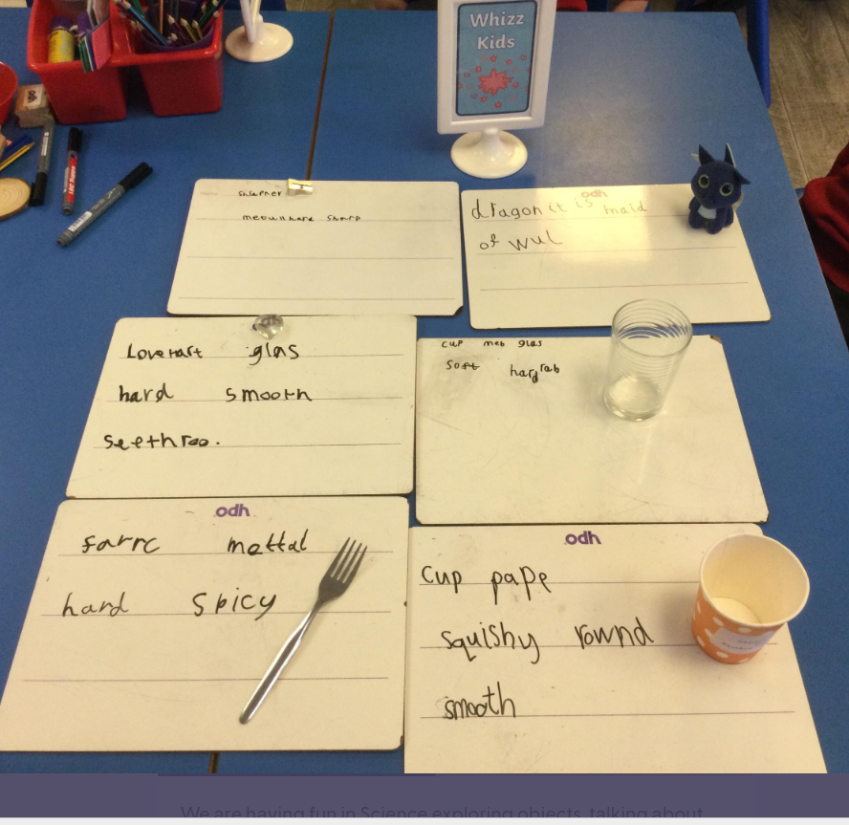

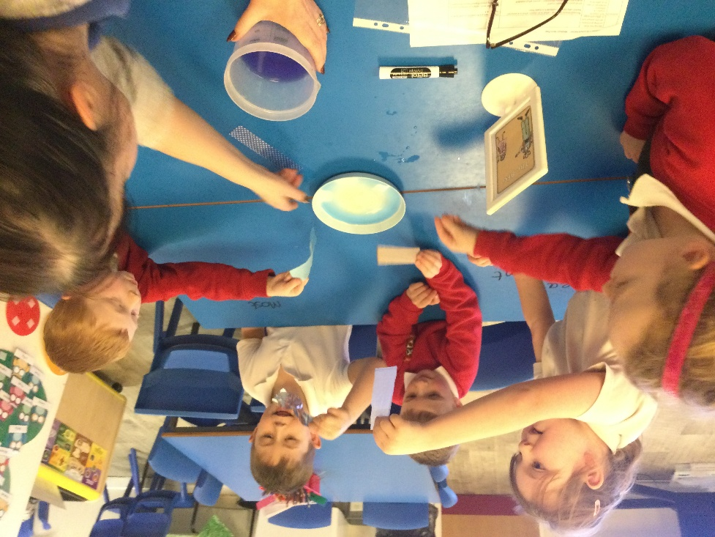
We explored materials to see if they are waterproof.

History: We invited parents and grandparents into school to share and answer questions about their toys.
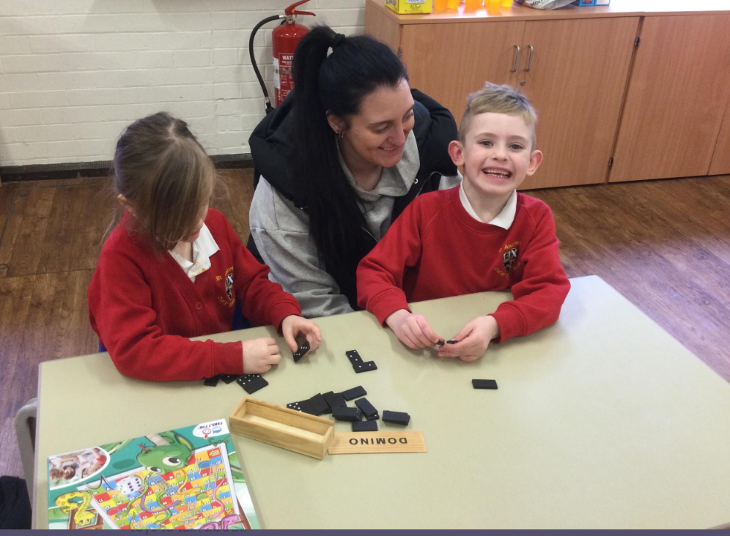
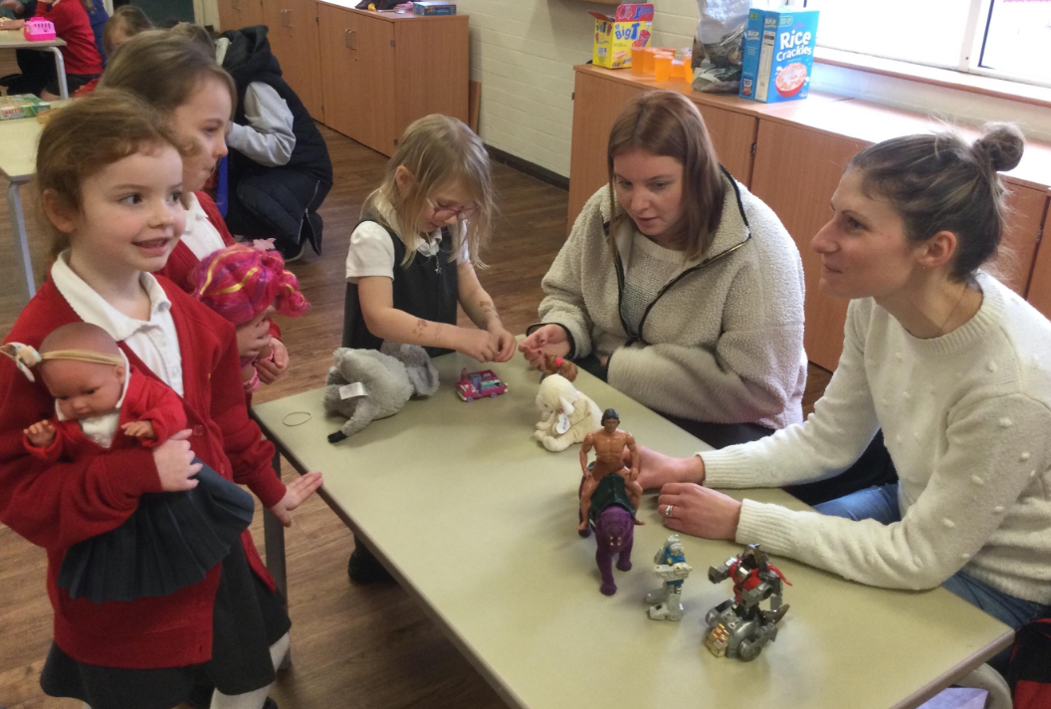

We explored, discussed and sorted historic and modern toys in History.

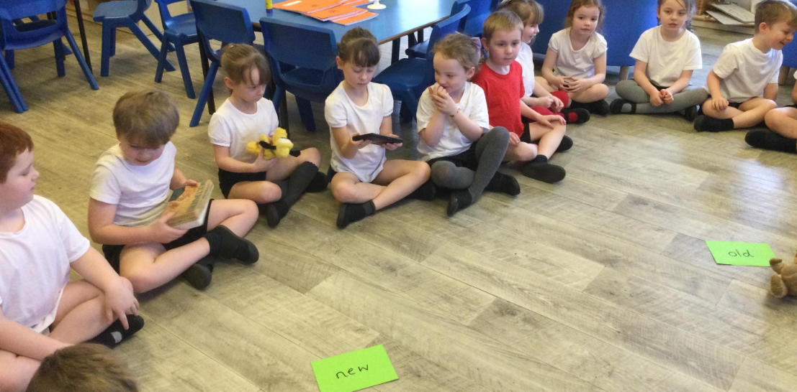
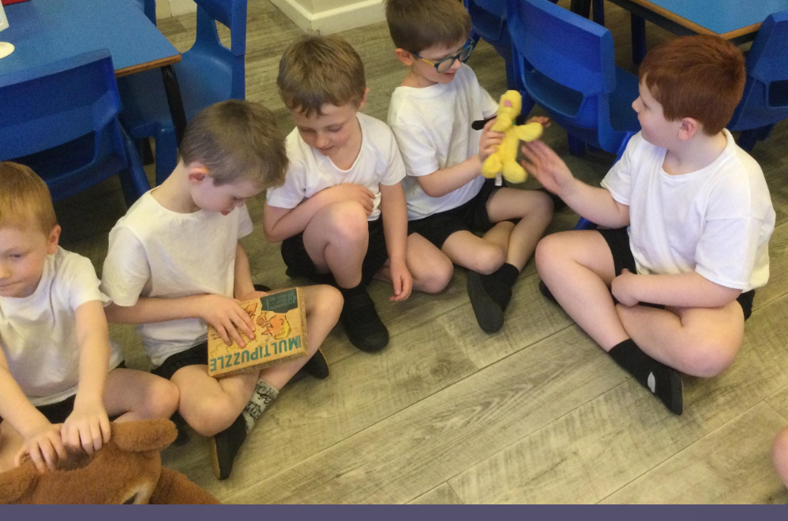

PSHRE: We celebrated Mental Health Week and completed lots of activities and we looked at being kind and unkind.
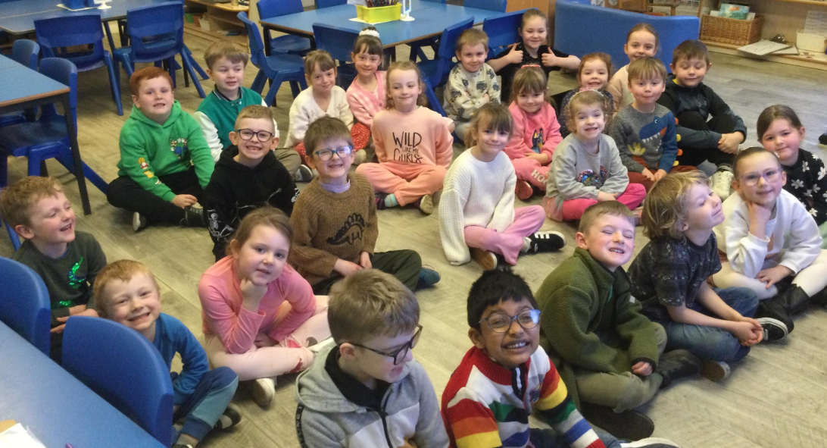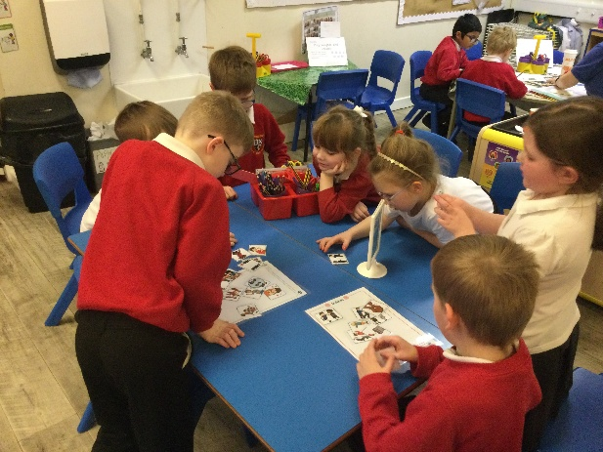

English using ‘hooks’ to excite the children to write!
A robot arrived in Owls class. We read No-Bot and changed the story to when No-Bot lost an arm.
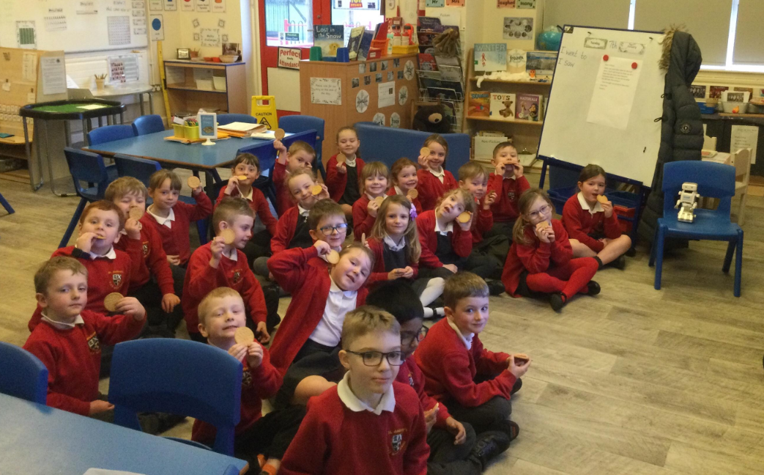
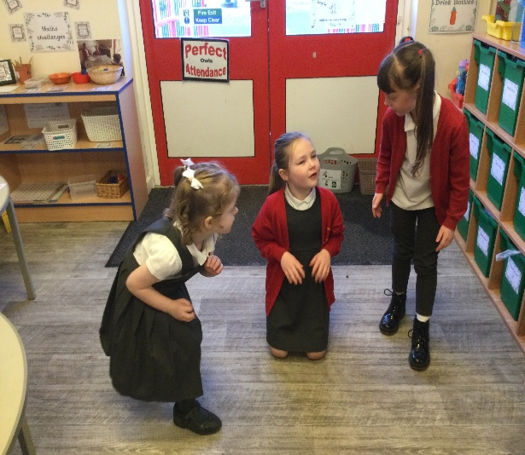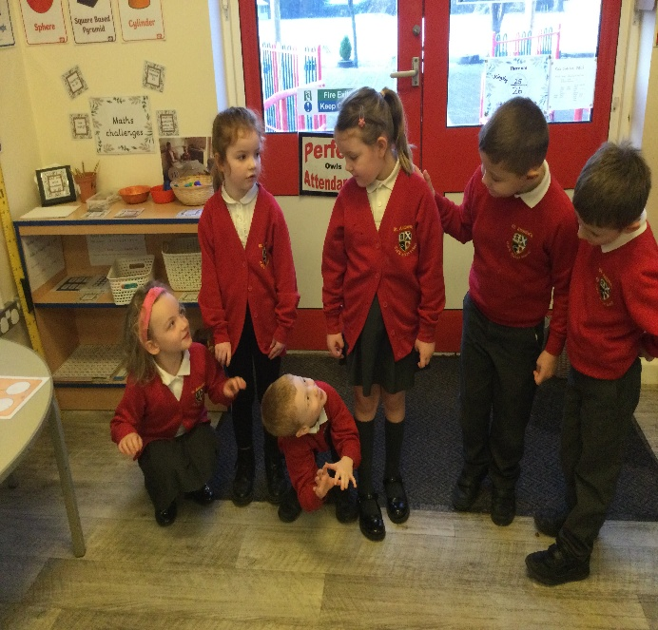
English: Acting out the No-Bot story.

