RE Blog

Butterflies Class

Spring 2

This half term we learnt about the Easter story. We reflected in the awe and wonder of new life and changes in nature. We talked about our own experiences of Easter and springtime.
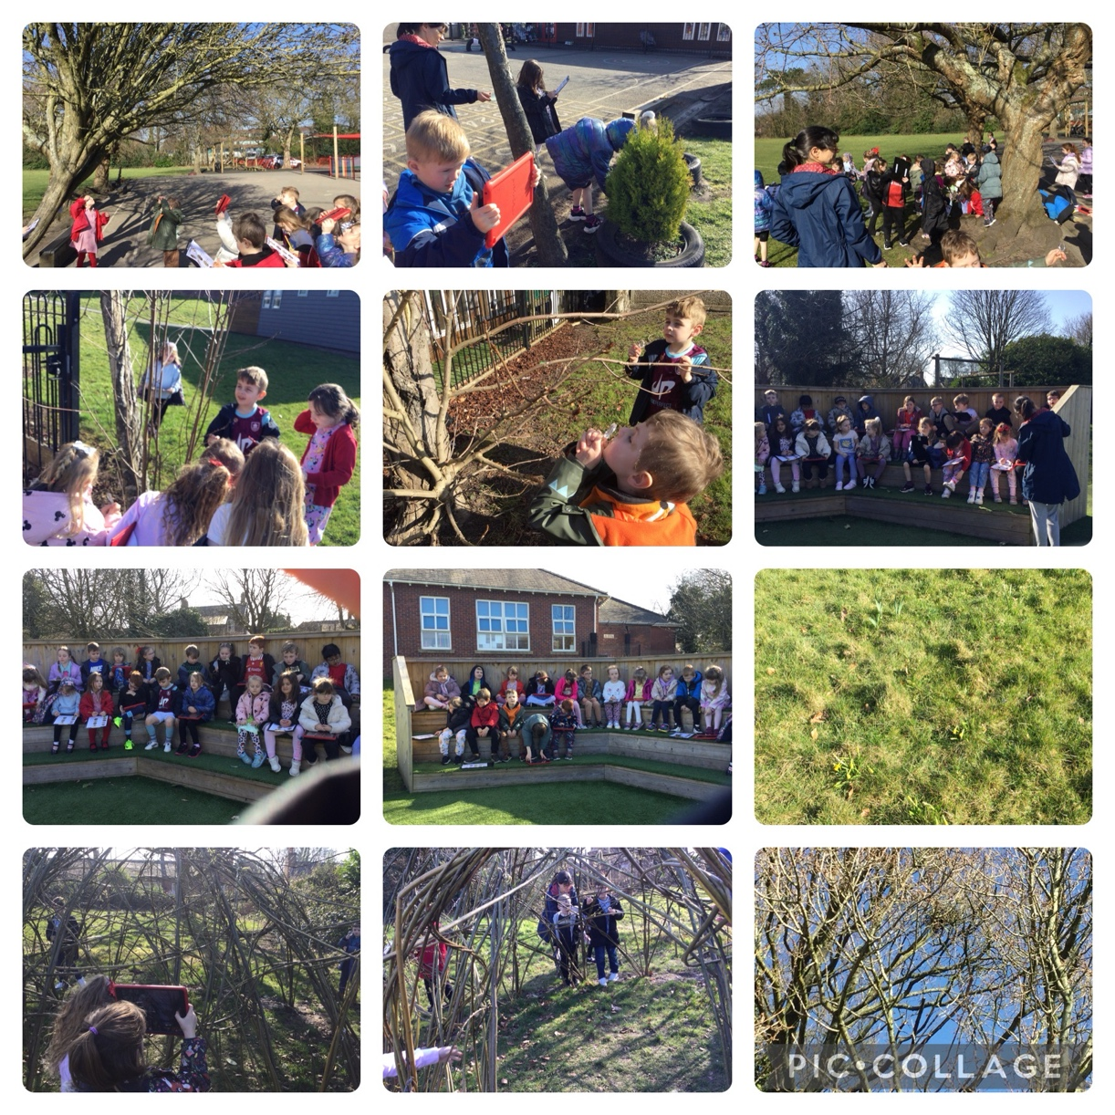
Enjoying looking for signs of Spring and new life.
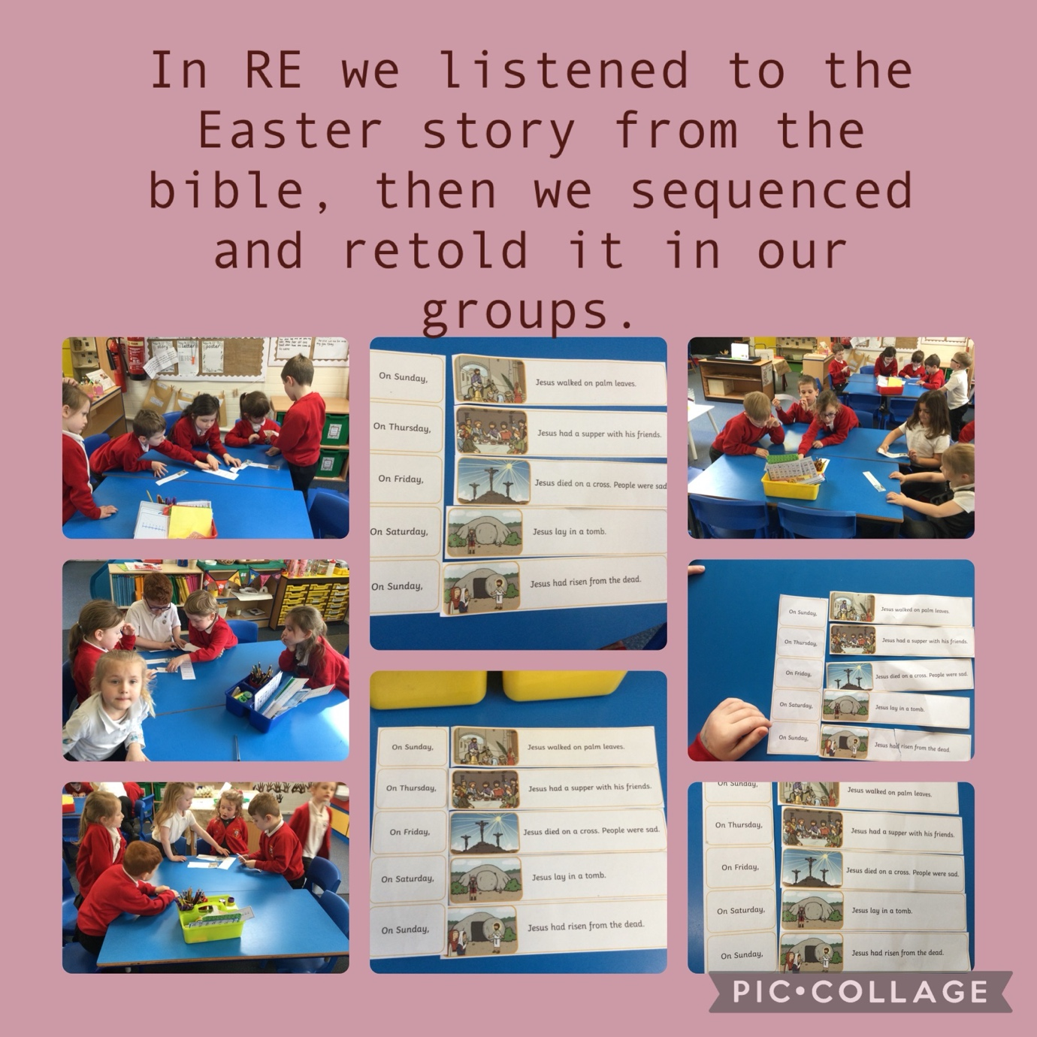

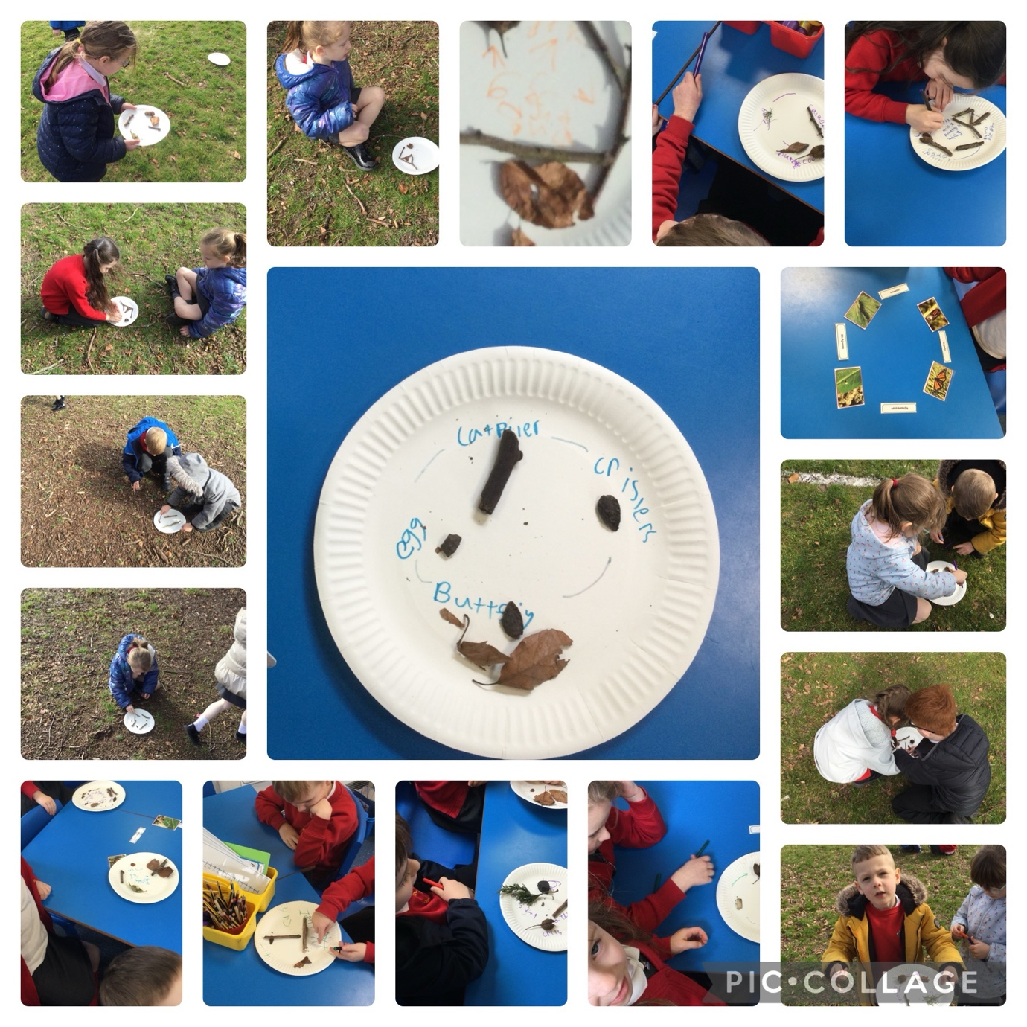
We linked the Easter story to the life cycle of a butterfly.

