Living Out Our Christian Vision

Butterflies Class

Here’s how we flourish

Spring 2

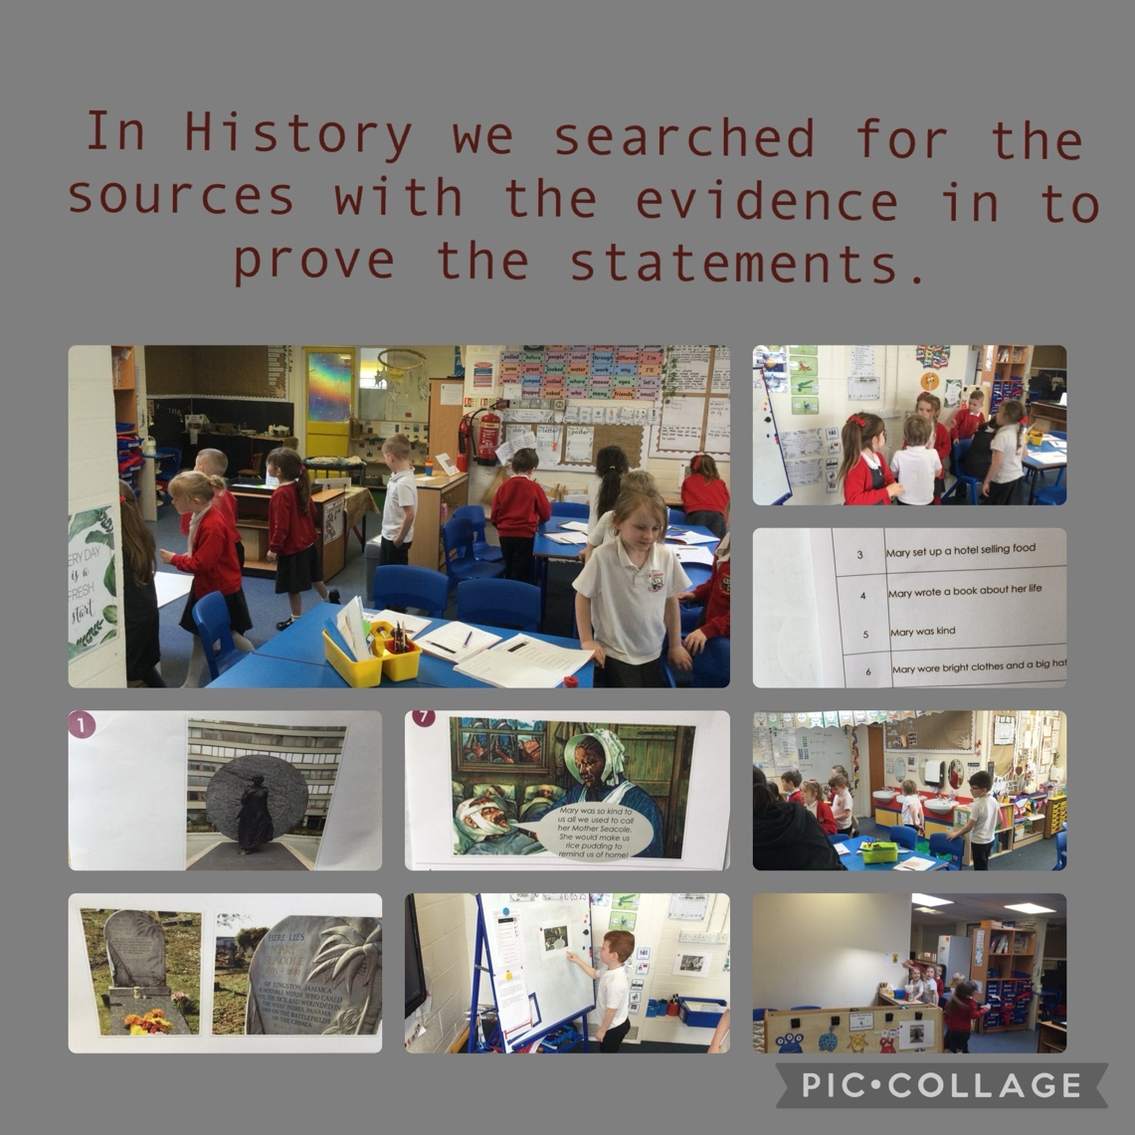
“I enjoyed looking for the clues” Felix

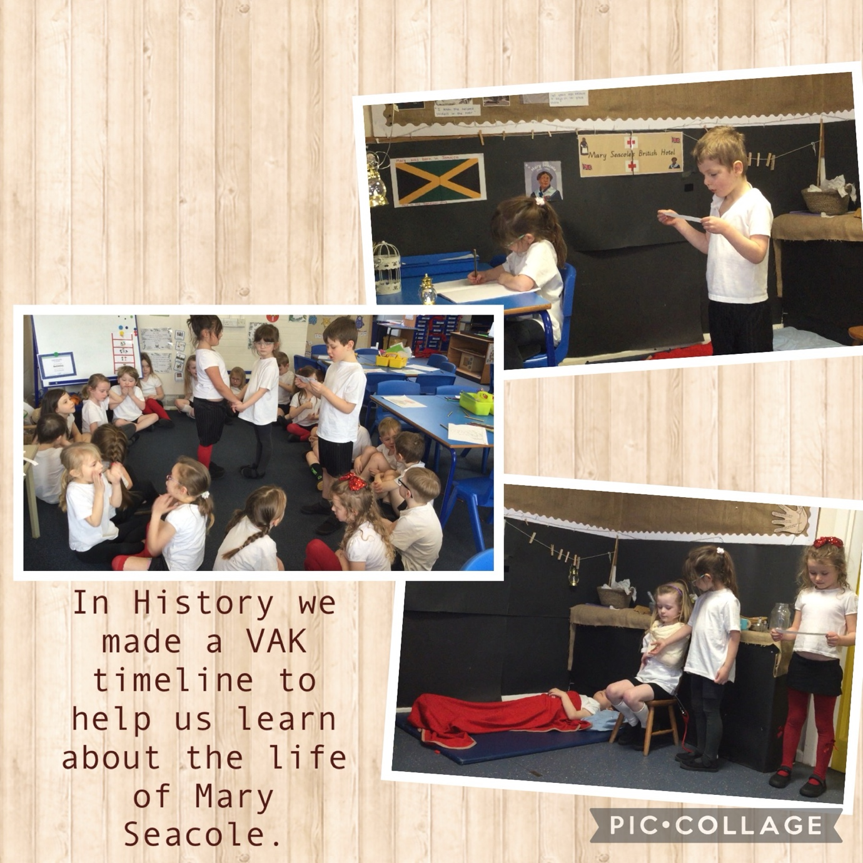

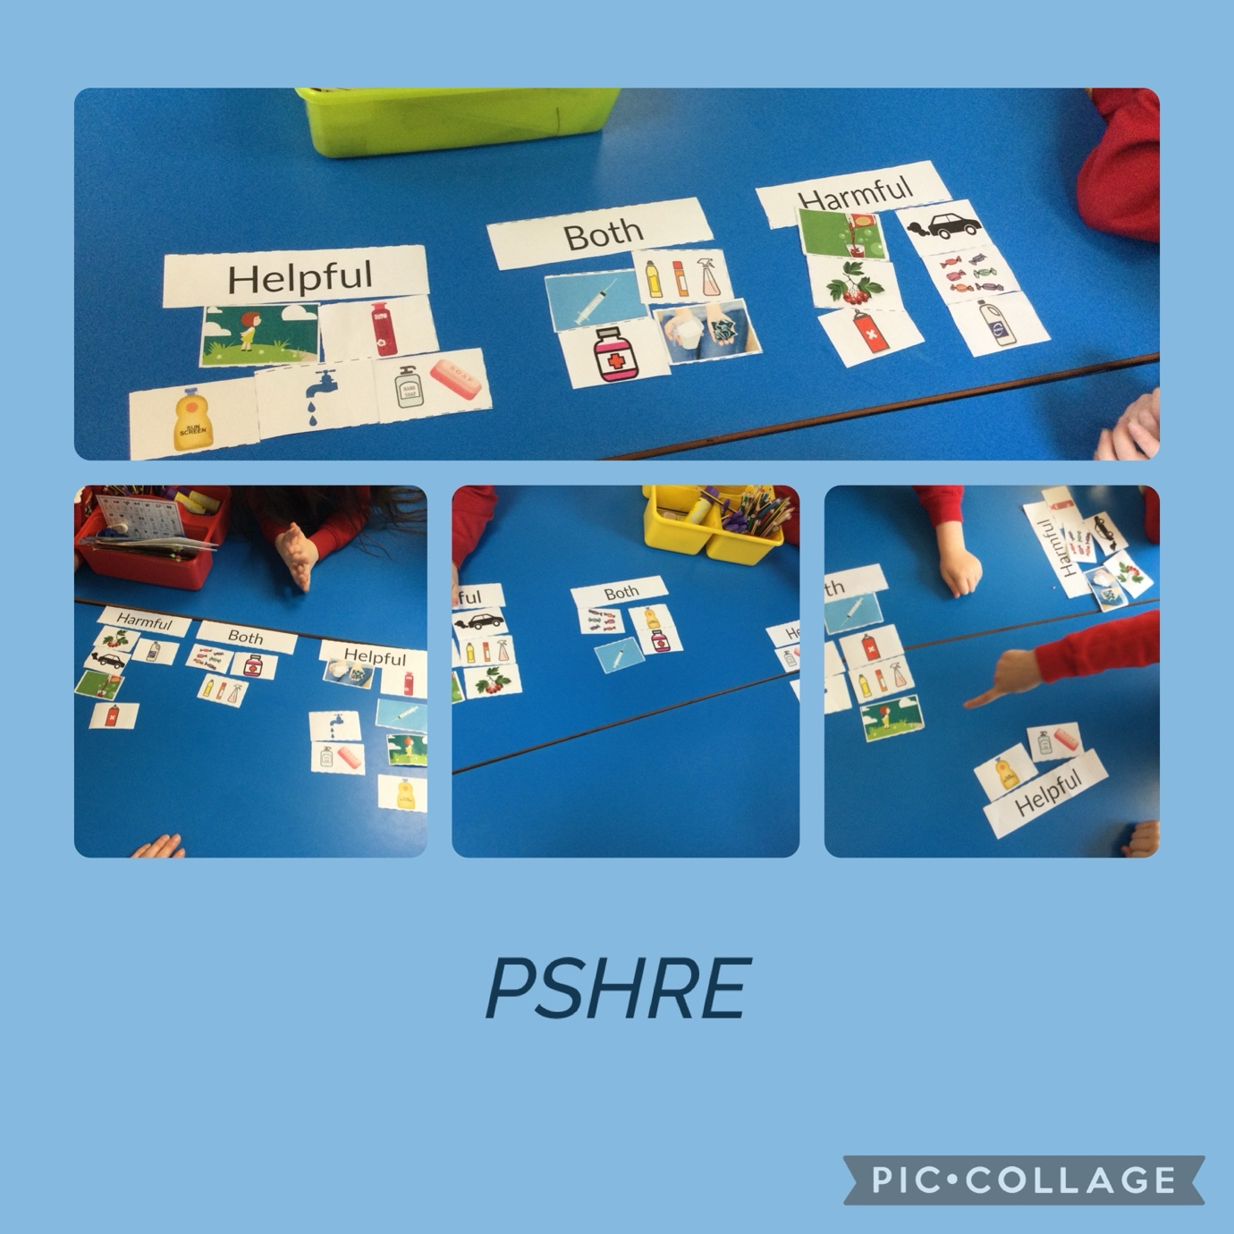

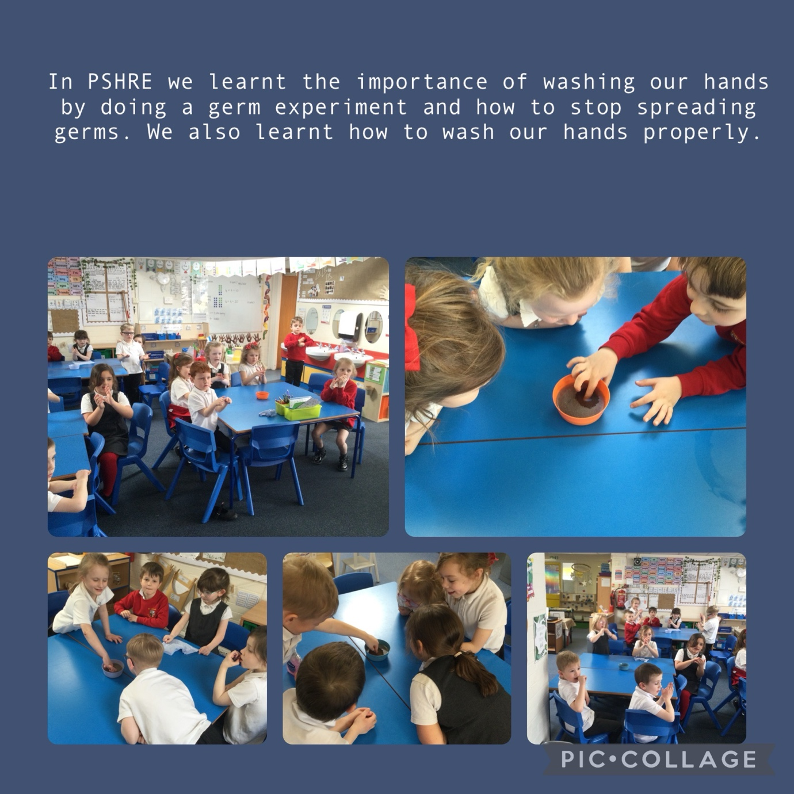

“When we put soap on our hands the germs moved” Xander

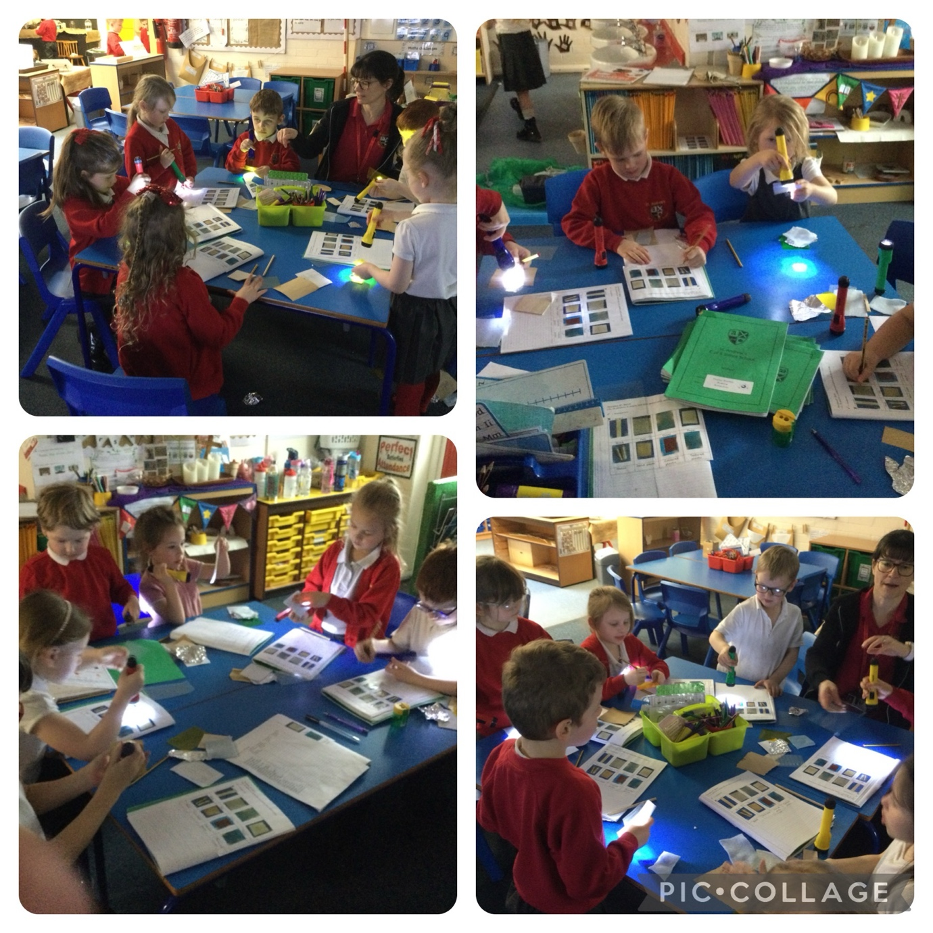

In Science we tested materials to see if they are transparent or opaque.

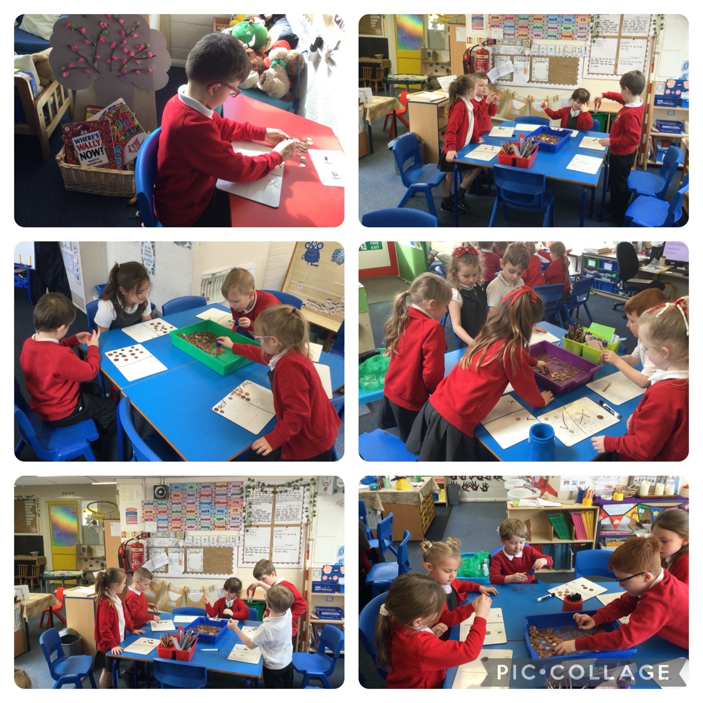

In Science we sorted the coins to see which were magnetic.

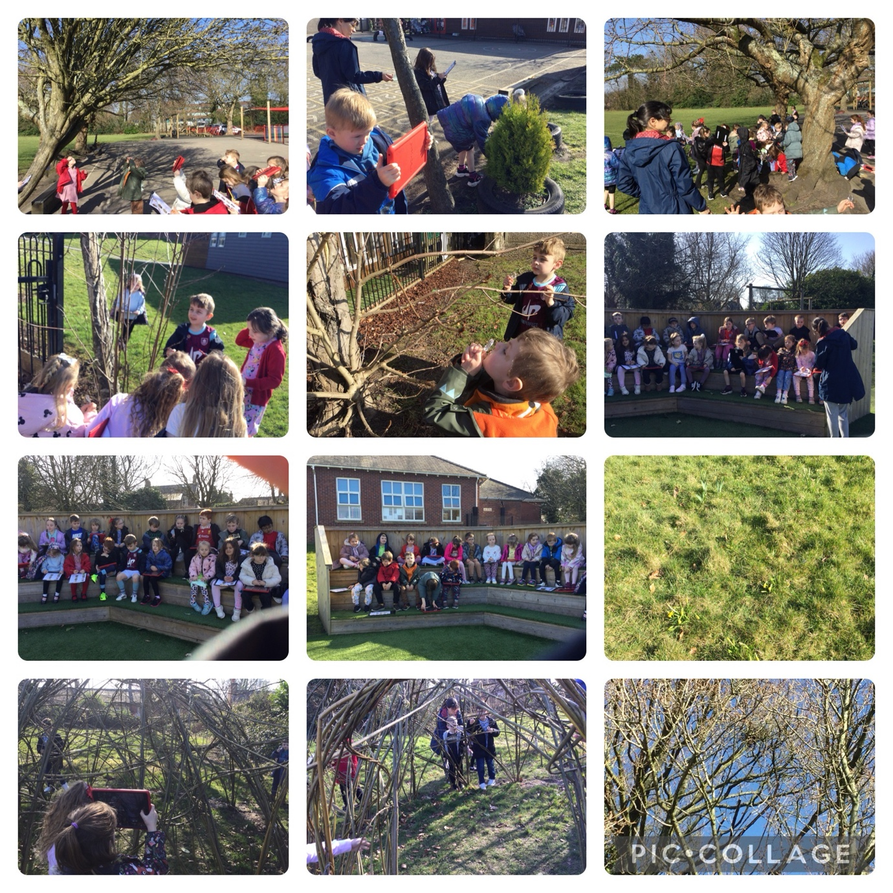

Science – hunting for the signs of Spring
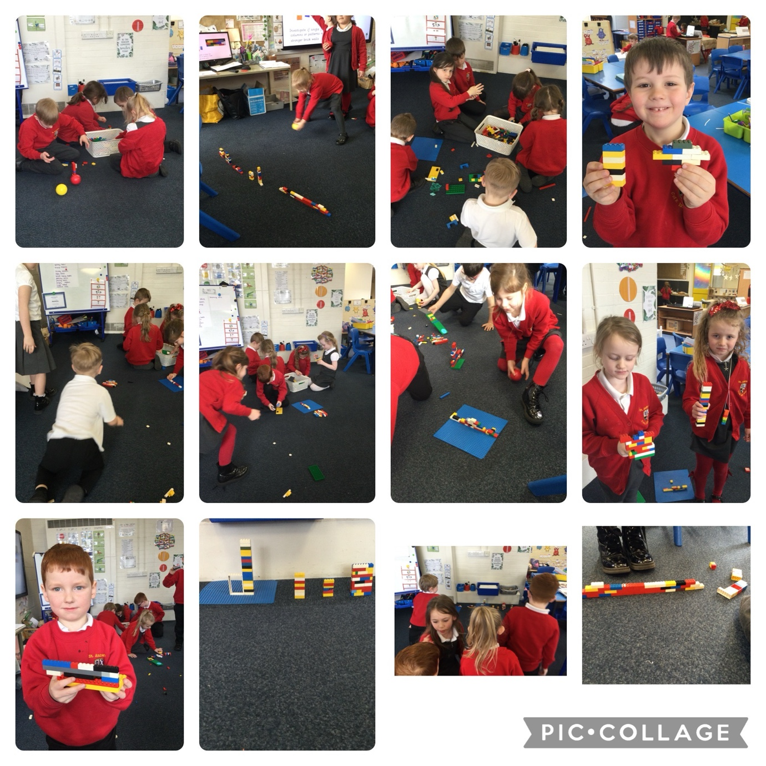

Making structures stronger in DT

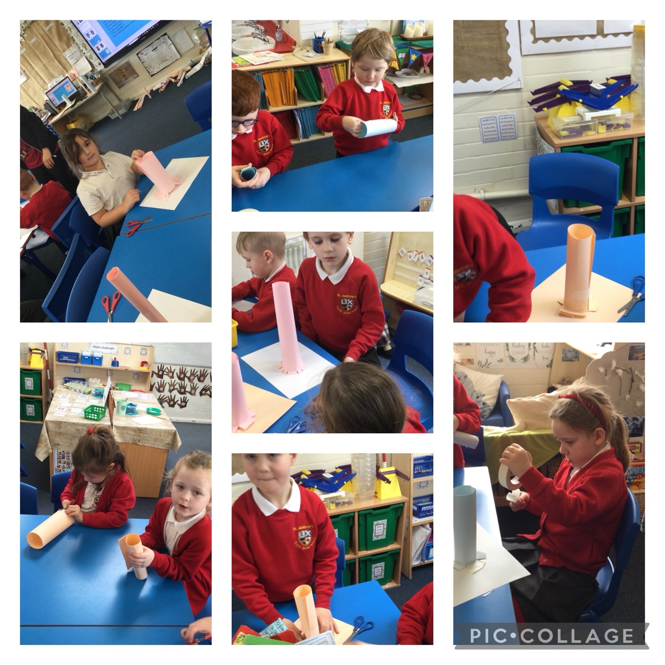

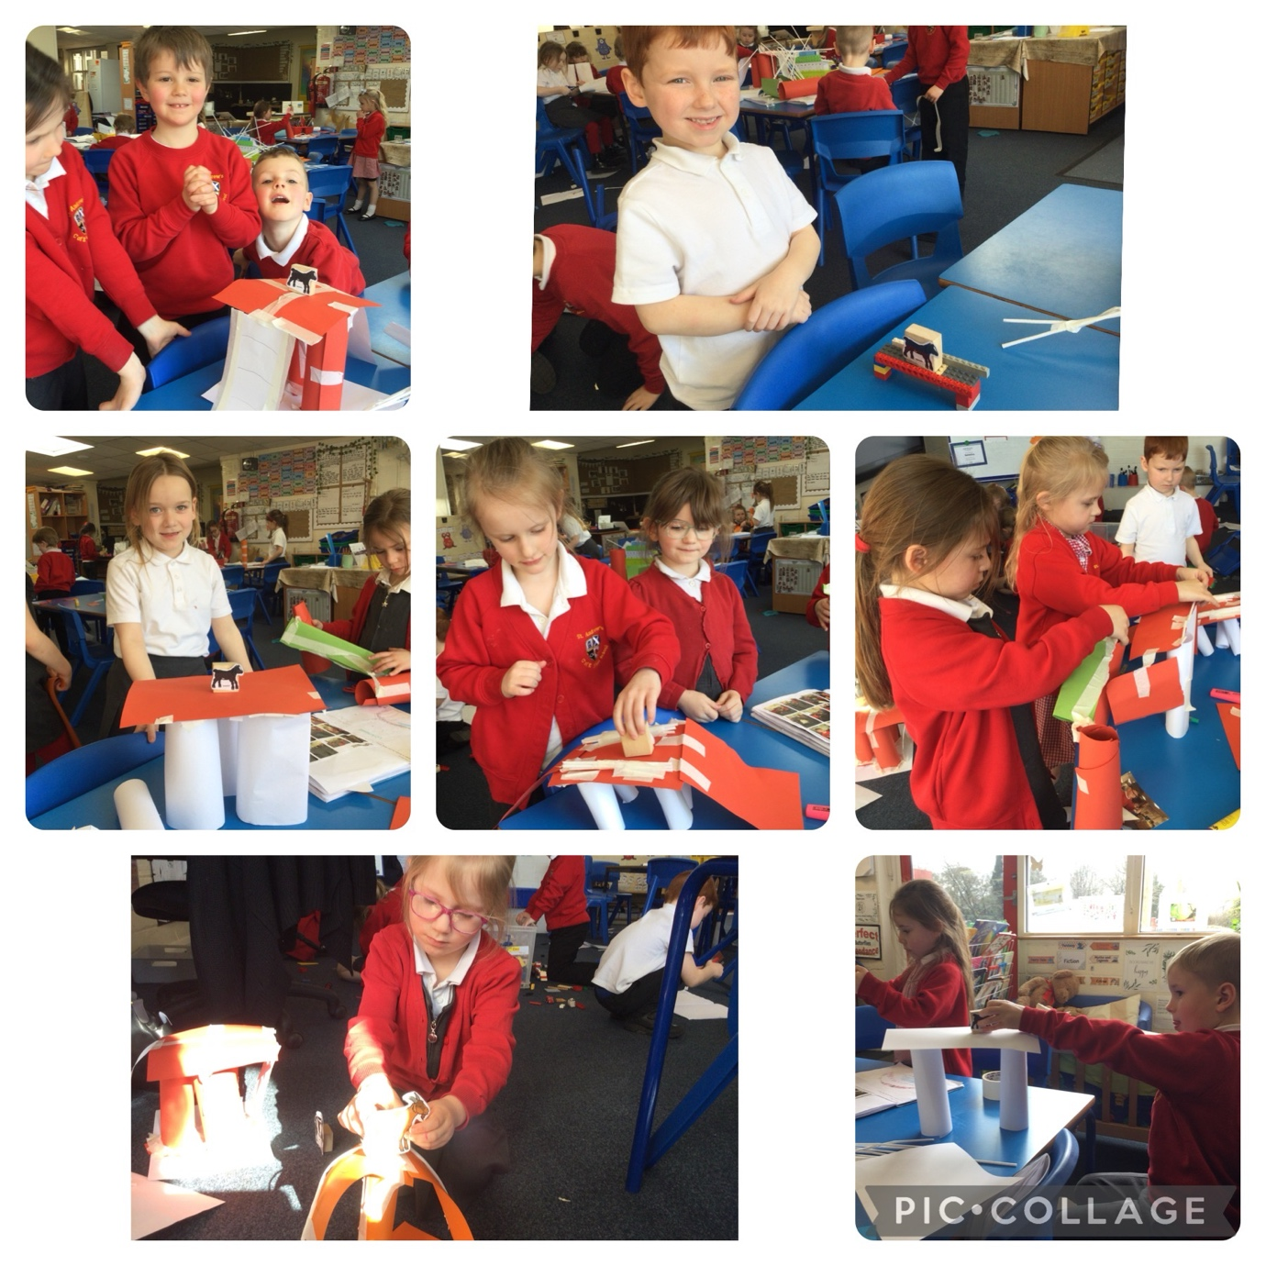

Using our knowledge of strong structures to design and build our own bridges.

“The goat could stand on mine” Soffia

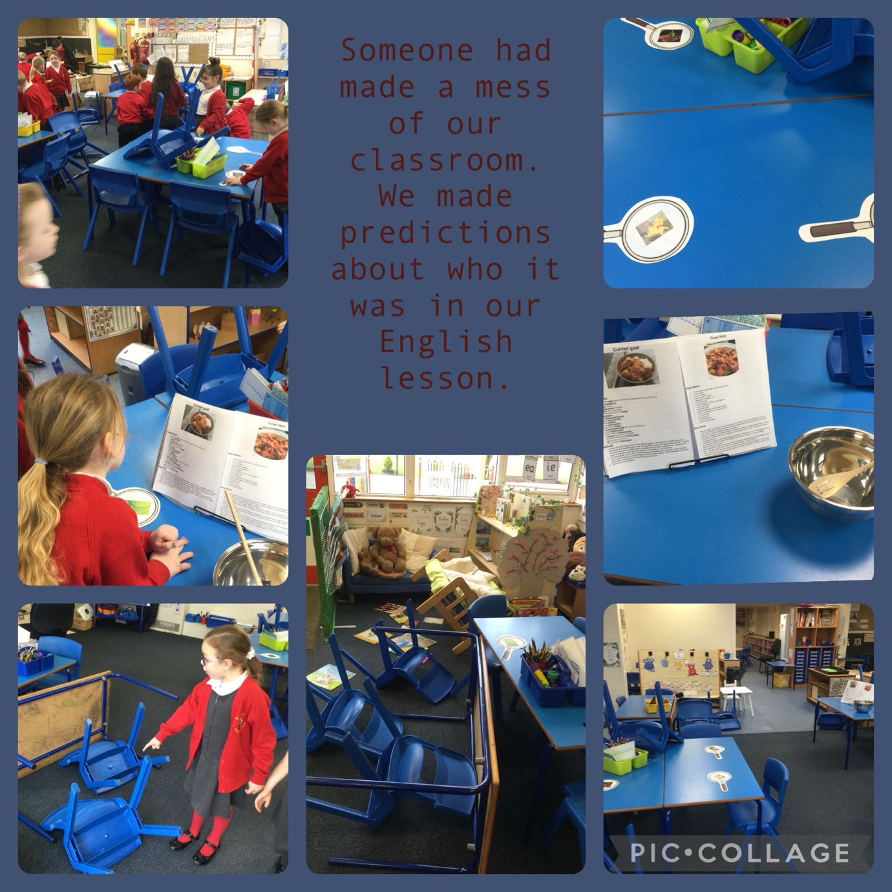

“The Troll had been in our class!!” Fia

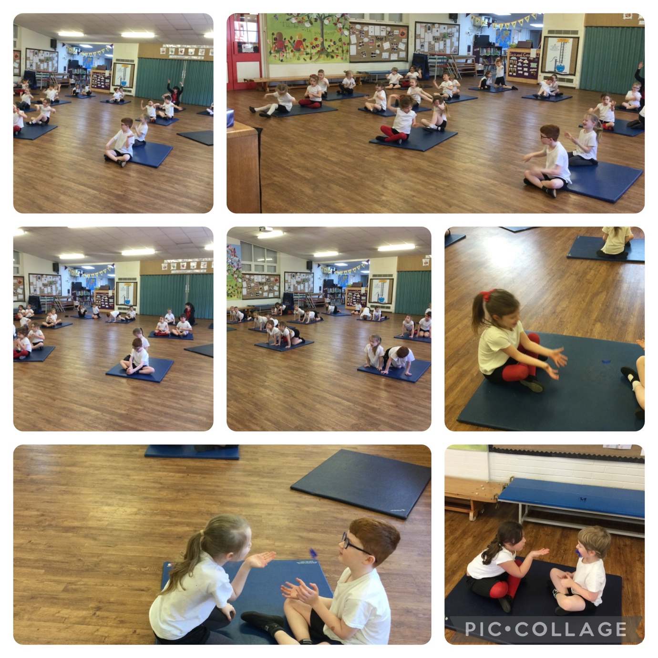

Mindful activities session in PE

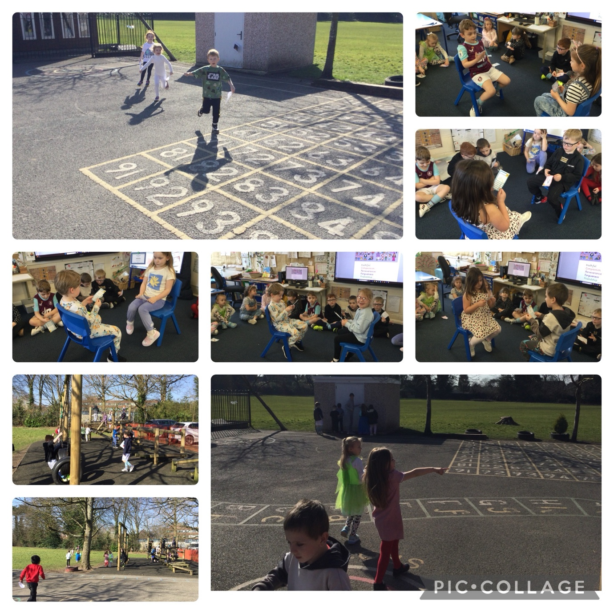

World book day

