RE Blog

Owls Class
Spring 2 - Easter
We have been learning about Easter. We have looked at how the Easter story links to Spring and new life. We enjoyed a Spring Walk looking at the signs of Spring and new life and taking time to reflect on the awe and wonder of nature. We have also looked at the lifecycle of a butterfly and how this links to Jesus in the Easter story. We used natural materials to make our own butterfly lifecycle outdoors.
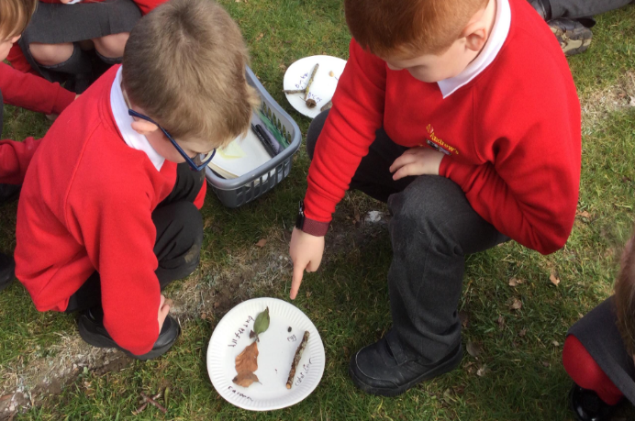
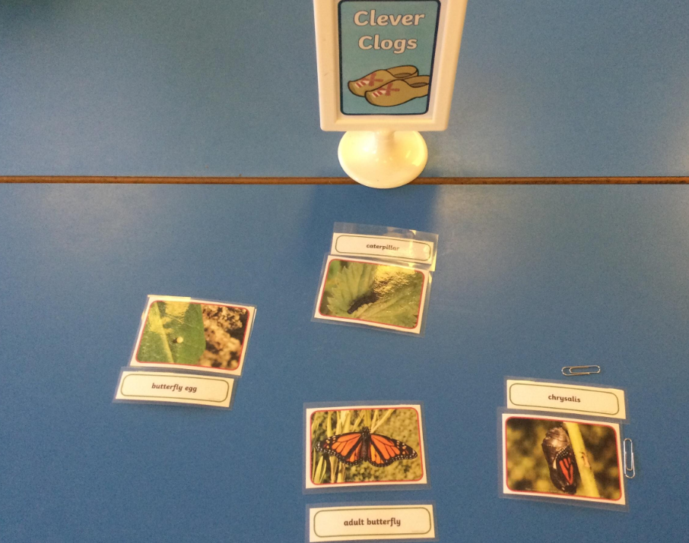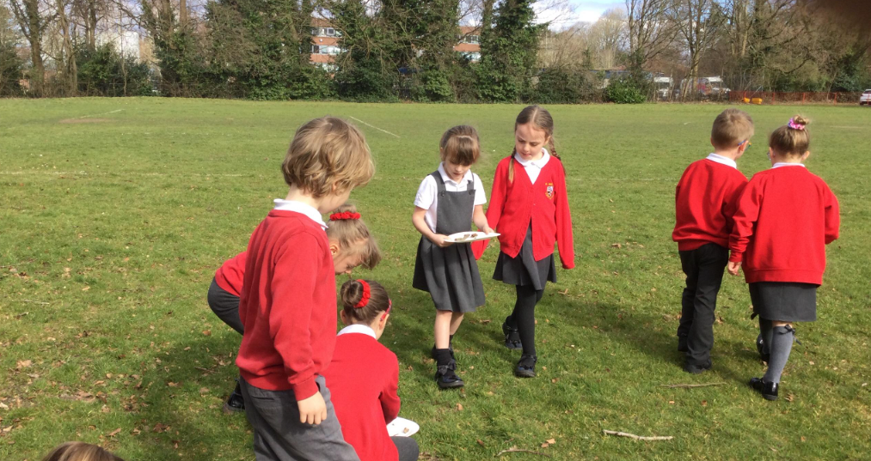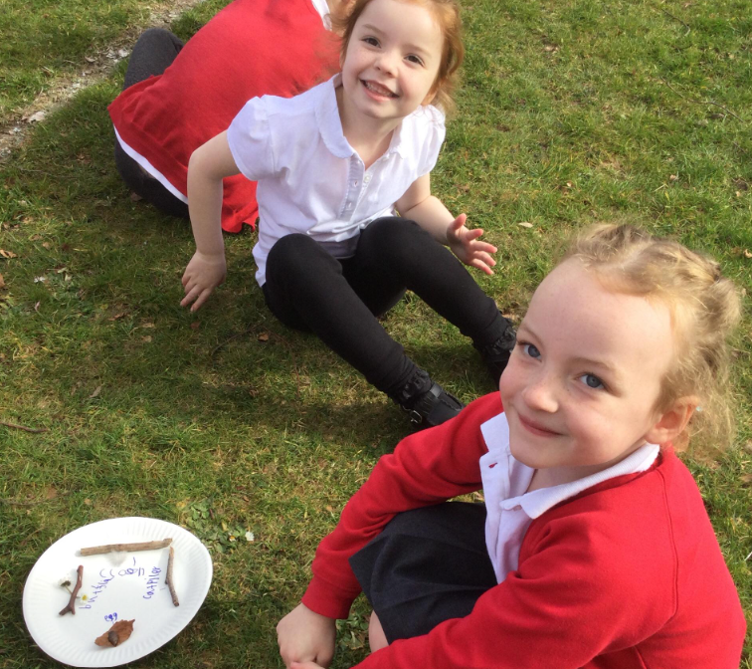
We then revisited all our learning as part of our end of topic assessment.

