Living Out Our Christian Vision

Owls Class

Here’s how we flourish

Spring 2

In Maths we have been busy working on lots of areas, one of our favourites this term has been telling the time.
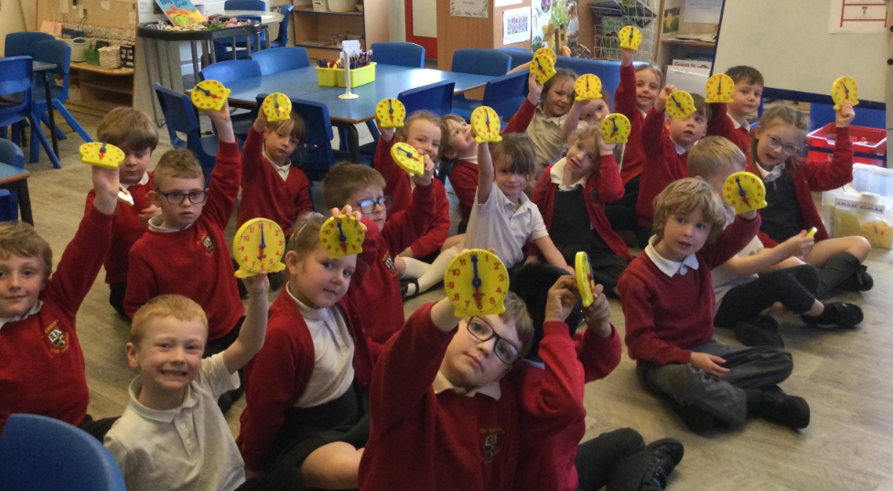

PE: We have been using our over arm throwing techniques in various games.

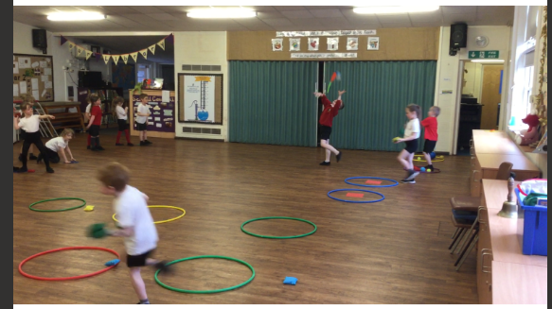

Science: we have explored materials and looked at whether they are transparent or opaque.

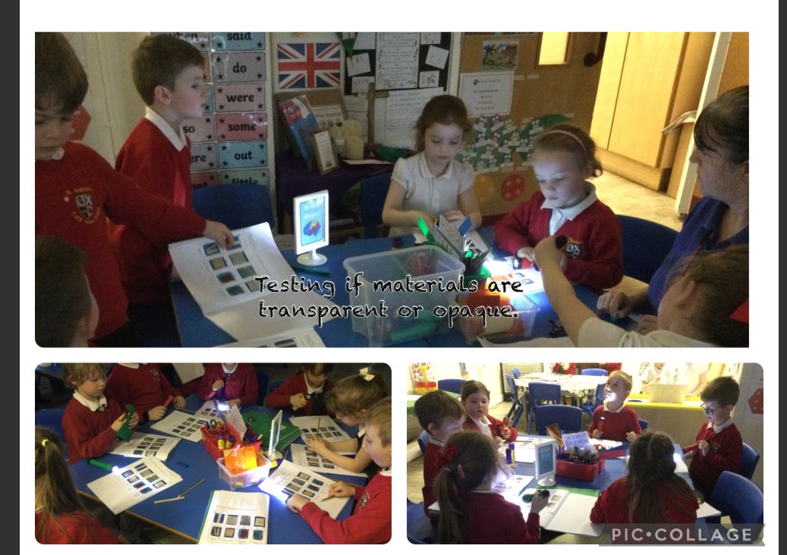

DT: we have been looking at structures and how to make them stronger. We have made our own bridges to link with our work on The Billy Goats Gruff.

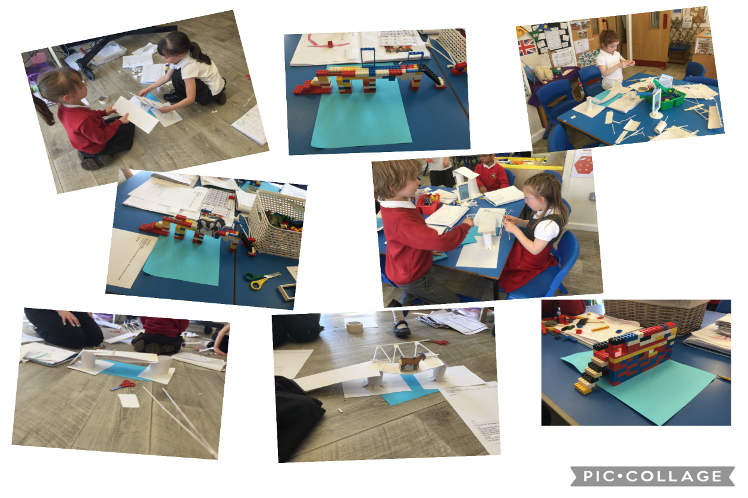
History: We have been learning at the key historical figure: Mary Seacole. We made a VAK timeline about her life.
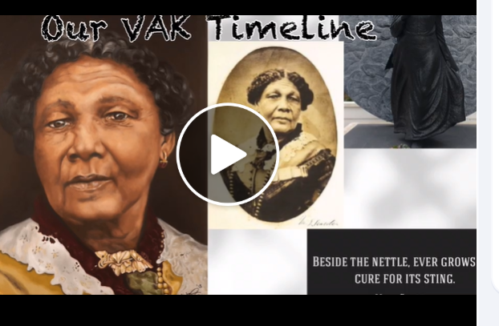

PSHRE: We have been looking at how we keep ourselves healthy.
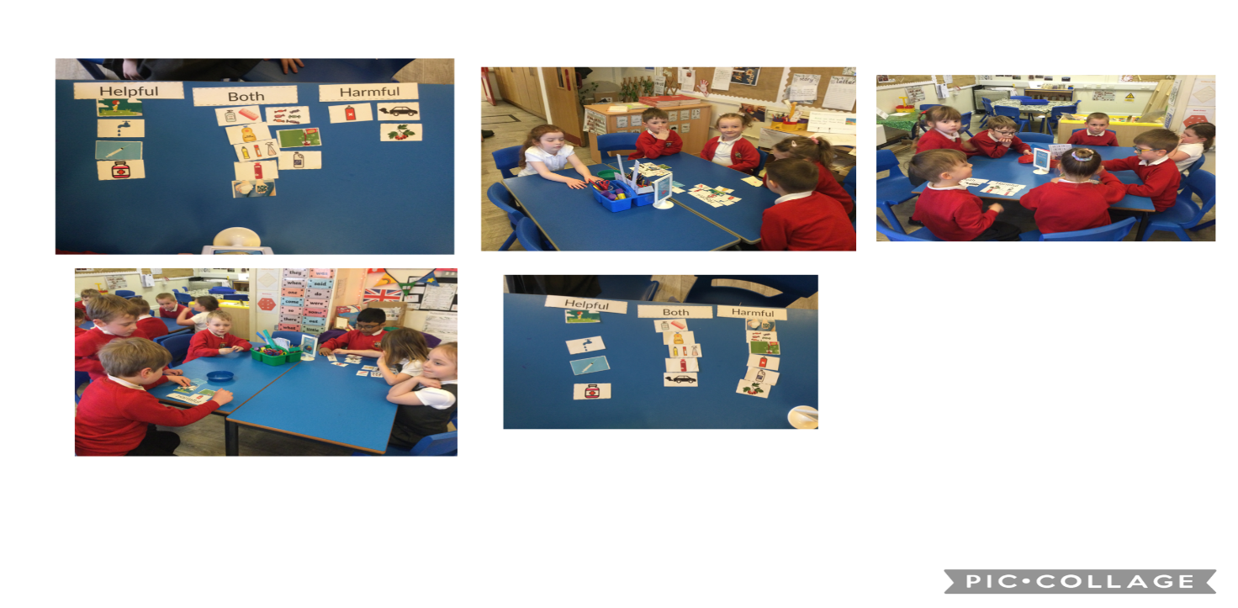
English using ‘hooks’ to excite the children to write!
Look what happened in our classroom! We followed the clues, furniture was turned over and we found photo clues and recipes for goat stew and a mixing bowl and spoon!
